Unit 1 Lesson 3: A Gallery of Data

1 Notice and Wonder: Dot Plots (Warm up)

Student Task Statement
The dot plots represent the distribution of the amount of tips, in dollars, left at 2 different restaurants on the same night.
What do you notice? What do you wonder?
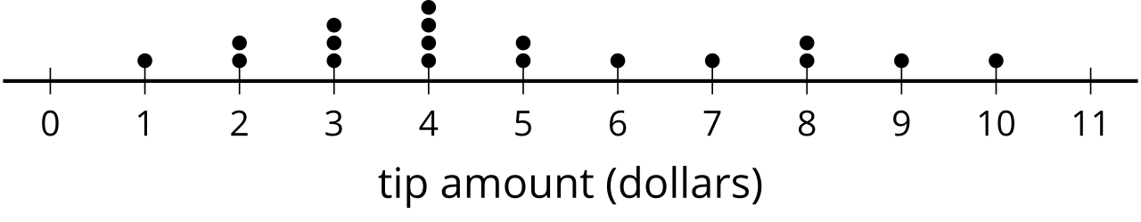
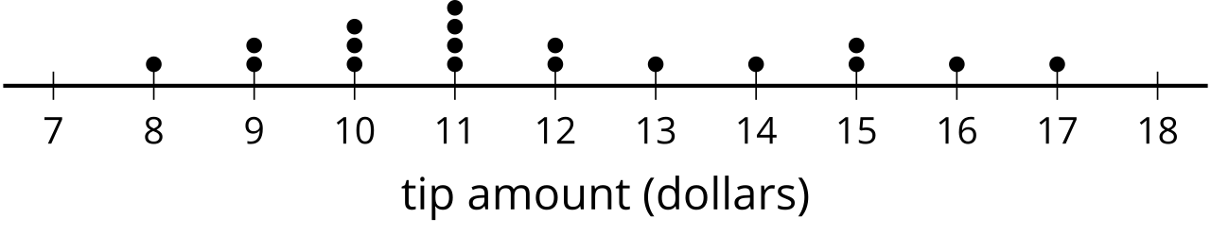

2 Data Displays

Student Task Statement
Your teacher will assign your group a statistical question. As a group:
- Create a dot plot, histogram, and box plot to display the distribution of the data.
- Write 3 comments that interpret the data.
As you visit each display, write a sentence or two summarizing the information in the display.
© CC BY 2019 by Illustrative Mathematics®

