Unit 2 Lesson 17: Systems of Linear Equations and Their Solutions

1 A Curious System (Warm up)

Student Task Statement
Andre is trying to solve this system of equations: $\left\{\begin{matrix}x+y=3 \\ 4x=12−4y\end{matrix}\right.$
Looking at the first equation, he thought, "The solution to the system is a pair of numbers that add up to 3. I wonder which two numbers they are."
- Choose any two numbers that add up to 3. Let the first one be the $x$-value and the second one be the $y$-value.
- The pair of values you chose is a solution to the first equation. Check if it is also a solution to the second equation. Then, pause for a brief discussion with your group.
- How many solutions does the system have? Use what you know about equations or about solving systems to show that you are right.

2 What's the Deal?

Student Task Statement
A recreation center is offering special prices on its pool passes and gym memberships for the summer. On the first day of the offering, a family paid $96 for 4 pool passes and 2 gym memberships. Later that day, an individual bought a pool pass for herself, a pool pass for a friend, and 1 gym membership. She paid $72.
- Write a system of equations that represents the relationships between pool passes, gym memberships, and the costs. Be sure to state what each variable represents.
- Find the price of a pool pass and the price of a gym membership by solving the system algebraically. Explain or show your reasoning.
- Use graphing technology to graph the equations in the system. Make 1-2 observations about your graphs.

3 Card Sort: Sorting Systems

Student Task Statement
Your teacher will give you a set of cards. Each card contains a system of equations.
Sort the systems into three groups based on the number of solutions each system has. Be prepared to explain how you know where each system belongs.

4 One, Zero, Infinitely Many (Optional)

Student Task Statement
Here is an equation: $5x−2y=10$.
Create a second equation that would make a system of equations with:
- One solution
- No solutions
- Infinitely many solutions

Images for Activity Synthesis
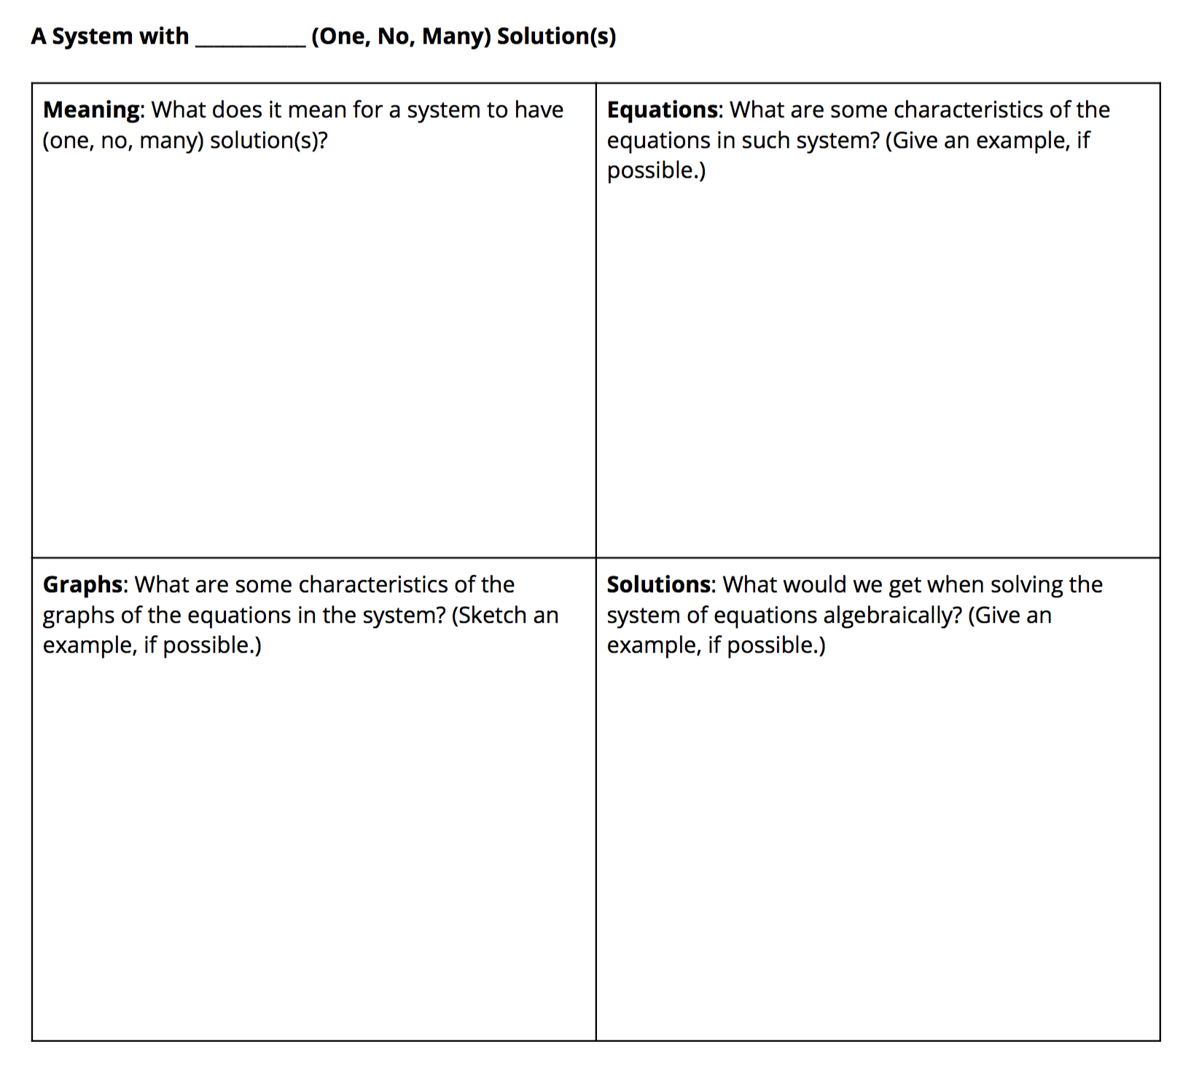
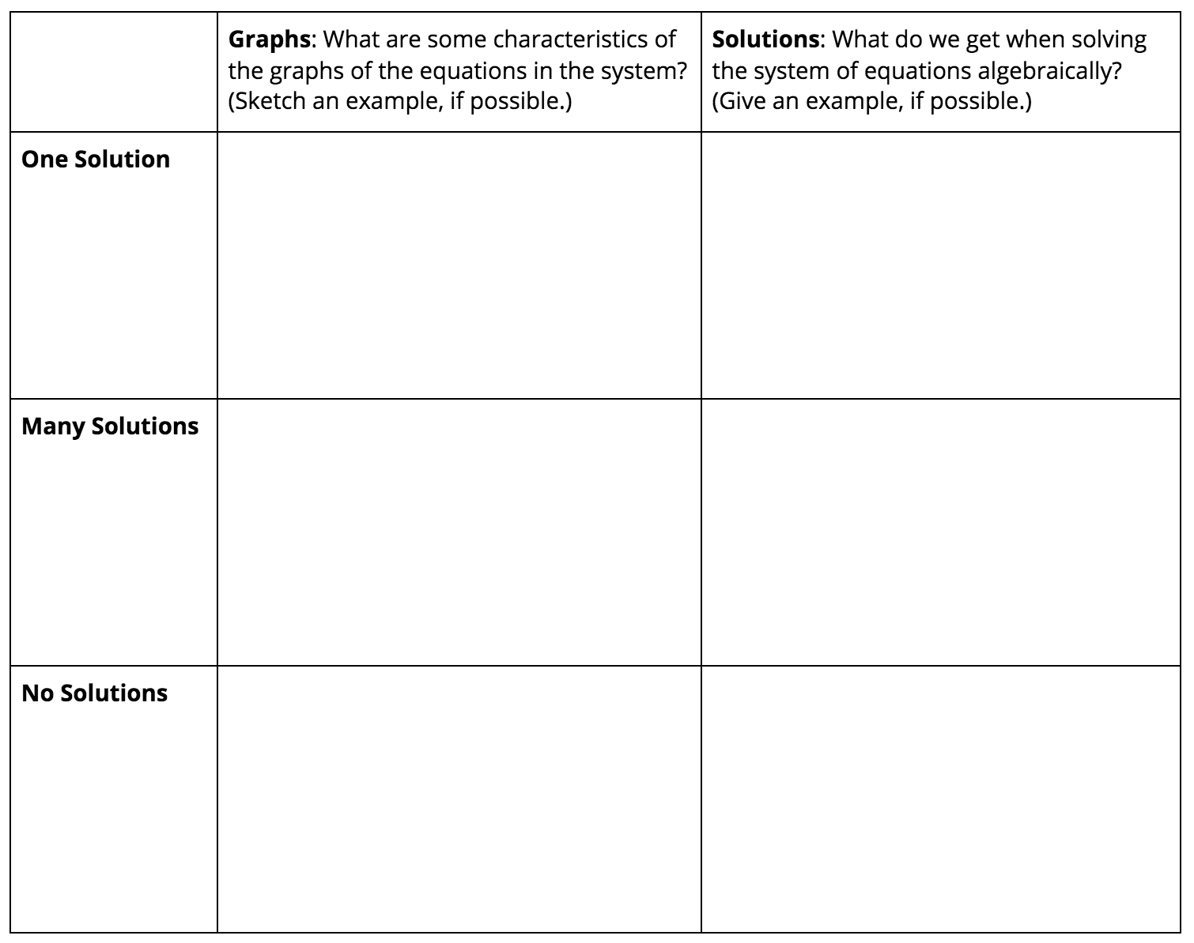
© CC BY 2019 by Illustrative Mathematics®

