Lesson 18: Use Whole Number Facts
- Let’s multiply whole numbers and decimals.

Warm-up: True or False: Group Dynamics
Decide if each statement is true or false. Be prepared to explain your reasoning.
- $30×2×10=6×10$
- $30×2×10=20×3×10$
- $60×10=30×20$

18.1: Agree or Disagree
- Decide whether each equation is true or false and explain or show why.
  - $4×0.7=28$
  - $5×0.8=0.40$
  - $6×0.03=\left(6×3\right)×0.01$
  - $8×0.07=\left(8×7\right)×0.1$
- Fill in the blank to make each equation true.
  - $3×0.7=3×7×\underset{_}{}$
  - $3×0.07=3×7×\underset{_}{}$
  - $5×\underset{_}{}=\left(5×4\right)×0.1$

18.2: Interpret Diagrams and Expressions
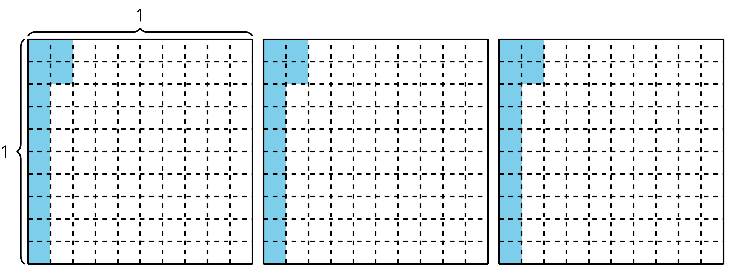
- Explain or show how the diagram represents each expression.
  - $3×0.12$
  - $\left(3×12\right)×0.01$
  - $\left(3×0.1\right)+\left(3×0.02\right)$
- Find the value of $\left(3×12\right)×0.01$. Explain or show your reasoning.
- Find the value of $\left(3×0.1\right)+\left(3×0.02\right)$. Explain or show your reasoning.
© CC BY 2021 Illustrative Mathematics®

