Unit 7 Lesson 6: Hierarchy of Quadrilaterals

WU Notice and Wonder: Squares and Rhombuses (Warm up)

Student Task Statement
What do you notice? What do you wonder?
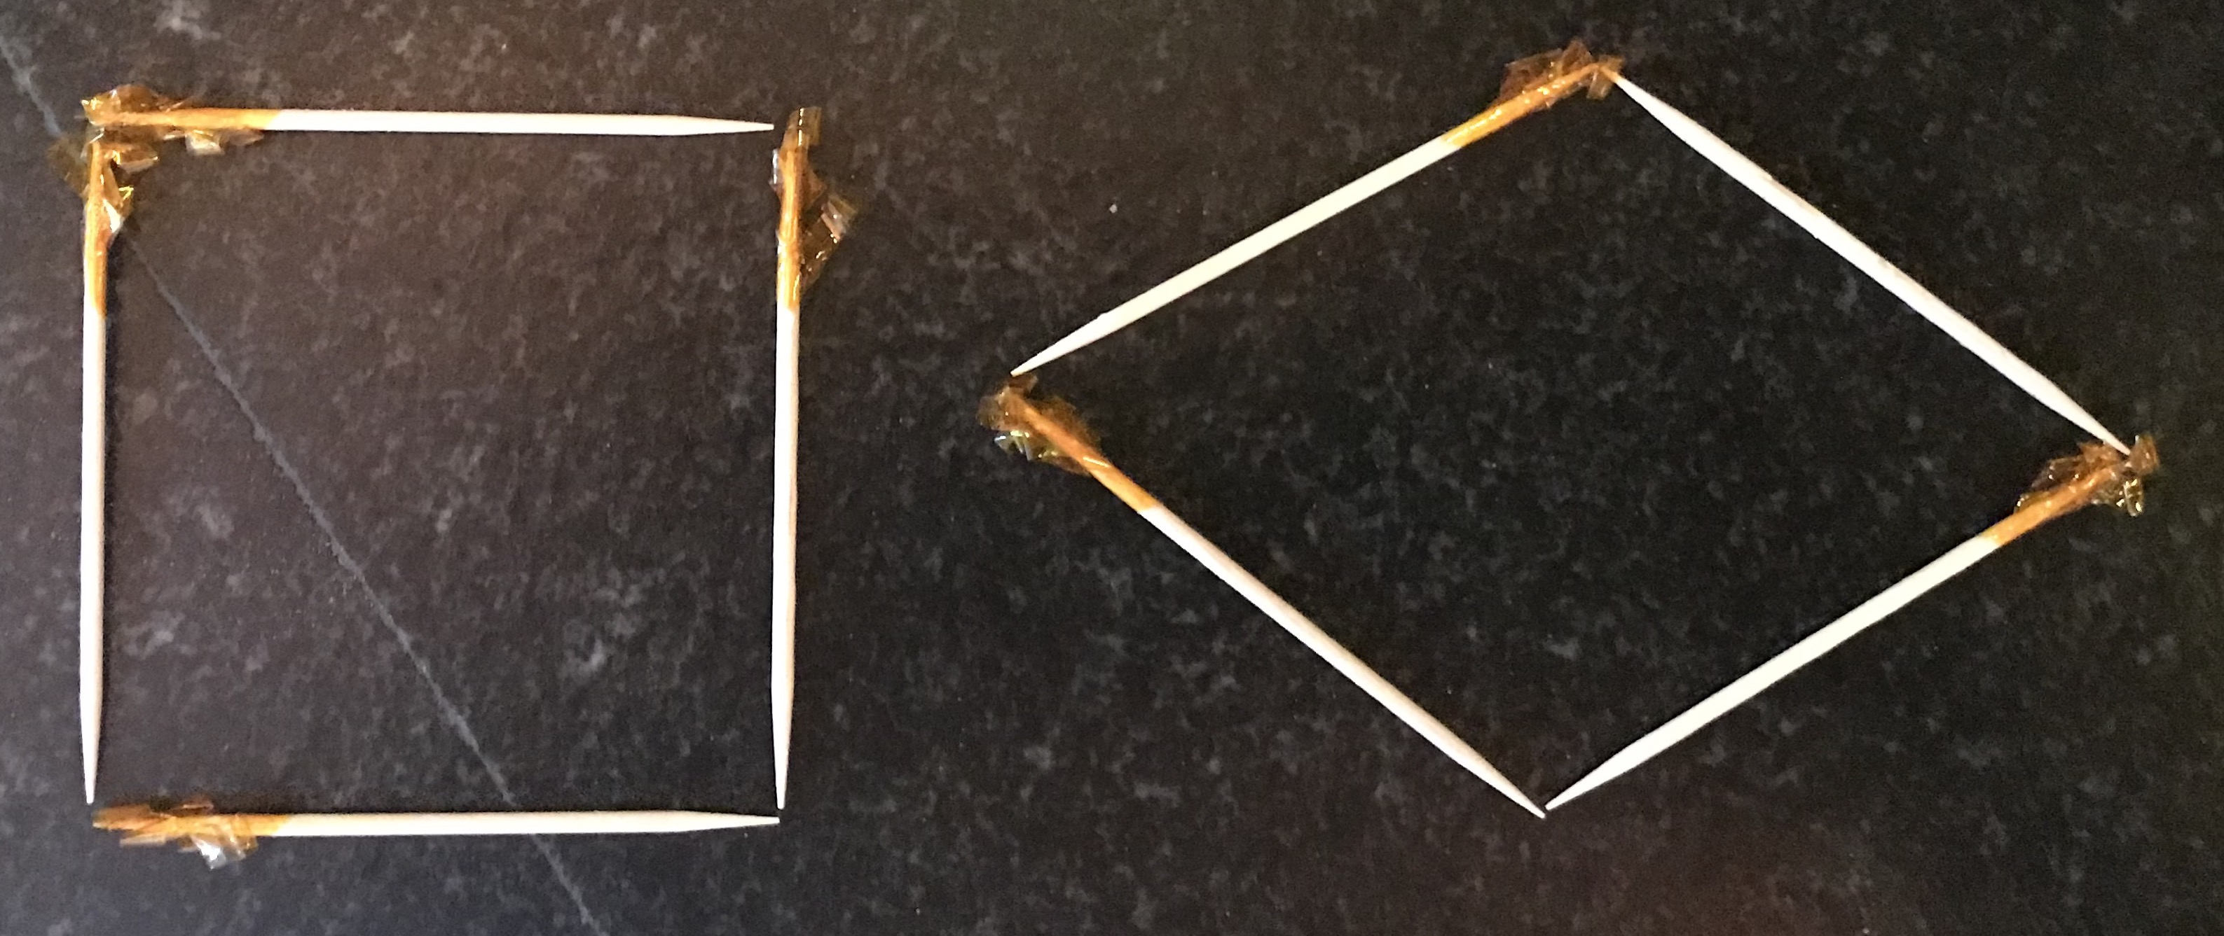

1 Shapes with Toothpicks

Student Task Statement
- Build a square with your toothpicks. How do you know it is a square?
- Use the same four toothpicks to build this shape. What stayed the same? What changed?
- 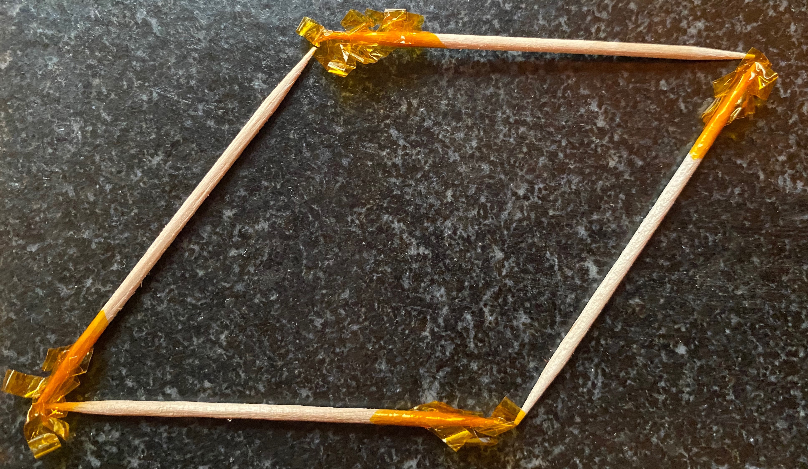
- Build a rectangle with six toothpicks. How do you know it is a rectangle?
- Use the same six toothpicks to build this shape. What stayed the same? What changed?
- 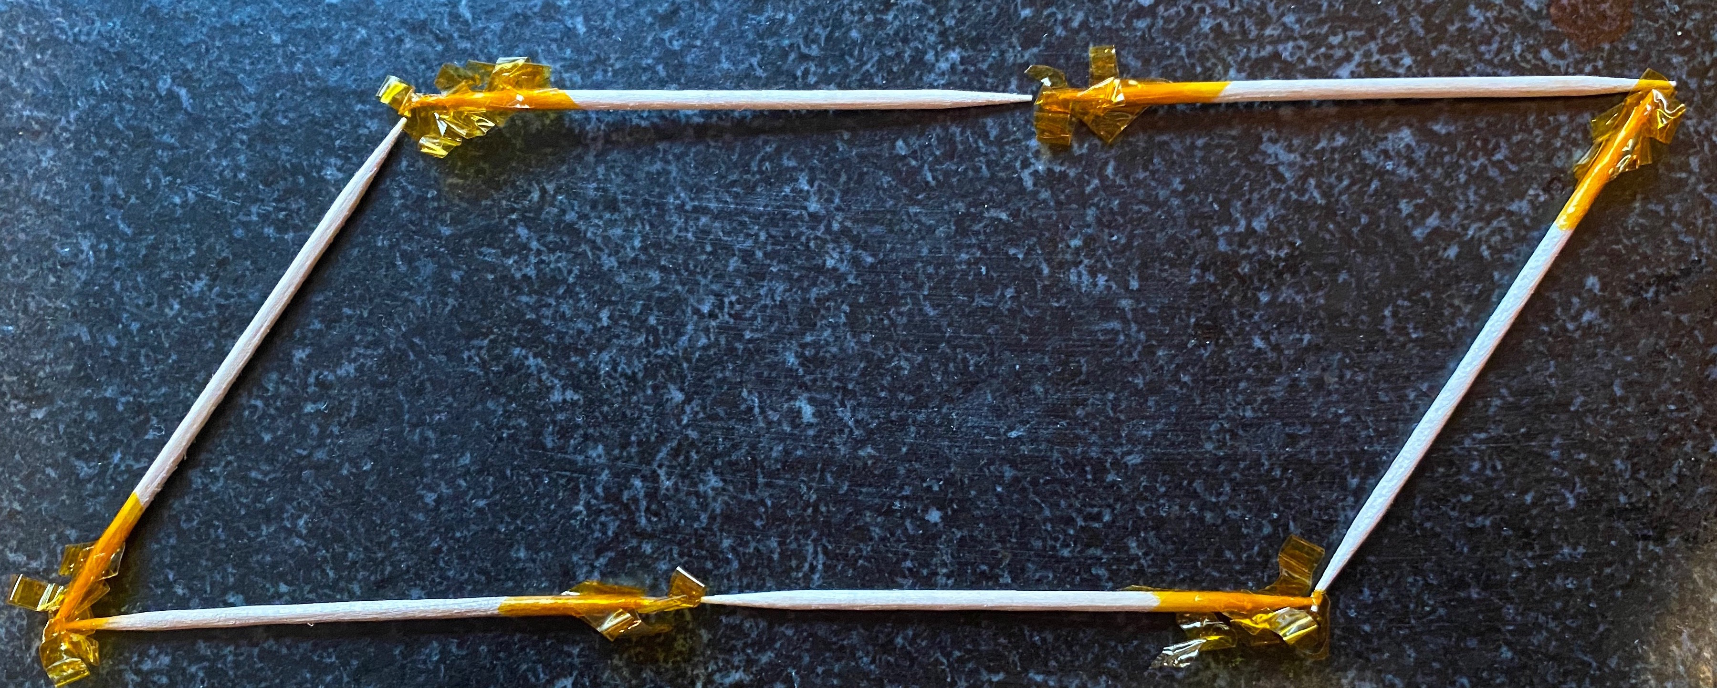

2 Three Quadrilaterals

Student Task Statement
- Draw 3 different quadrilaterals on the grid, making sure at least one of them is a parallelogram.
- For each of your quadrilaterals determine if it is a:
  - square
  - rhombus
  - rectangle
  - parallelogram
- Explain or show your reasoning.
- Draw a rhombus that is not a square. Explain or show how you know it is a rhombus but not a square.
- Draw a rhombus that is a square. Explain or show how you know it is a rhombus and a square.
- Diego says that it is impossible to draw a square that is not a rhombus. Do you agree with him? Explain or show your reasoning.

Activity Synthesis
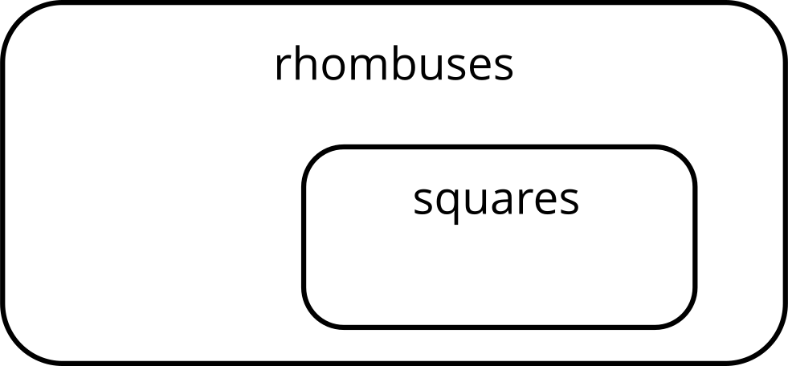

Images for Activity Synthesis
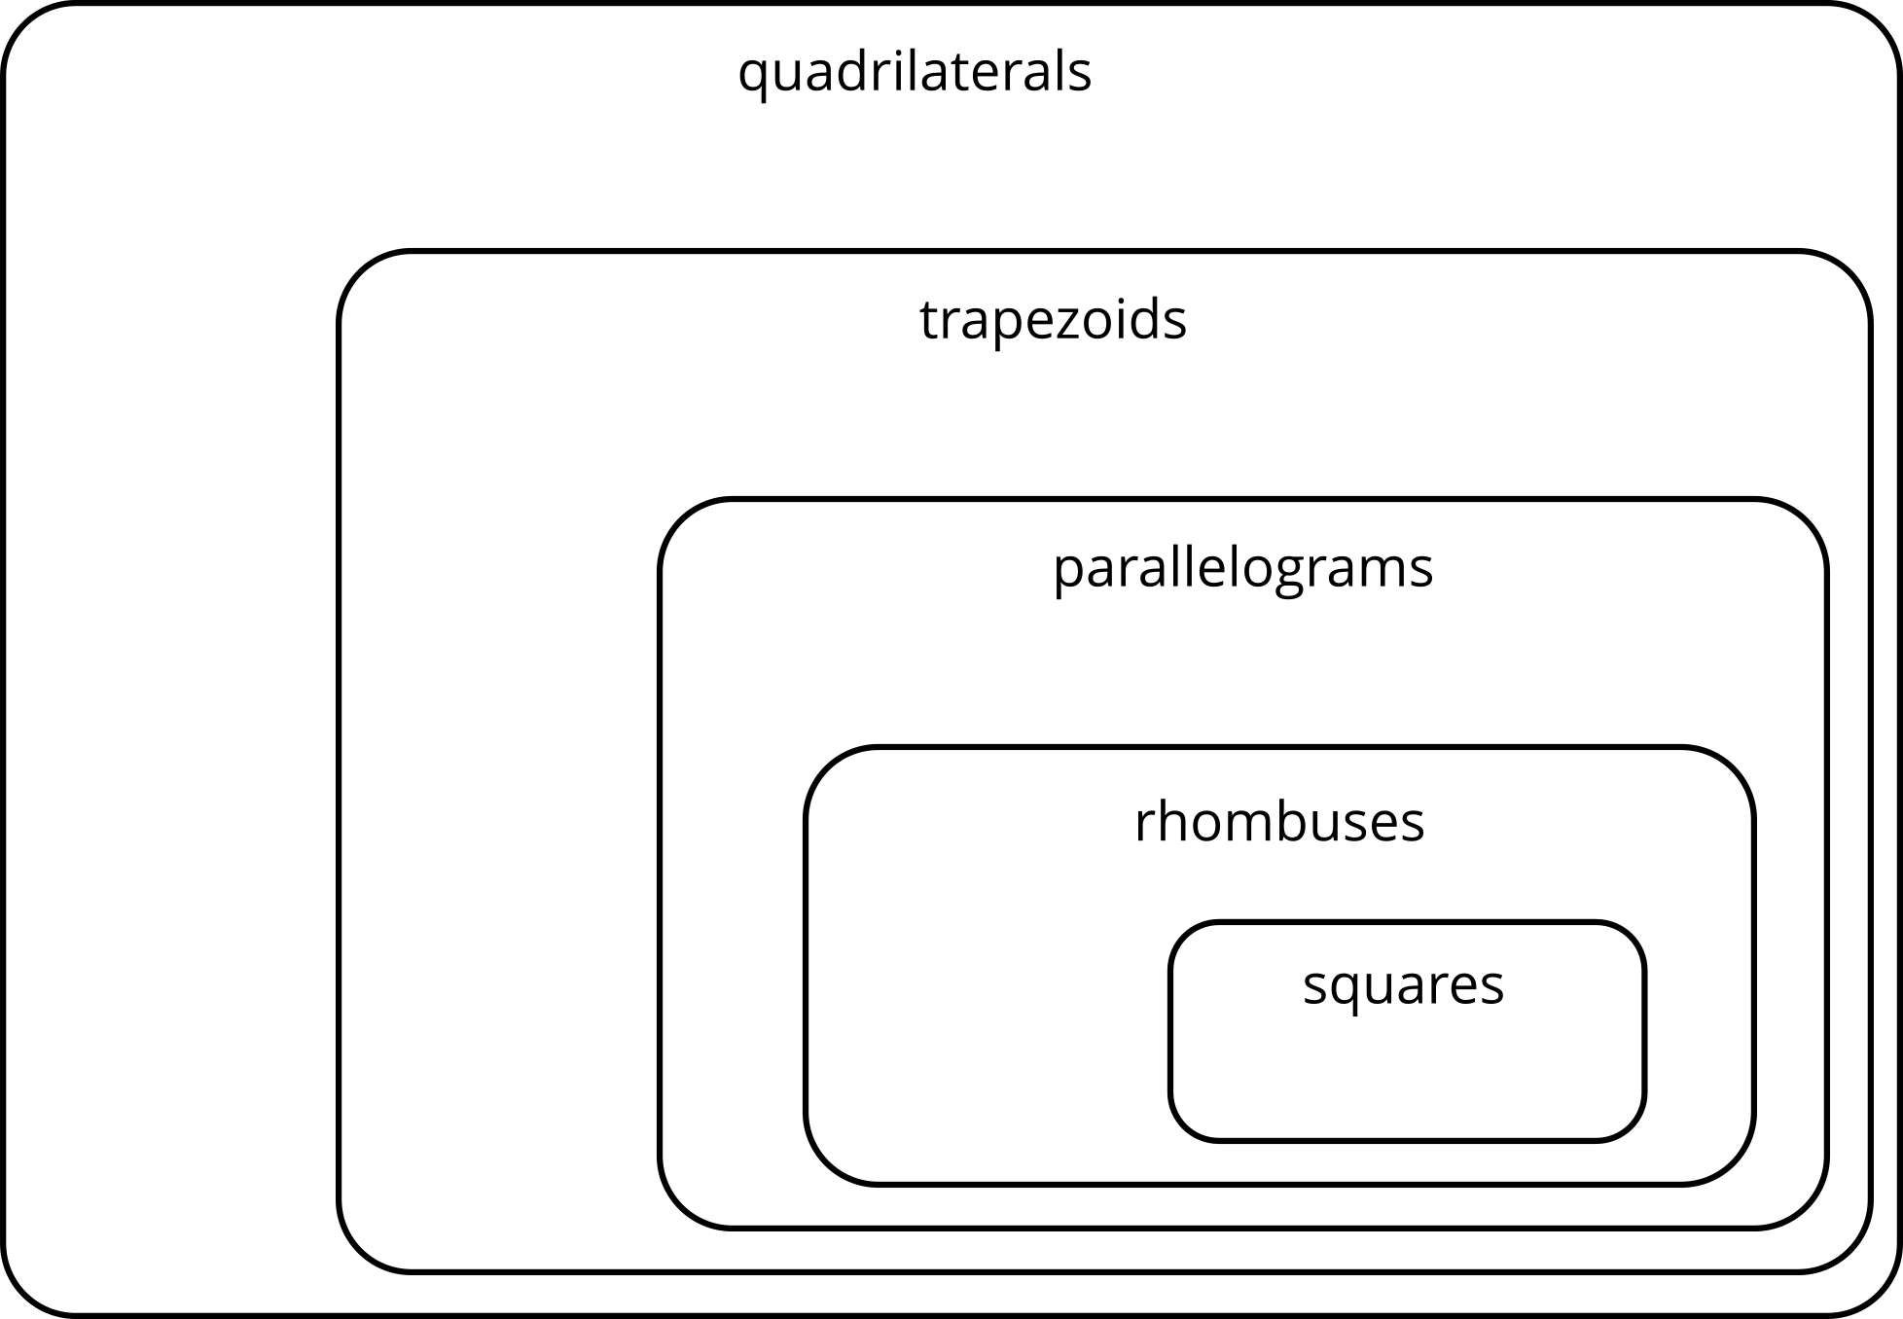
© CC BY 2021 Illustrative Mathematics®

