Lesson 13: Create Story Problems
- Let’s think of our own story problems.

13.1: Create a Story Problem

13.2: Switch the Operation

13.3: Revisit Math Stories, Act It Out
Choose a center.
Bingo
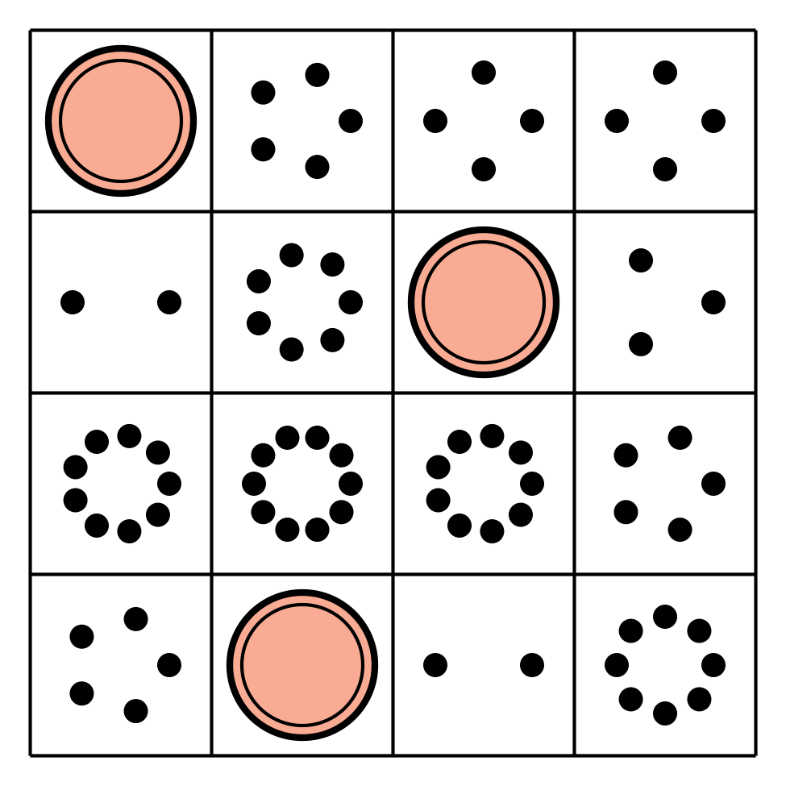
Math Fingers
Subtraction Towers
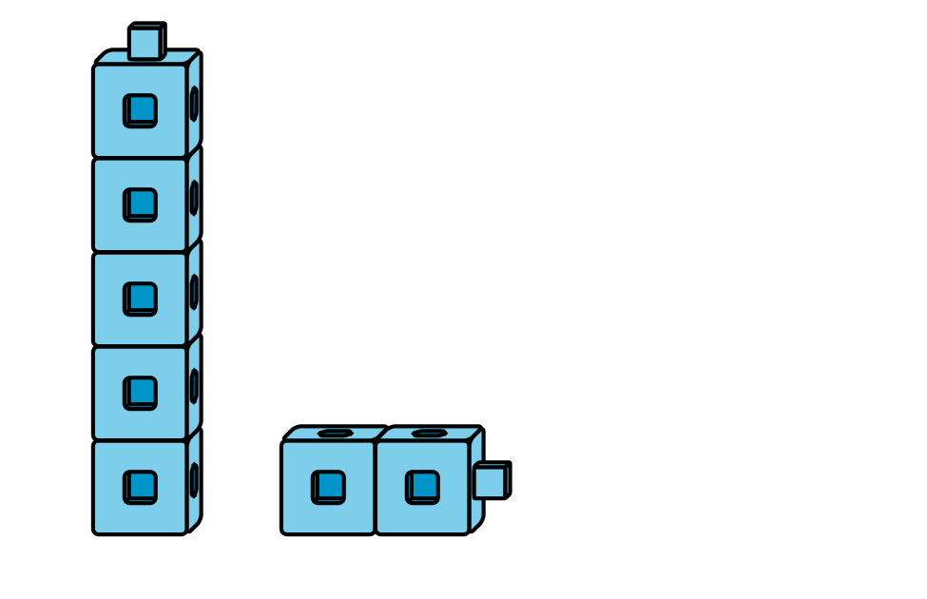
5-frames
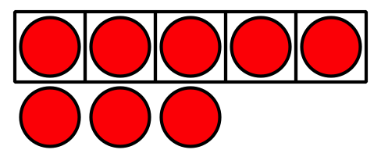
Math Stories
Counting Collections
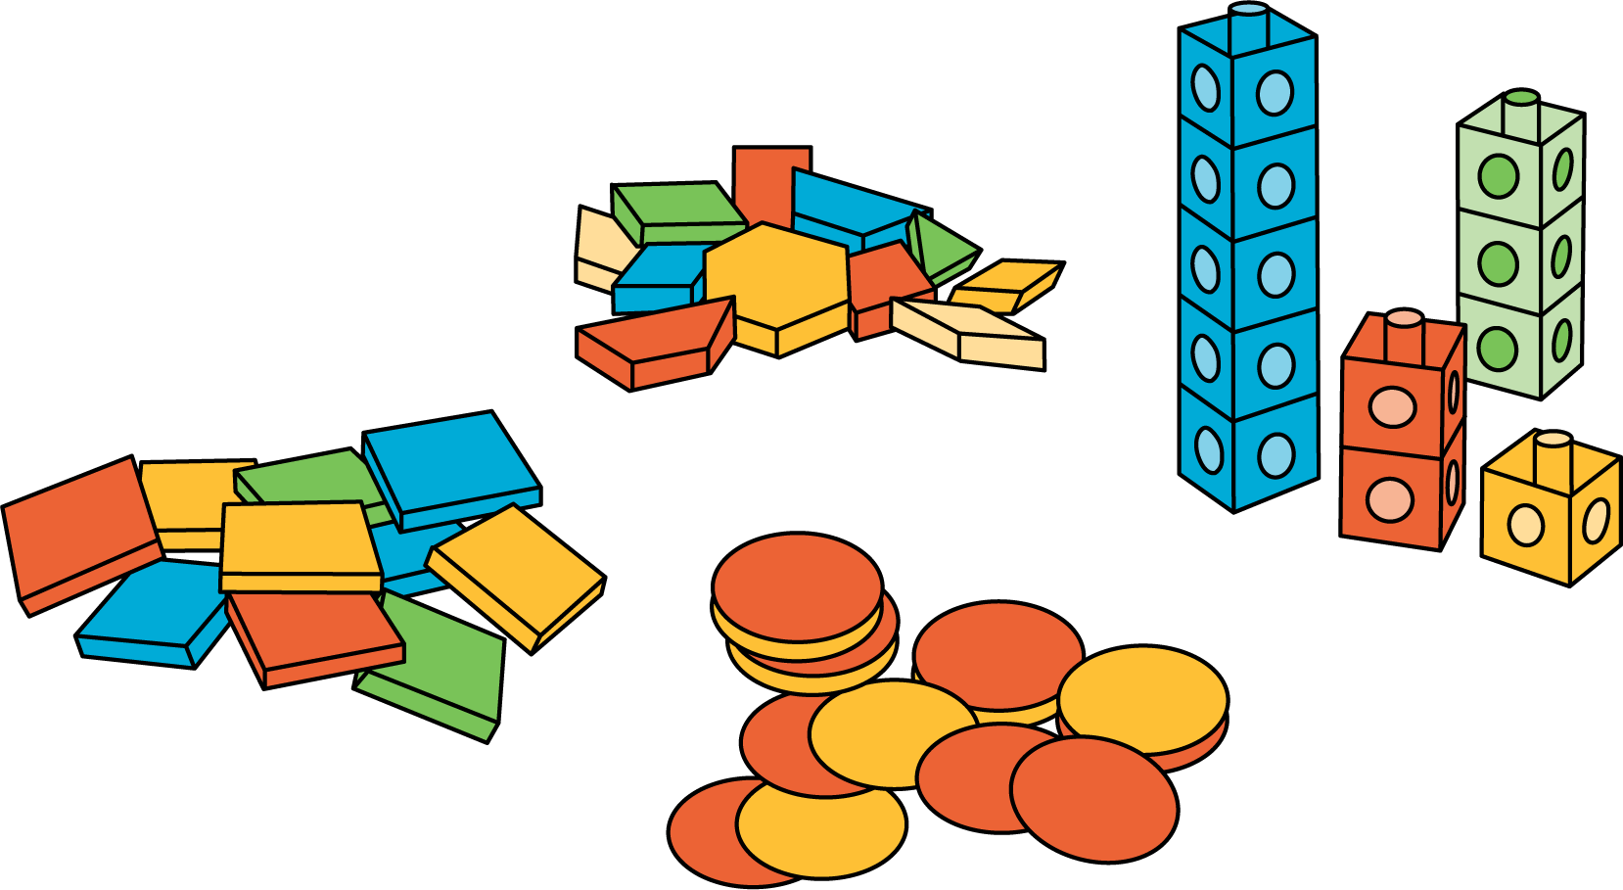
© CC BY 2021 Illustrative Mathematics®

