Unit 4 Lesson 13: Center Day 2

WU Number Talk: Within 20 (Warm up)

Student Task Statement
Find the value of each expression mentally.
- $10+4$
- $9+4$
- $9+6$
- $15–6$

1 Centers: Choice Time

Student Task Statement
Choose a center.
Grab and Count
Five in a Row
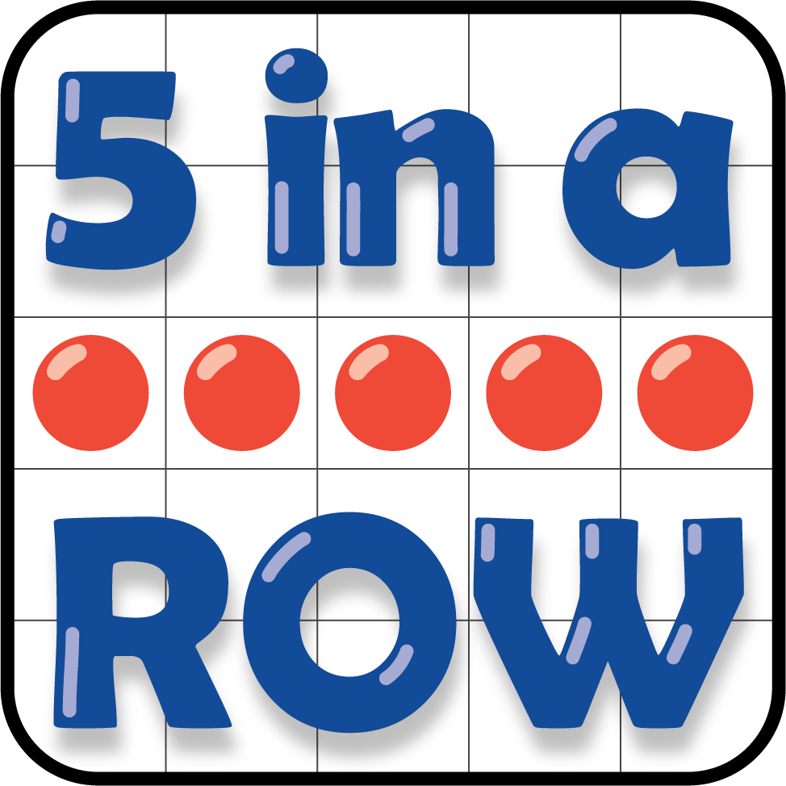
Check It Off

2 Centers Choice Time

Student Task Statement
Choose a center.
How Close?
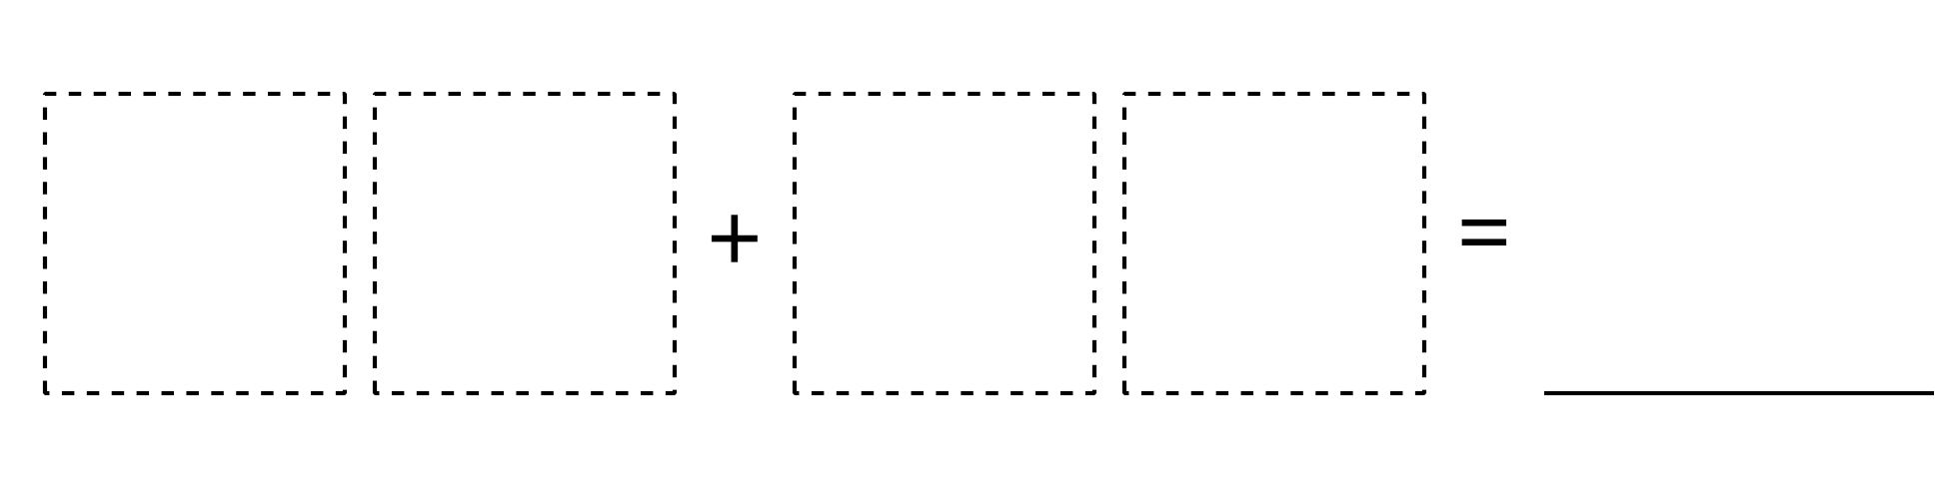
Number Puzzles
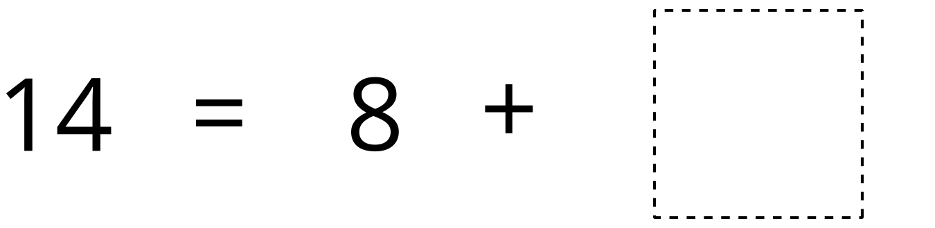
Shake and Spill
© CC BY 2021 Illustrative Mathematics®

