Lesson 8 Practice Problems
- In each pair of graphs shown here, the values of function $g$ are the values of function $f$ multiplied by a scale factor. Express $g$ in terms of $f$ using function notation.

- Here is the graph of $y=f(x)$ for a cubic function $f$.
- 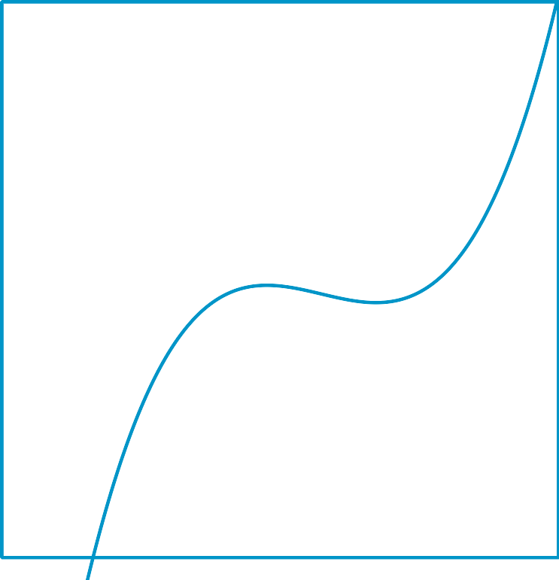
  - Will scaling the outputs of $f$ change the $x$-intercepts of the graph? Explain how you know.
  - Will scaling the outputs of $f$ change the $y$-intercept of the graph? Explain how you know.
- The function $f$ is given by $f(x)=2^{x}$, while the function $g$ is given by $g(x)=4⋅2^{x}$. Kiran says that the graph of $g$ is a vertical scaling of the graph of $f$. Mai says that the graph of $g$ is a horizontal shift of the graph of $f$. Do you agree with either of them? Explain your reasoning.
- The dashed function is the graph of $f$ and the solid function is the graph of $g$. Express $g$ in terms of $f$.
- (From Unit 5, Lesson 4.)
- The table shows some values for an odd function $f$.
- $x$ | - -4 | - -3 | - -2 | - -1 | - 0 | - 1 | - 2 | - 3 | - 4
- $f(x)$ | - -3 |  | - 5 |  | - -10 | - 19 |  | - -11
- Complete the table.
- (From Unit 5, Lesson 5.)
- Here is a graph of $f(x)=x^{3}$ and a graph of $g$, which is a transformation of $f$. Write an equation for the function $g$.
- 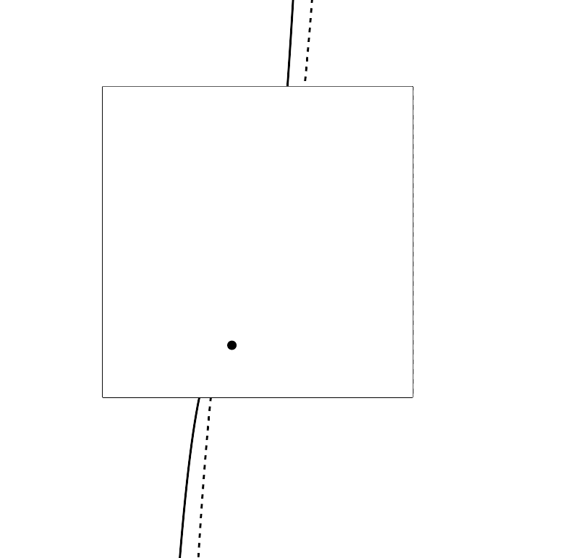
- (From Unit 5, Lesson 7.)
© CC BY 2019 by Illustrative Mathematics®

