Lesson 19 Practice Problems
- An agent at an advertising agency asks a random sample of people how many episodes of a TV show they watch each day. The results are shown in the dot plot.
- 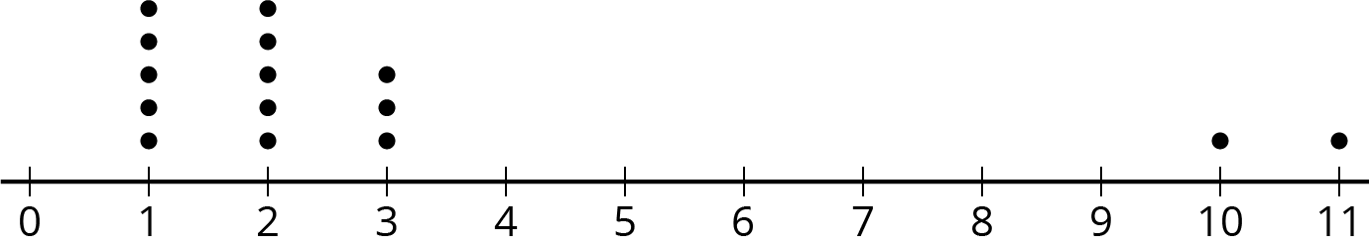
- The agency currently advertises on a different show, but wants to change to this one as long as the typical number of episodes is not meaningfully less.
  - What measure of center and measure of variation would the agent need to find for their current show to determine if there is a meaningful difference? Explain your reasoning.
  - What are the values for these same characteristics for the data in the dot plot?
  - What numbers for these characteristics would be meaningfully different if the measure of variability for the current show is similar? Explain your reasoning.
- Jada wants to know if there is a meaningful difference in the mean number of friends on social media for teens and adults. She looks at the friend count for the 10 most popular of her friends and the friend count for 10 of her parents’ friends. She then computes the mean and MAD of each sample and determines there is a meaningful difference.
- Jada’s dad later tells her he thinks she has not come to the right conclusion. Jada checks her calculations and everything is right. Do you agree with her dad? Explain your reasoning.
- The mean weight for a sample of a certain kind of ring made from platinum is 8.21 grams. The mean weight for a sample of a certain kind of ring made from gold is 8.61 grams. Is there a meaningful difference in the weights of the two types of rings? Explain your reasoning.
- The lengths in feet of a random sample of 20 male and 20 female humpback whales were measured and used to create the box plot.
- 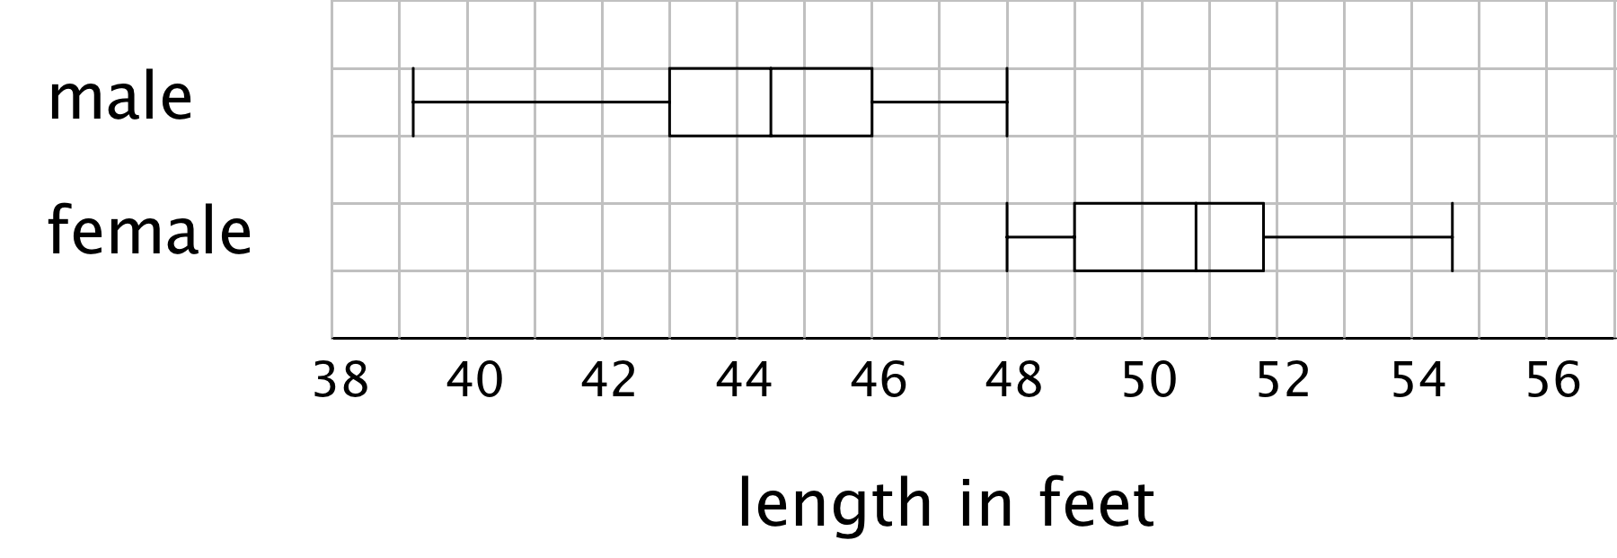
- Estimate the median lengths of male and female humpback whales based on these samples.
- (From Unit 8, Lesson 15.)
© CC BY Open Up Resources. Adaptations CC BY IM.

