Lesson 15 Practice Problems
- Evaluate each expression, giving the answer in scientific notation:
  - $5.3×{10}^{4}+4.7×{10}^{4}$
  - $3.7×{10}^{6}−3.3×{10}^{6}$
  - $4.8×{10}^{\text{-}3}+6.3×{10}^{\text{-}3}$
  - $6.6×{10}^{\text{-}5}−6.1×{10}^{\text{-}5}$

  - Write a scenario that describes what is happening in the graph.
  - What is happening at 5 minutes?
  - What does the slope of the line between 6 and 8 minutes mean?
- 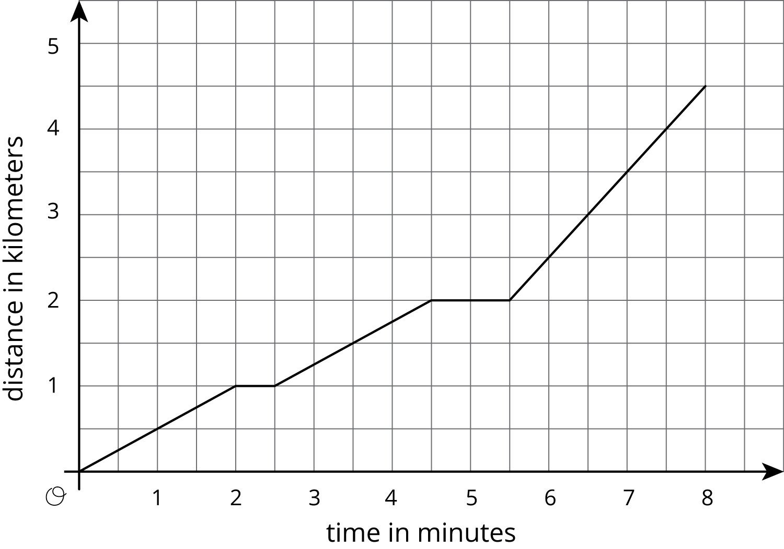
- (From Unit 5, Lesson 10.)
- Apples cost $1 each. Oranges cost $2 each. You have $10 and want to buy 8 pieces of fruit. One graph shows combinations of apples and oranges that total to $10. The other graph shows combinations of apples and oranges that total to 8 pieces of fruit.
- 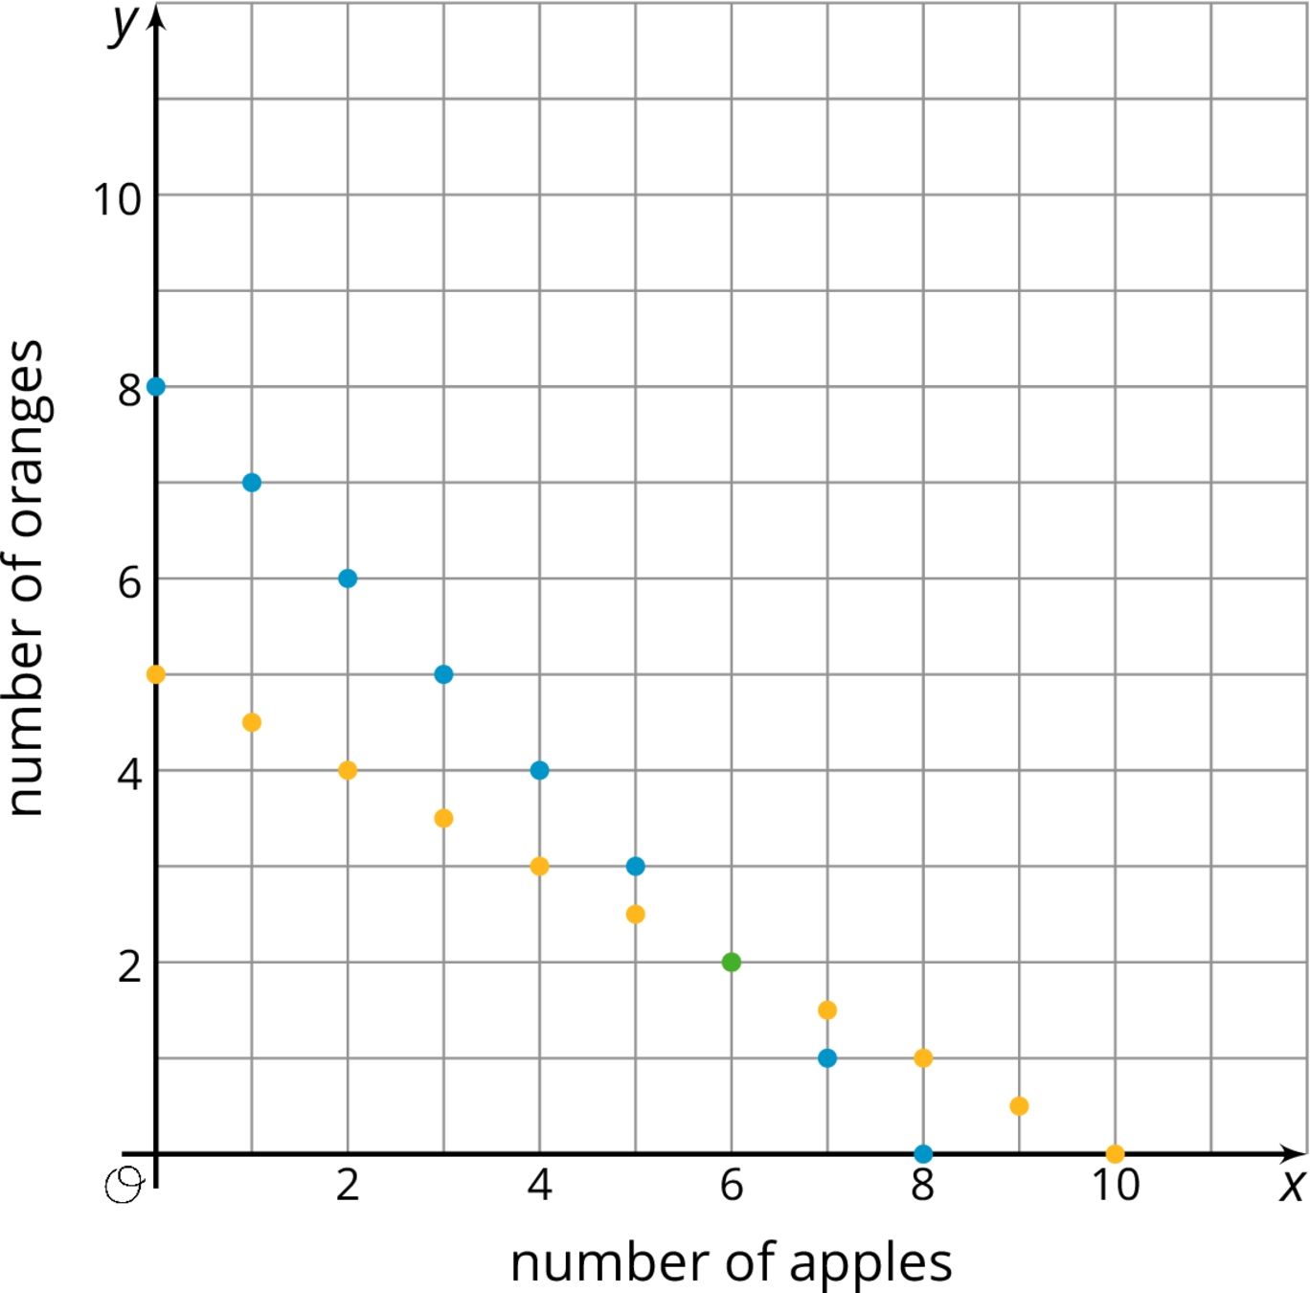
  - Name one combination of 8 fruits shown on the graph that whose cost does not total to $10.
  - Name one combination of fruits shown on the graph whose cost totals to $10 that are not 8 fruits all together.
  - How many apples and oranges would you need to have 8 fruits that cost $10 at the same time?
- (From Unit 4, Lesson 10.)
- Solve each equation and check your solution.
- $\text{-}2\left(3x−4\right)=4\left(x+3\right)+6$
- $\frac{1}{2}\left(z+4\right)−6=\text{-}2z+8$
- $4w−7=6w+31$
- (From Unit 4, Lesson 5.)
© CC BY Open Up Resources. Adaptations CC BY IM.

