Lesson 1: Tiling the Plane

1.1: Which One Doesn’t Belong: Tilings
Which pattern doesn’t belong?
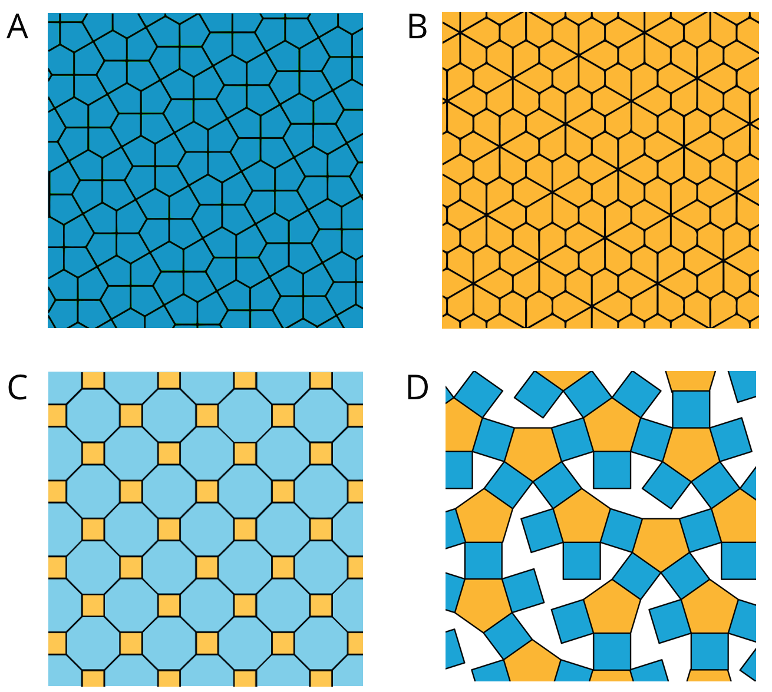

1.2: More Red, Green, or Blue?
Your teacher will assign you to look at Pattern A or Pattern B.
In your pattern, which shape covers more of the plane: blue rhombuses, red trapezoids, or green triangles? Explain how you know.

Pattern A
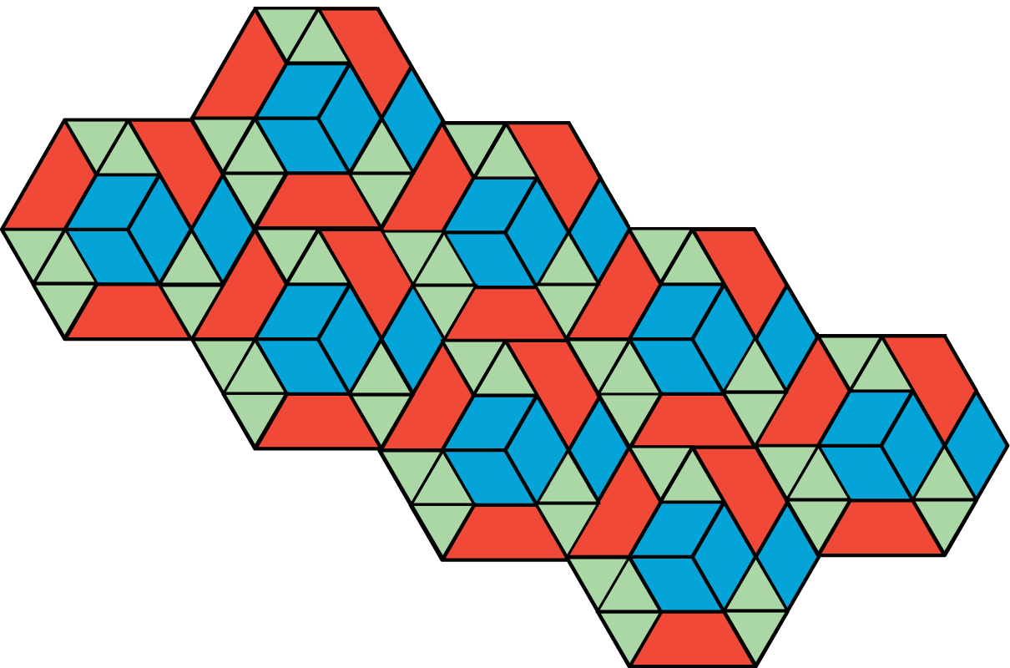

Pattern B
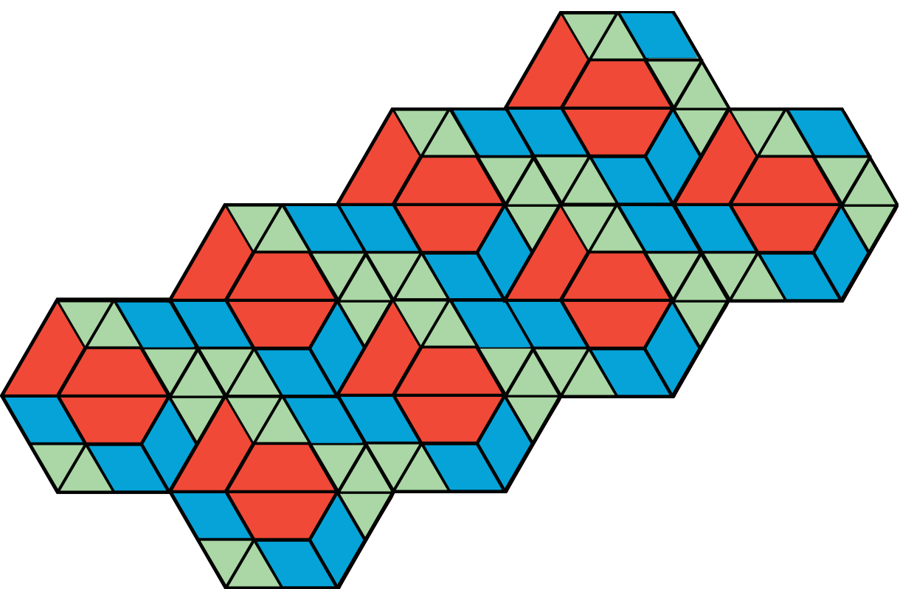

Are you ready for more?
On graph paper, create a tiling pattern so that:
- The pattern has at least two different shapes.
- The same amount of the plane is covered by each type of shape.

Lesson 1 Summary
In this lesson, we learned about tiling the plane, which means covering a two-dimensional region with copies of the same shape or shapes such that there are no gaps or overlaps.
Then, we compared tiling patterns and the shapes in them. In thinking about which patterns and shapes cover more of the plane, we have started to reason about area.
We will continue this work, and to learn how to use mathematical tools strategically to help us do mathematics.
© CC BY Open Up Resources. Adaptations CC BY IM.

