Lesson 2 Practice Problems
- Match each coordinate rule to a description of its resulting transformation.
  - $(x,y)→(x+3,y)$
  - $(x,y)→(2x,2y)$
  - $(x,y)→(x,y+4)$
  - $(x,y)→(x,y−4)$
  - $(x,y)→(x−3,y+4)$
  - Translate by the directed line segment from $(0,0)$ to $(0,4)$.
  - Translate by the directed line segment from $(0,0)$ to $(3,0)$.
  - Dilate using the origin as the center and a scale factor of 2.
  - Translate by the directed line segment from $(0,0)$ to $(0,\text{-}4)$.
  - Translate by the directed line segment from $(0,0)$ to $(\text{-}3,4)$.
  - Draw the image of triangle $ABC$ under the transformation $(x,y)→(x−4,y+1)$. Label the result $T$.
  - Draw the image of triangle $ABC$ under the transformation $(x,y)→(\text{-}x,y)$. Label the result $R$.
- 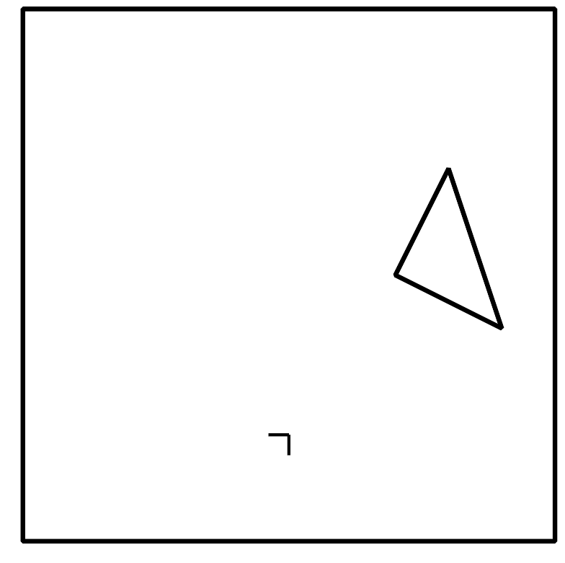
- Here are some transformation rules. For each rule, describe whether the transformation is a rigid motion, a dilation, or neither.
  - $(x,y)→(x−2,y−3)$
  - $(x,y)→(2x,3y)$
  - $(x,y)→(3x,3y)$
  - $(x,y)→(2−x,y)$
- Reflect triangle $ABC$ over the line $x=0$. Call this new triangle $A^{′}B^{′}C^{′}$. Then reflect triangle $A^{′}B^{′}C^{′}$ over the line $y=0$. Call the resulting triangle $A^{″}B^{″}C^{″}$.
- Which single transformation takes $ABC$ to $A^{″}B^{″}C^{″}$?
  - Translate triangle $ABC$ by the directed line segment from $(1,1)$ to $(\text{-}2,1)$.
  - Reflect triangle $ABC$ across the line $y=\text{-}x$.
  - Rotate triangle $ABC$ counterclockwise using the origin as the center by 180 degrees.
  - Dilate triangle $ABC$ using the origin as the center and a scale factor of 2.
- (From Unit 6, Lesson 1.)
- Reflect triangle $ABC$ over the line $y=2$.
- Translate the image by the directed line segment from $(0,0)$ to $(3,2)$.
- What are the coordinates of the vertices in the final image?
- (From Unit 6, Lesson 1.)
- The density of water is 1 gram per cm³. An object floats in water if its density is less than water’s density, and it sinks if its density is greater than water’s. Will a cylindrical log with radius 0.4 meters, height 5 meters, and mass 1,950 kilograms sink or float? Explain your reasoning.
- (From Unit 5, Lesson 17.)
- These 3 congruent square pyramids can be assembled into a cube with side length 3 feet. What is the volume of each pyramid?
  - 1 cubic foot
  - 3 cubic feet
  - 9 cubic feet
  - 27 cubic feet
- (From Unit 5, Lesson 12.)
- Reflect square $ABCD$ across line $CD$. What is the ratio of the length of segment $AA^{′}$ to the length of segment $AD$? Explain or show your reasoning.
- (From Unit 2, Lesson 1.)
© CC BY 2019 by Illustrative Mathematics®

