Unit 5 Lesson 3: Representing Exponential Growth

1 Math Talk: Exponent Rules (Warm up)

Student Task Statement
Rewrite each expression as a power of 2.
$2^{3}⋅2^{4}$
$2^{5}⋅2$
$2^{10}÷2^{7}$
$2^{9}÷2$

2 What Does $x^{0}$ Mean? (Optional)

Student Task Statement
- Complete the table. Take advantage of any patterns you notice.
- $x$ | - 4 | - 3 | - 2 | - 1 | - 0
- $3^{x}$ | - 81 | - 27
- Here are some equations. Find the solution to each equation using what you know about exponent rules. Be prepared to explain your reasoning.
  - $9^{?}⋅9^{7}=9^{7}$
  - $\frac{9^{12}}{9^{?}}=9^{12}$
- What is the value of $5^{0}$? What about $2^{0}$?

3 Multiplying Microbes

Student Task Statement
- In a biology lab, 500 bacteria reproduce by splitting. Every hour, on the hour, each bacterium splits into two bacteria.
  - Write an expression to show how to find the number of bacteria after each hour listed in the table.
  - Write an equation relating $n$, the number of bacteria, to $t$, the number of hours.
  - Use your equation to find $n$ when $t$ is 0. What does this value of $n$ mean in this situation?
- hour | - number of bacteria
- 0 | - 500
- 1
- 2
- 3
- 6
- t
- In a different biology lab, a population of single-cell parasites also reproduces hourly. An equation which gives the number of parasites, $p$, after $t$ hours is $p=100⋅3^{t}.$ Explain what the numbers 100 and 3 mean in this situation.

4 Graphing the Microbes

Student Task Statement
- Refer back to your work in the table of the previous task. Use that information and the given coordinate planes to graph the following:
- a. Graph $\left(t,n\right)$ when $t$ is 0, 1, 2, 3, and 4.
- 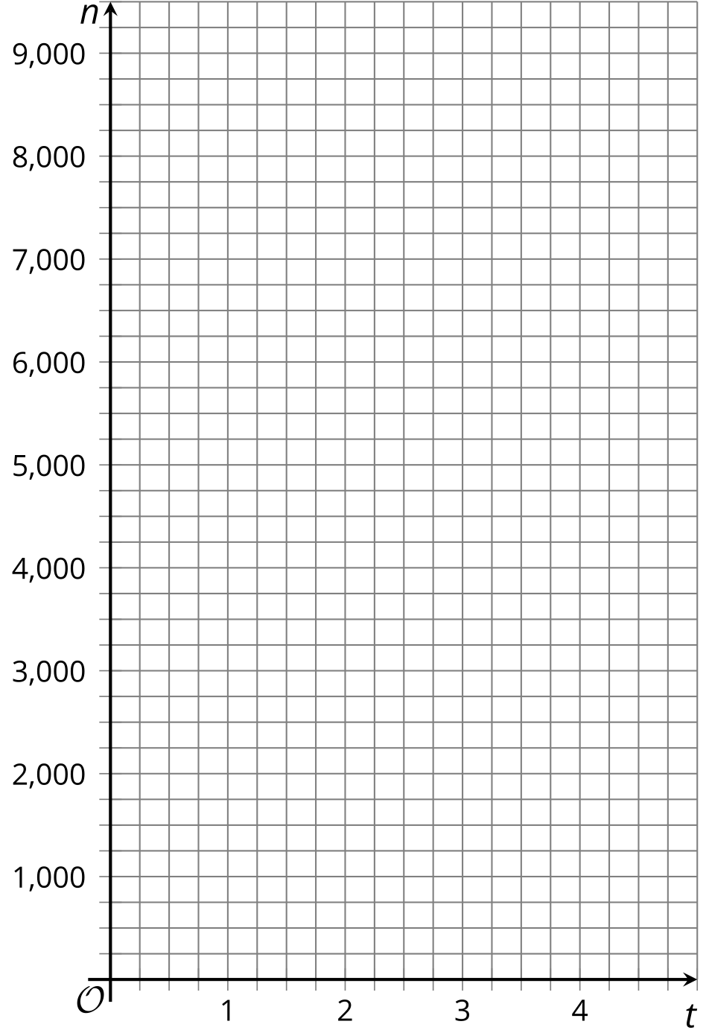
- b. Graph $\left(t,p\right)$ when $t$ is 0, 1, 2, 3, and 4. (If you get stuck, you can create a table.)
- 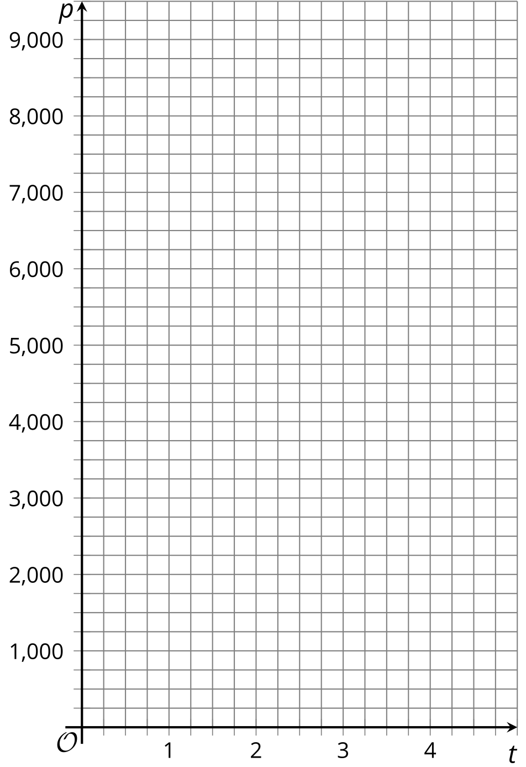
- On the graph of $n$, where can you see each number that appears in the equation?
- On the graph of $p$, where can you see each number that appears in the equation?

Images for Activity Synthesis
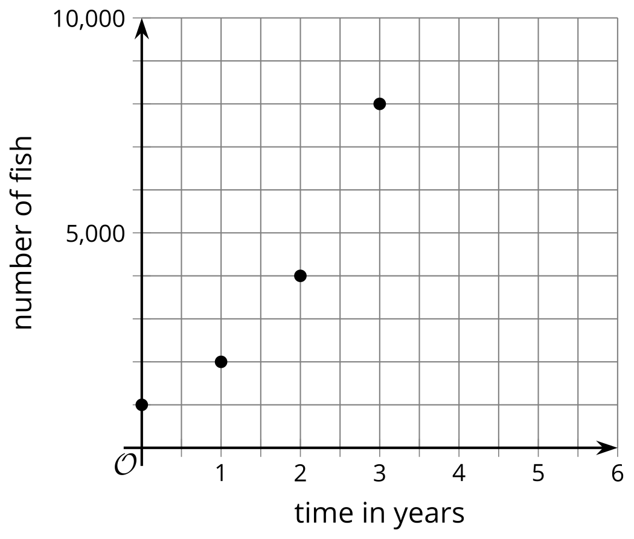
© CC BY 2019 by Illustrative Mathematics®

