Unit 7 Lesson 7: Rectangles and Squares

WU What Do You Know About This Shape? (Warm up)

Student Task Statement
What do you know about this shape?

1 Quadrilateral Clues

Student Task Statement
Spread out your shape cards so you and your partner can see all of them.
Work together to find a shape that fits each clue. If you don’t think it is possible to find that shape, explain why. You can only use each shape one time.
- Find a quadrilateral that is not a parallelogram.
- Find a rhombus that is also a square.
- Find a rhombus that is not a square.
- Find a trapezoid that is not a rectangle.
- Find a rectangle that is not a square.
- Find a parallelogram that is not a rectangle.
- Find a square that is not a rectangle.

Activity Synthesis
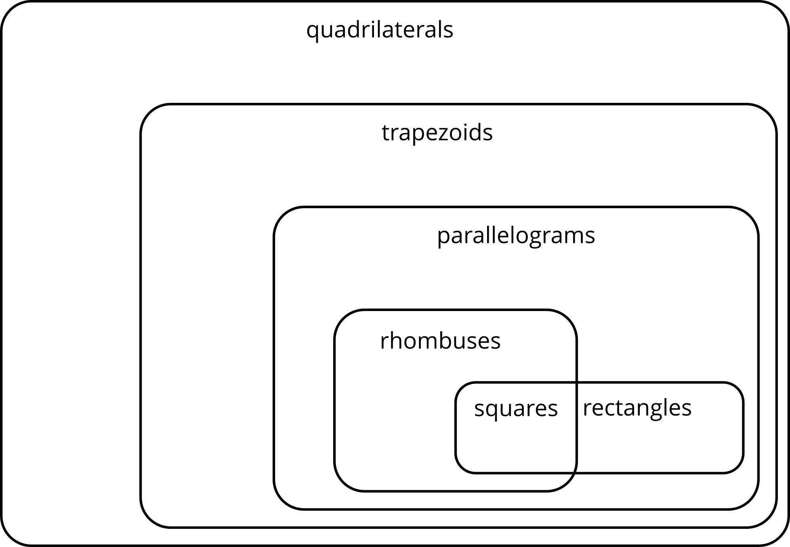

2 Always, Sometimes, Never

Student Task Statement
Write always, sometimes, or never in each blank to make the statements true.
For each statement that is completed with “sometimes,” draw a figure for which the statement is true and another figure for which the statement is not true.
- A rhombus is ________________________ a square.
- A square is ________________________ a rhombus.
- A triangle is ________________________ a quadrilateral.
- A square is ________________________ a rectangle.
- A rectangle is ________________________ a parallelogram.
- A parallelogram is ________________________ a rhombus.
- A trapezoid is ________________________ a parallelogram.

Activity Synthesis

Images for Activity Synthesis
© CC BY 2021 Illustrative Mathematics®

