Lesson 14: Expressions and Story Problems
- Let’s figure out how expressions go with the story problems.

14.1: Expression for a Story Problem
There were 10 people riding bikes in the park.
Then 6 of the people stopped riding to have lunch.
How many people are riding bikes now?
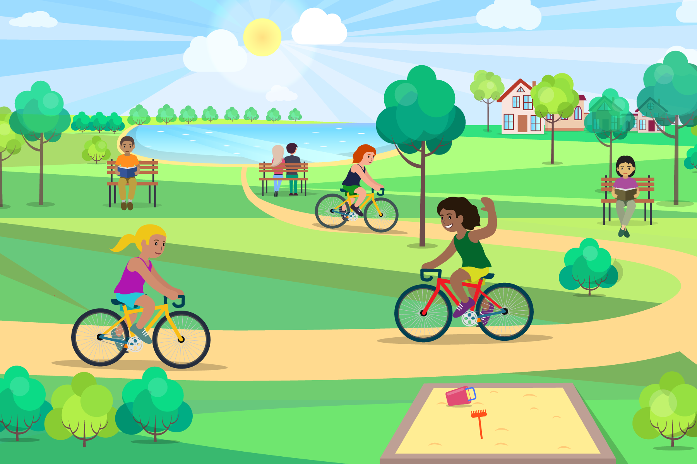

14.2: Which Expression?
- There were 2 rocks in Lin’s jar.
At the park, Lin put 4 more rocks into her jar.
How many rocks are in Lin’s jar now?
- $3+3$
- $6−2$
- $2+4$
- There were 8 kids playing hopscotch.
3 of the kids left to go jump rope.
How many kids are playing hopscotch now?
- $8+3$
- $3−3$
- $8−3$
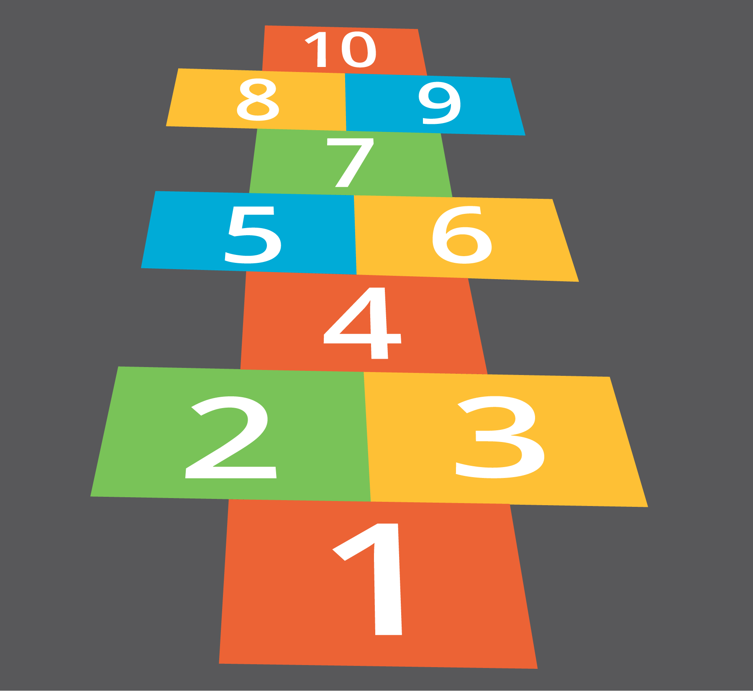

14.3: Centers: Choice Time
Choose a center.
Number Race
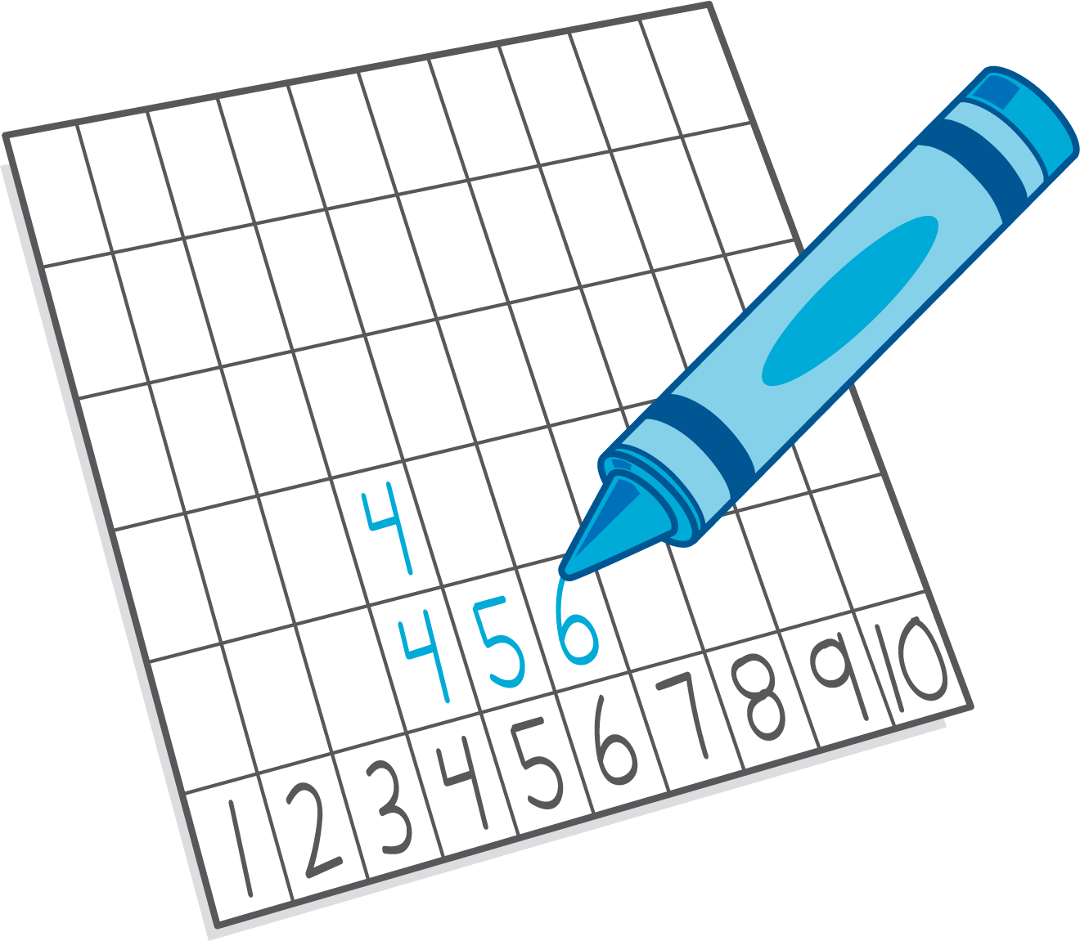
Math Stories
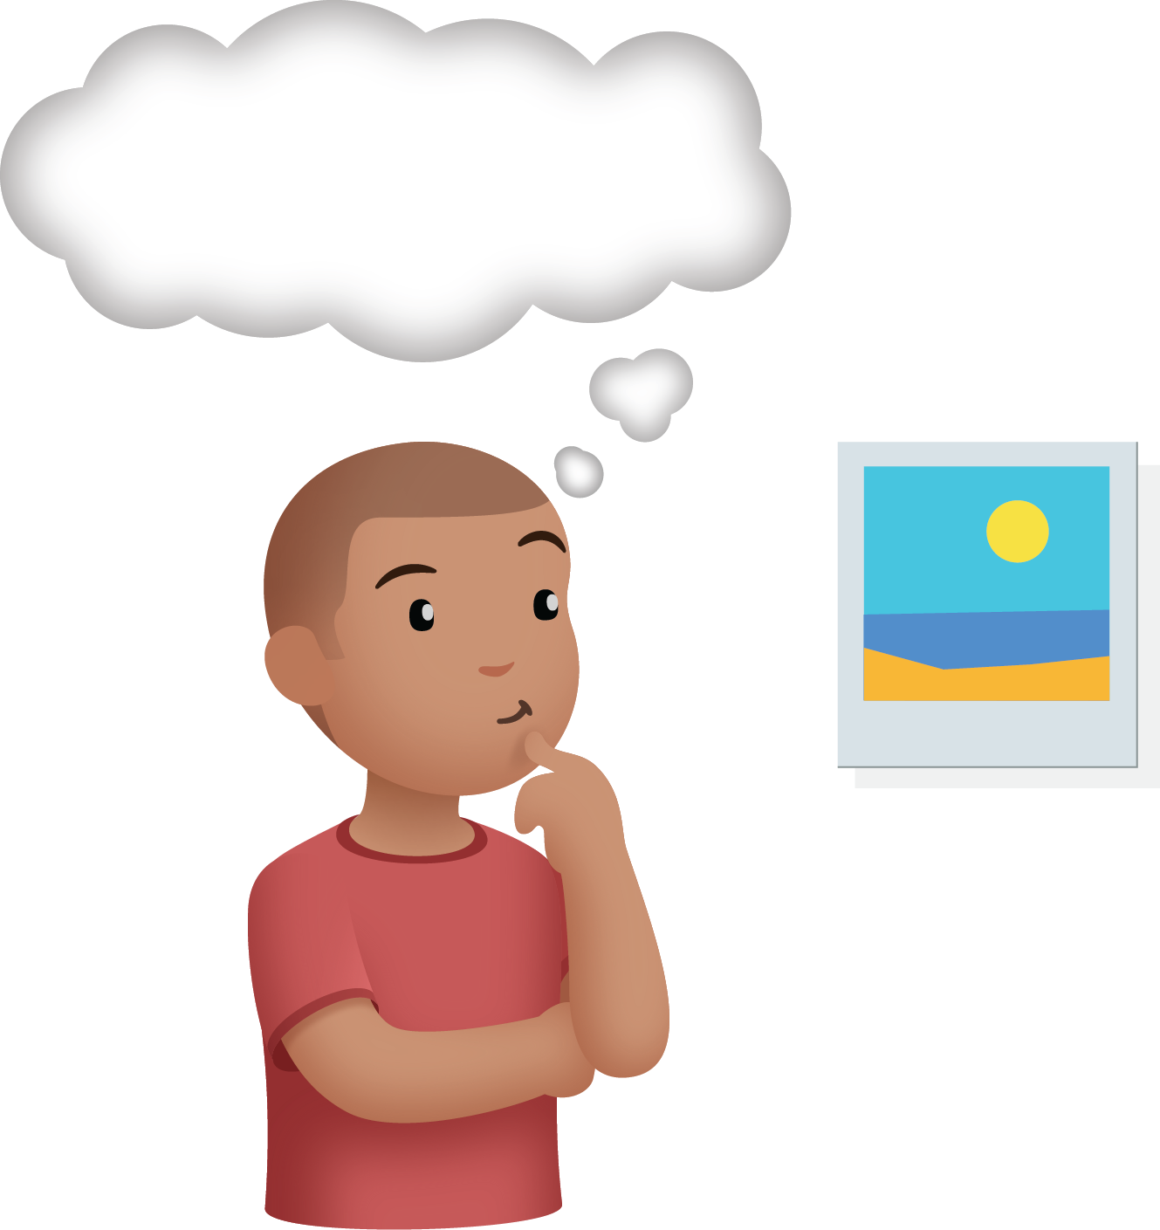
© CC BY 2021 Illustrative Mathematics®

