Unit 4 Lesson 14: Let’s Compare

WU Choral Count: Plus 10 (Warm up)

Student Task Statement

1 Which is More?

Student Task Statement
- Each partner spins a spinner.
- Each partner shows the number any way they choose.
- Compare with your partner.
- Which number is more?
Spinner A:
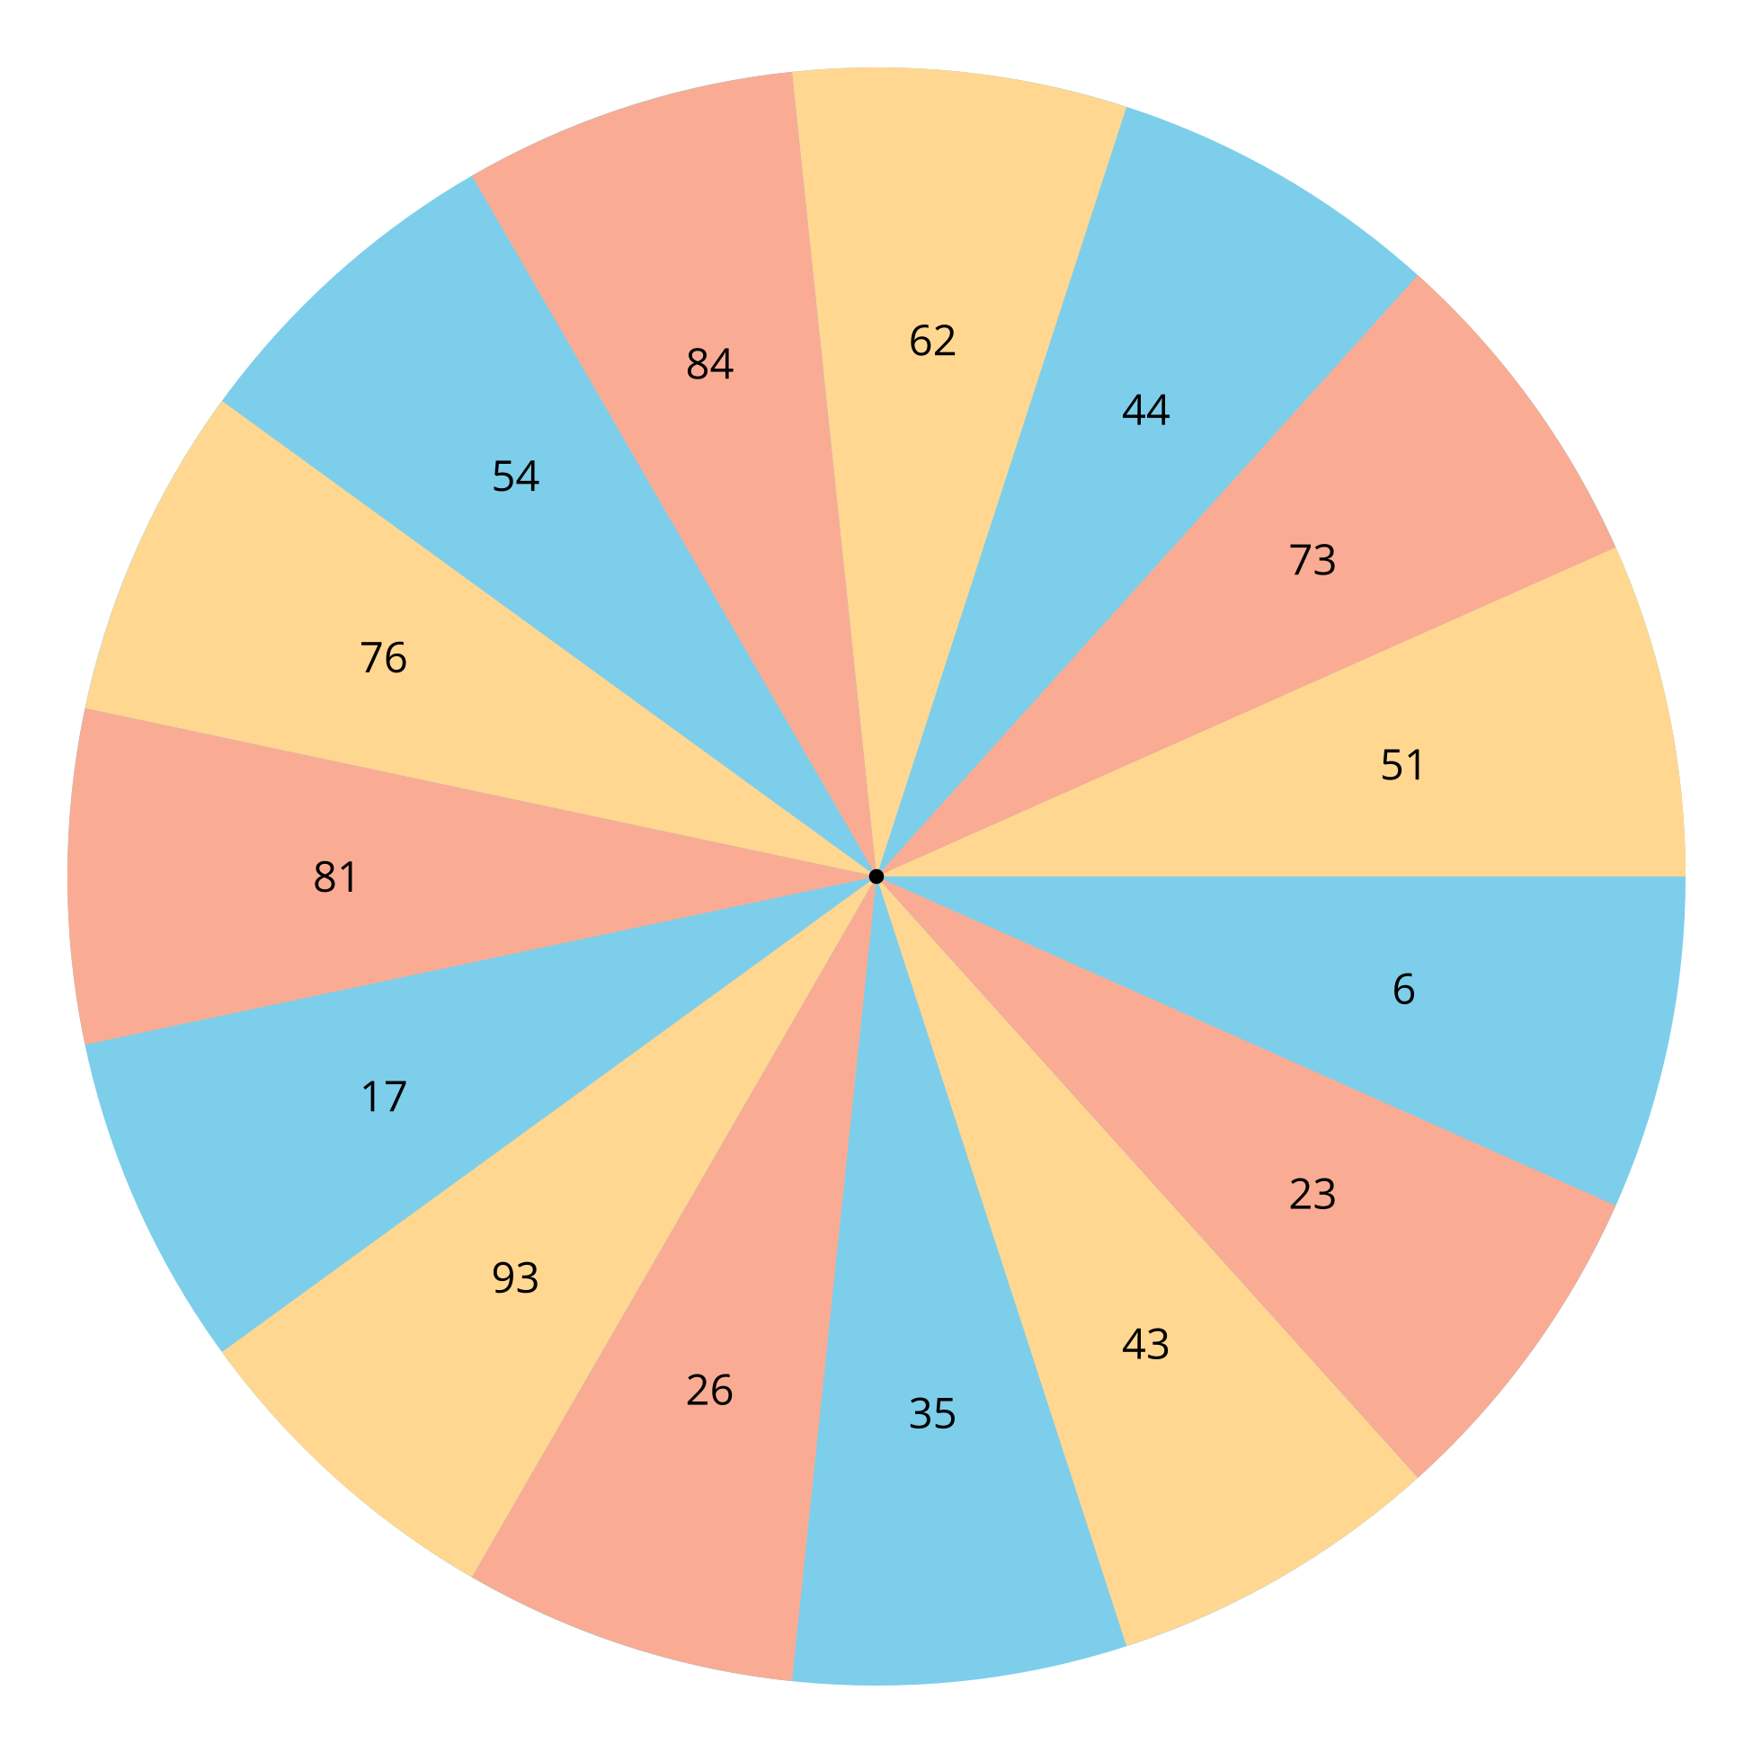
Spinner B:
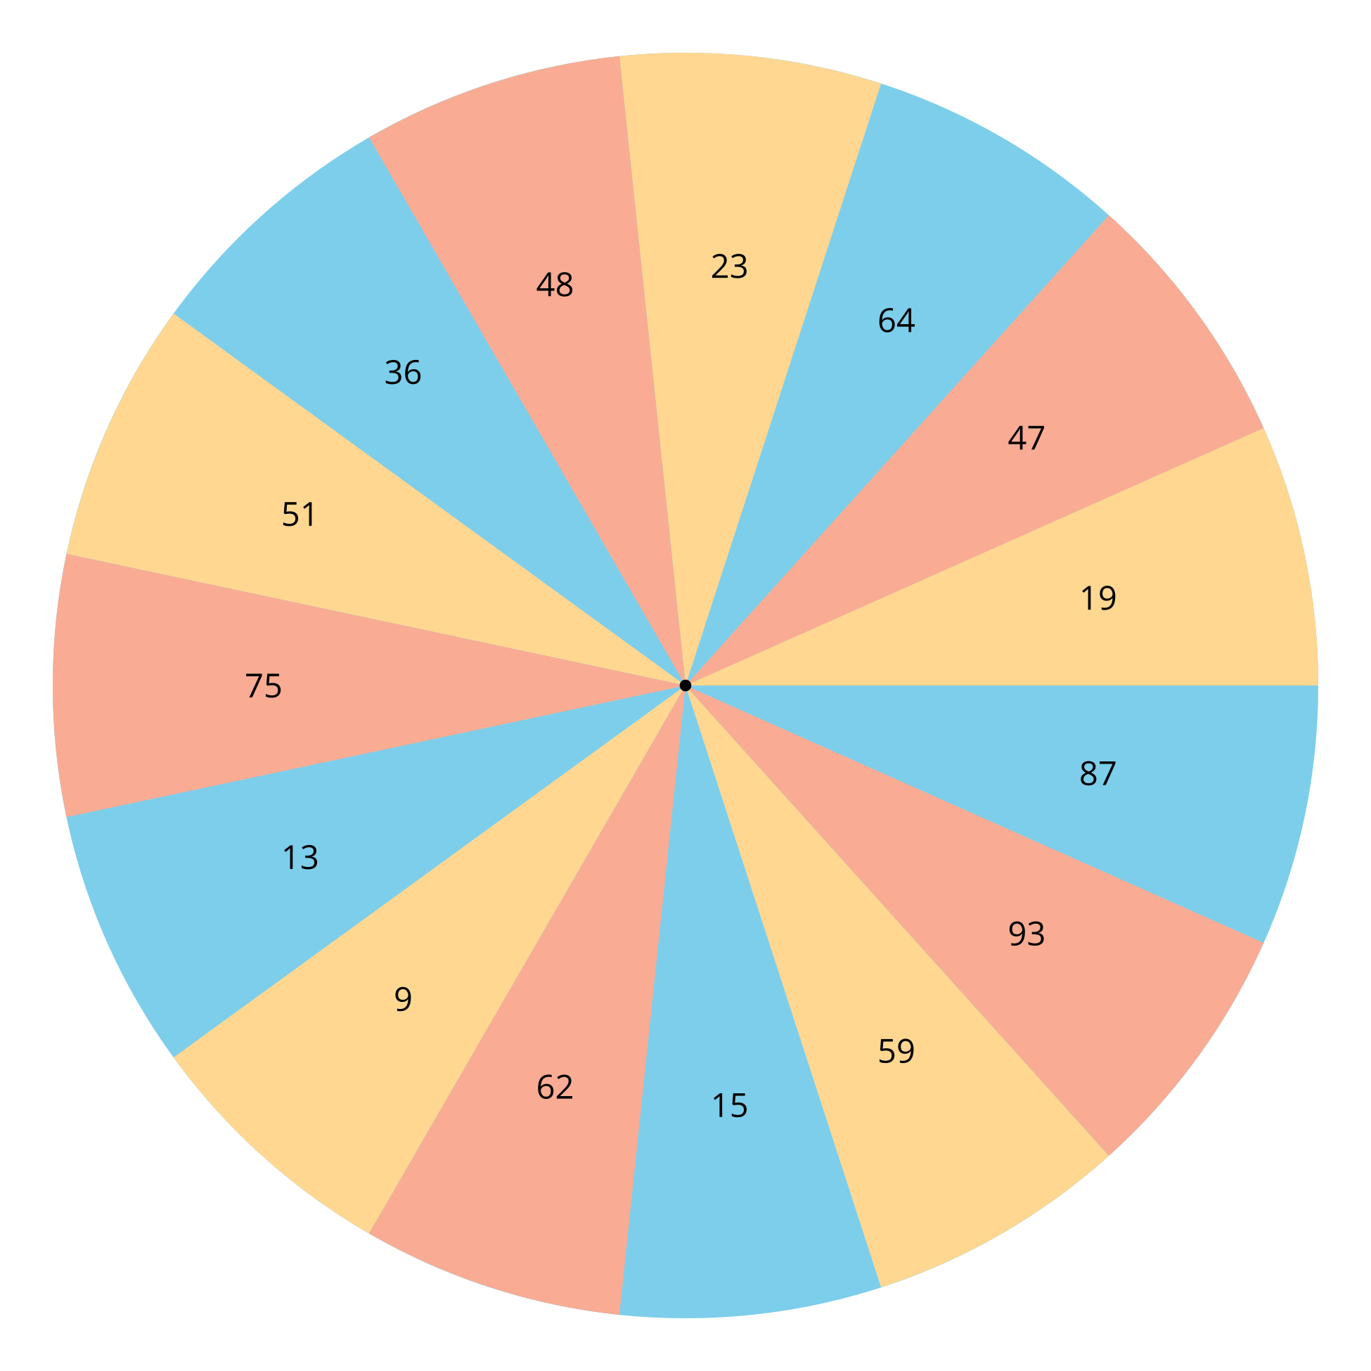

2 Elena and Noah Compare Numbers

Student Task Statement
- Elena says 75 is greater than 65 because 7 is greater than 6.
What do you think Elena means?
How could Elena be more clear?
- Noah says 39 is greater than 41 because it has a 9 and 9 is the greatest number.
Do you agree with Noah?
What could you tell Noah to help him compare these numbers?

3 Centers: Choice Time

Student Task Statement
Choose a center.
Write Numbers
Grab and Count
Five in a Row
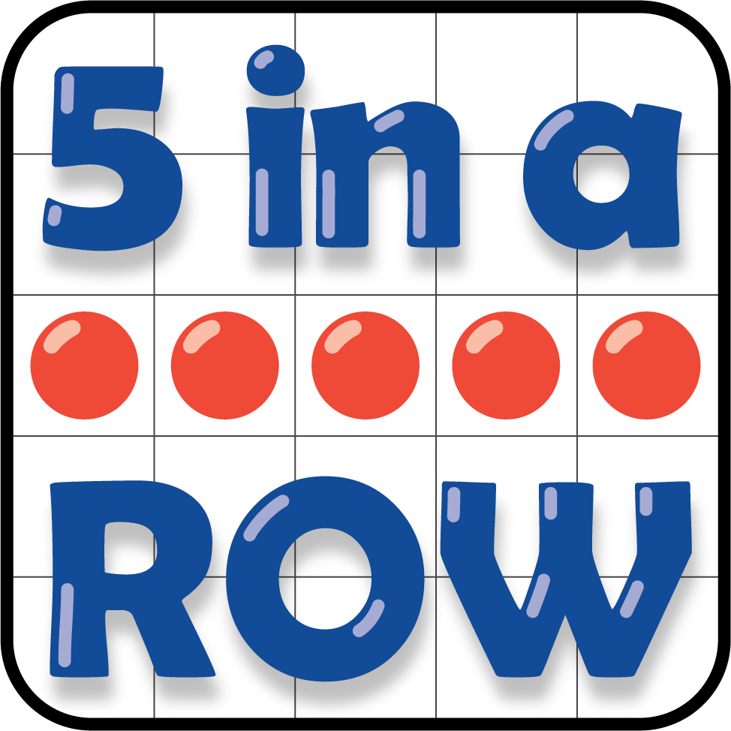
© CC BY 2021 Illustrative Mathematics®

