Lesson 17: Match and Draw Arrays
- Let’s match arrays to equal groups and draw arrays.

Warm-up: Which One Doesn’t Belong: Arrangements
Which one doesn't belong?
A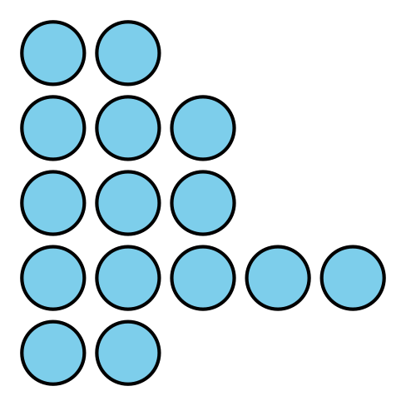
B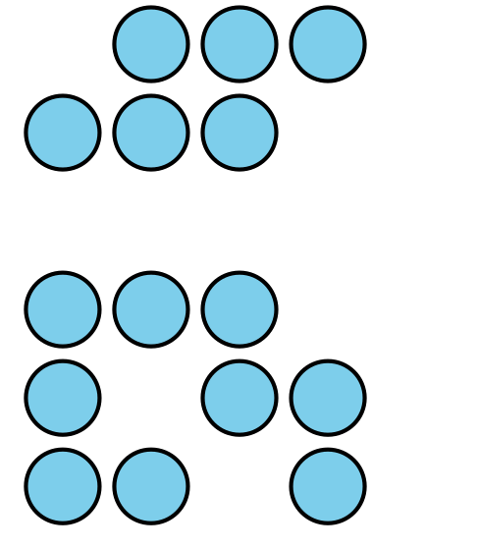
C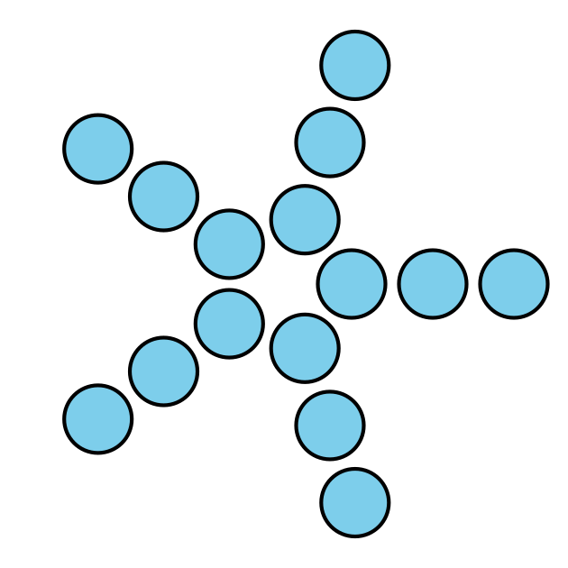
D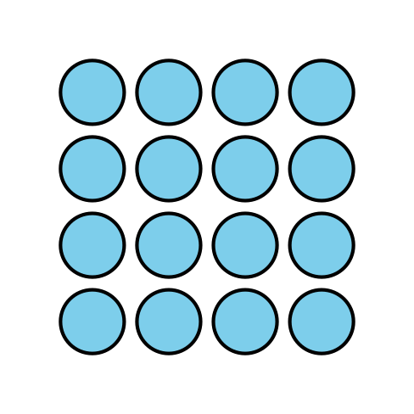

17.1: Card Sort: Arrays
- Match the drawings of equal groups and arrays that are alike. Be prepared to explain your reasoning.
- 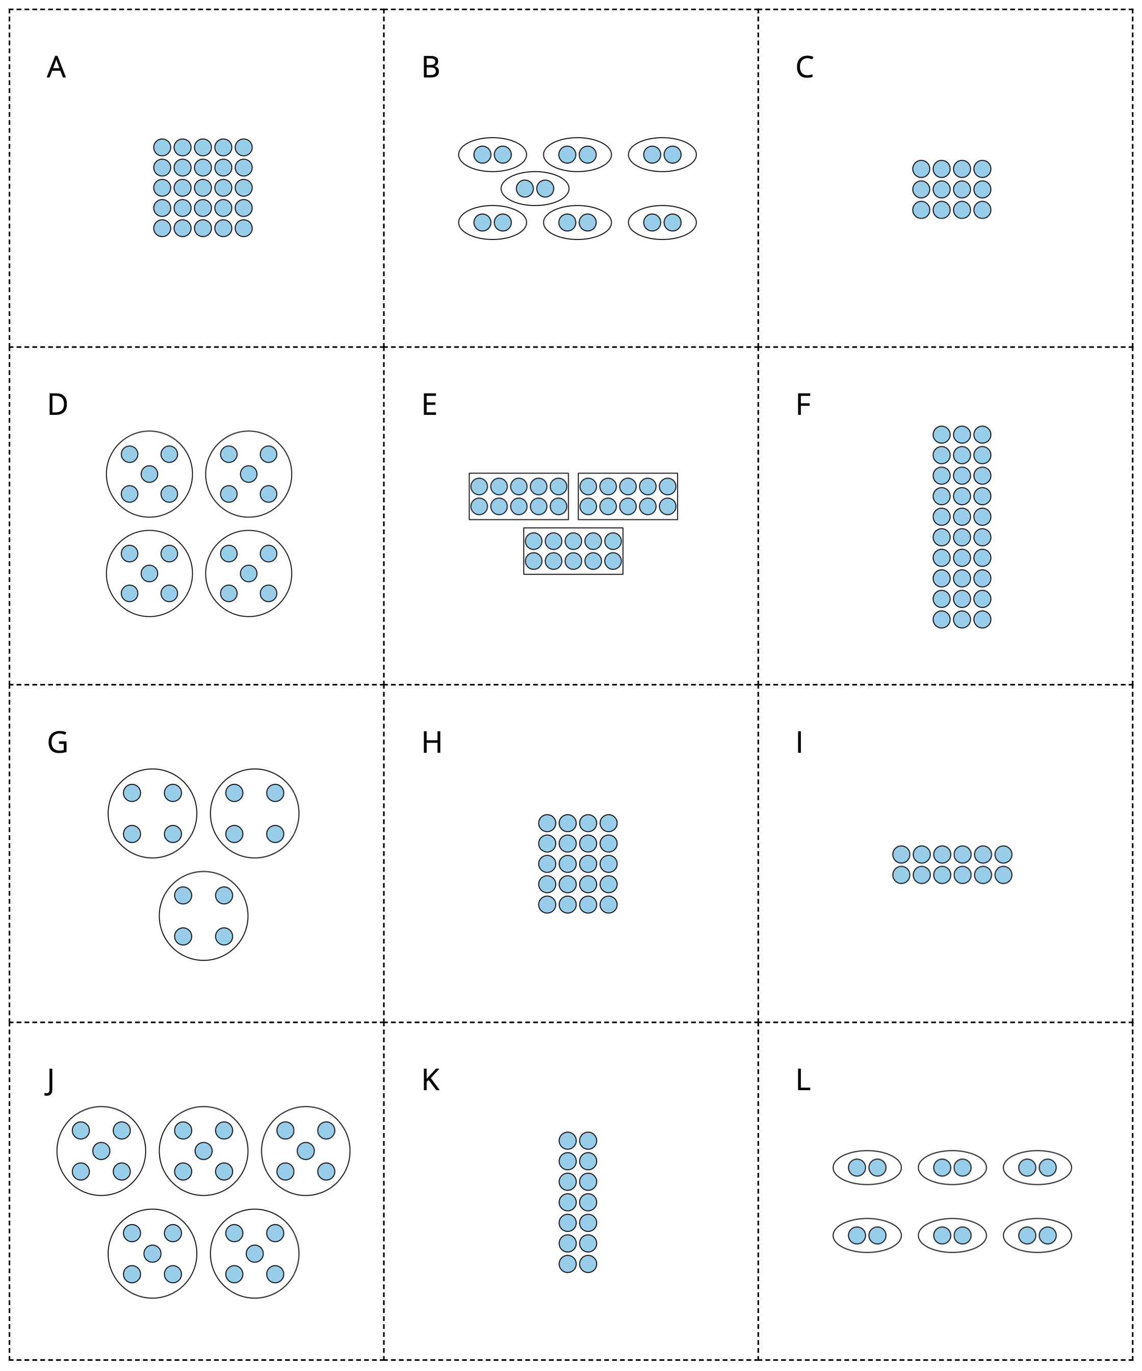
- Choose a match you and your partner made. Write down how you know the drawing matches the array.

17.2: Draw Arrays

  - Draw 1 way the dots could be rearranged into an array.
  - 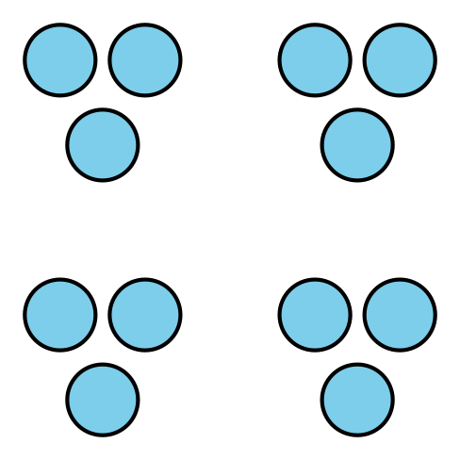
  - Explain or show how the array is related to multiplication.

  - Draw ways that the dots could be arranged into arrays. Draw as many ways as you can.
  - 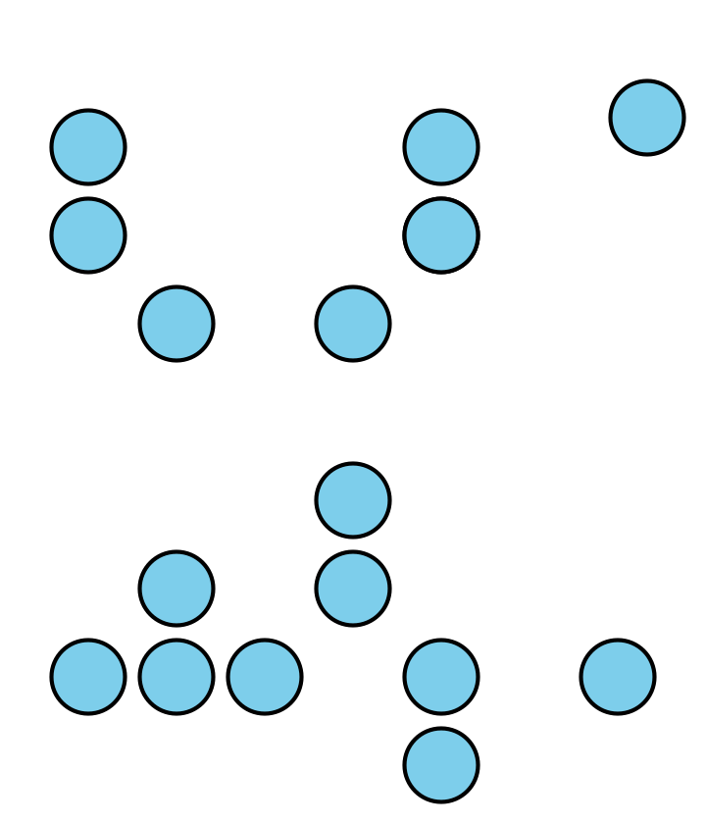
  - Explain or show how each array is related to multiplication.
© CC BY 2021 Illustrative Mathematics®

