Lesson 18: Modeling Circular Motion
- Let's use trigonometric functions to model circular motion.

18.1: Comparing Bikes
Each graph shows the vertical position $v$, in inches, of a point on the outside of a bike wheel, $s$ seconds after the wheel begins to spin.
- Which bike has larger wheels? Explain how you know.
- Which bike’s wheels are spinning faster? Explain how you know.

18.2: Around a Carousel
Jada, Noah, and Elena are riding a carousel. Here is a view, from above, of the carousel.
The carousel moves in a counterclockwise direction. When the ride begins, Jada is at position $J$, Noah is at position $N$, and Elena is at position $E$. The measure of angle $JON$ is $\frac{π}{2}$ and the measure of angle $NOE$ is $\frac{2π}{3}$.
- The radius of the carousel is 20 feet. How far does Jada travel to reach Noah’s starting position? What about Elena’s starting position? Explain or show how you know.
- The carousel makes 1 complete rotation every 10 seconds. At which times will Jada be at her starting position? At which times will she be at Noah's starting position? Explain or show how you know.
- The carousel ride lasts for 3.25 minutes. Where will Elena be when the ride ends? How far will she have traveled? Explain or show how you know.

18.3: Modeling the Carousel Motion
Jada begins the carousel ride at point $J$ and Noah begins the ride at point $N$. The radius of the carousel is 20 feet and it rotates in a counterclockwise direction, making one complete rotation every 10 seconds.
  - Write an equation describing the horizontal coordinate of Jada’s location as a function of time relative to the center of the carousel. Make sure to indicate the units of your variables.
  - Sketch a graph of your function.
  - 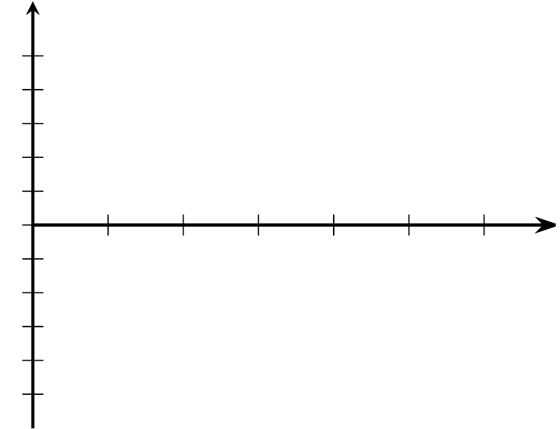
  - What does the graph tell you about Jada’s location during the carousel ride?
  - Write an equation describing the vertical coordinate of Noah’s location as a function of time relative to the center of the carousel. Make sure to indicate the units of your variables.
  - Sketch a graph of your function.
  - What does the graph tell you about Noah’s location during the carousel ride?

Are you ready for more?
Diego rides a different carousel and begins at position $D$. An equation describing the horizontal coordinate, $d(t)$, of his location in feet relative to the center of the carousel as a function of time is $d(t)=15\text{cos}(\frac{πt}{15}−π)$ where $t$ is the number of seconds since the carousel started to move.
- What is the radius of the carousel?
- How long does it take the carousel to make a complete rotation?
- Where did Diego start?

Lesson 18 Summary
Here is a point $P$ on a Ferris wheel:
This Ferris wheel has a diameter of 100 feet and its center is 60 feet off the ground. The Ferris wheel makes one revolution every 5 minutes. We can use this information to write a function that describes the vertical position of $P$, in feet, after $t$ minutes. We know
- The amplitude is 50 (the diameter of the Ferris wheel is 100 feet)
- The midline is at 60 (the center of the Ferris wheel is 60 feet high)
- The horizontal translation is $\frac{π}{2}$ ($P$ starts at the angle $\frac{π}{2}$ on the circle)
- The period is 5 (every 5 minutes the Ferris wheel makes one complete revolution)
Since we want the vertical position, let's use the sine function. Putting all of this information together the height of $P$ is modeled by the function $h=50\text{sin}\left(\frac{π}{2}+\frac{2πt}{5}\right)+60$. Here is a graph of the function:
© CC BY 2019 by Illustrative Mathematics®

