Unit 8 Lesson 4 Cumulative Practice Problems
  - Find the exact length of each line segment.
  - 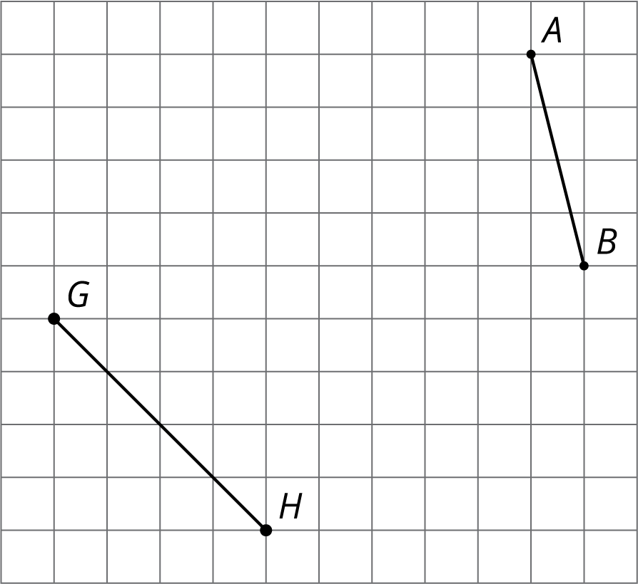
  - Estimate the length of each line segment to the nearest tenth of a unit. Explain your reasoning.
- Plot each number on the $x$-axis: $\sqrt{16}, \sqrt{35}, \sqrt{66}$. Consider using the grid to help.
- 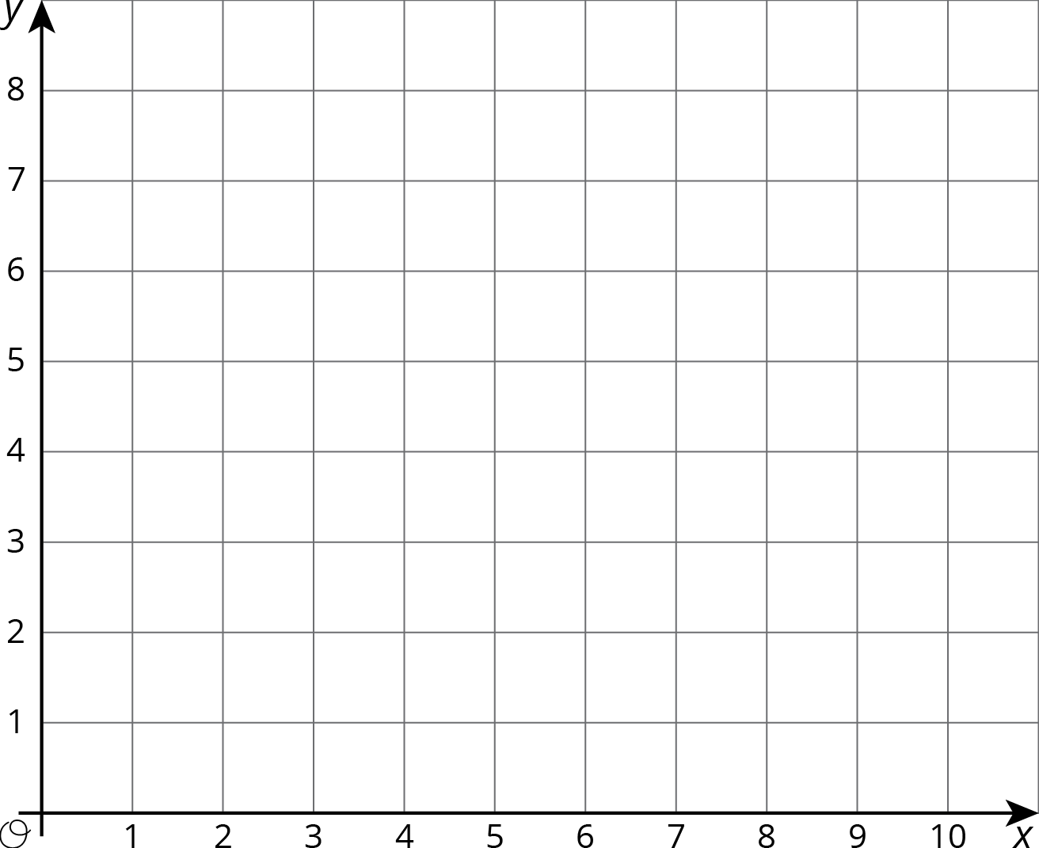

- Use the fact that $\sqrt{7}$ is a solution to the equation $x^{2}=7$ to find a decimal approximation of $\sqrt{7}$ whose square is between 6.9 and 7.1.

- Graphite is made up of layers of graphene. Each layer of graphene is about 200 picometers, or $200×{10}^{\text{-}12}$ meters, thick. How many layers of graphene are there in a 1.6-mm-thick piece of graphite? Express your answer in scientific notation.
- (From Unit 7, Lesson 14.)
- Here is a scatter plot that shows the number of assists and points for a group of hockey players. The model, represented by $y=1.5x+1.2$, is graphed with the scatter plot.
- 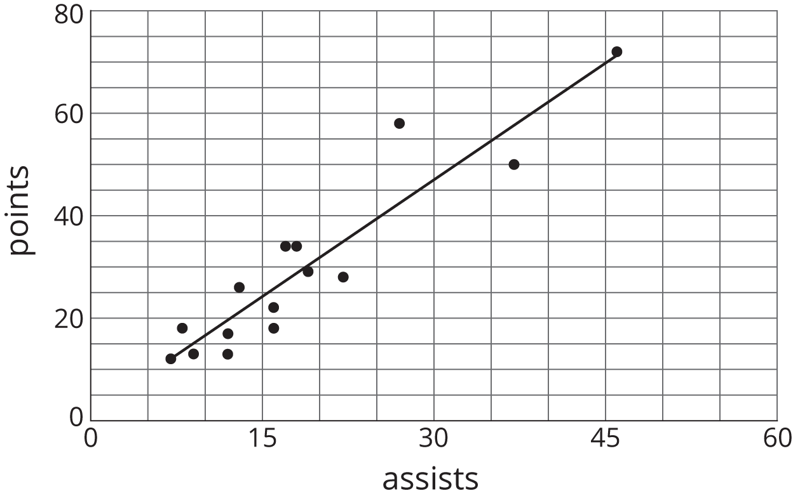
  - What does the slope mean in this situation?
  - Based on the model, how many points will a player have if he has 30 assists?
- (From Unit 6, Lesson 6.)
- The points $(12,23)$ and $(14,45)$ lie on a line. What is the slope of the line?
- (From Unit 3, Lesson 5.)
© CC BY Open Up Resources. Adaptations CC BY IM.

