Lesson 2: Finding Area by Decomposing and Rearranging

2.1: What is Area?
You may recall that the term area tells us something about the number of squares inside a two-dimensional shape.
- Here are four drawings that each show squares inside a shape. Select all drawings whose squares could be used to find the area of the shape. Be prepared to explain your reasoning.
- 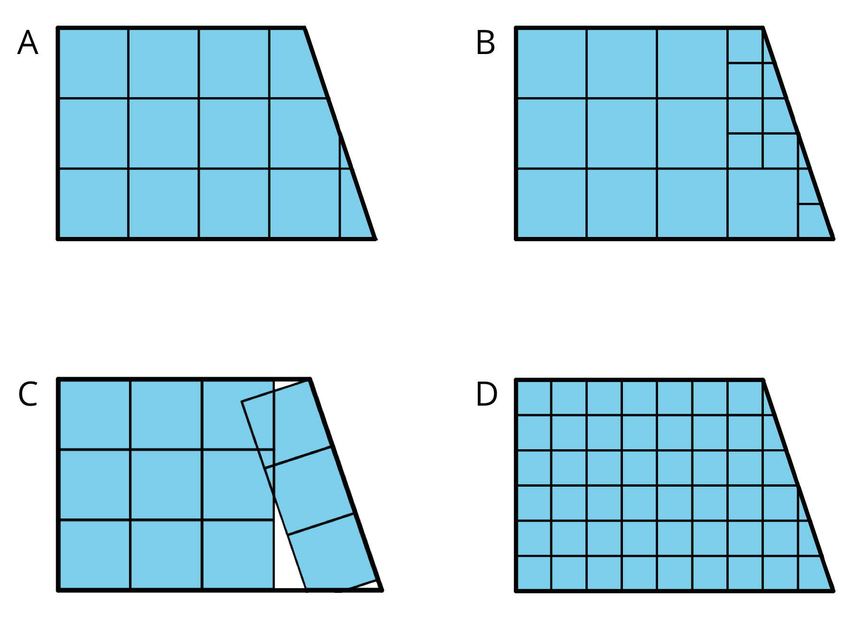
- Write a definition of area that includes all the information that you think is important.

2.2: Composing Shapes
Your teacher will give you one square and some small, medium, and large right triangles. The area of the square is 1 square unit.
- Notice that you can put together two small triangles to make a square. What is the area of the square composed of two small triangles? Be prepared to explain your reasoning.
- Use your shapes to create a new shape with an area of 1 square unit that is not a square. Trace your shape.
- Use your shapes to create a new shape with an area of 2 square units. Trace your shape.
- Use your shapes to create a different shape with an area of 2 square units. Trace your shape.
- Use your shapes to create a new shape with an area of 4 square units. Trace your shape.

Are you ready for more?
Find a way to use all of your pieces to compose a single large square. What is the area of this large square?

2.3: Tangram Triangles
Recall that the area of the square you saw earlier is 1 square unit. Complete each statement and explain your reasoning.
- The area of the small triangle is _________ square units. I know this because . . .
- The area of the medium triangle is _________ square units. I know this because . . .
- The area of the large triangle is _________ square units. I know this because . . .

Lesson 2 Summary
Here are two important principles for finding area:
- If two figures can be placed one on top of the other so that they match up exactly, then they have the same area.
- We can decompose a figure (break a figure into pieces) and rearrange the pieces (move the pieces around) to find its area.
Here are illustrations of the two principles.
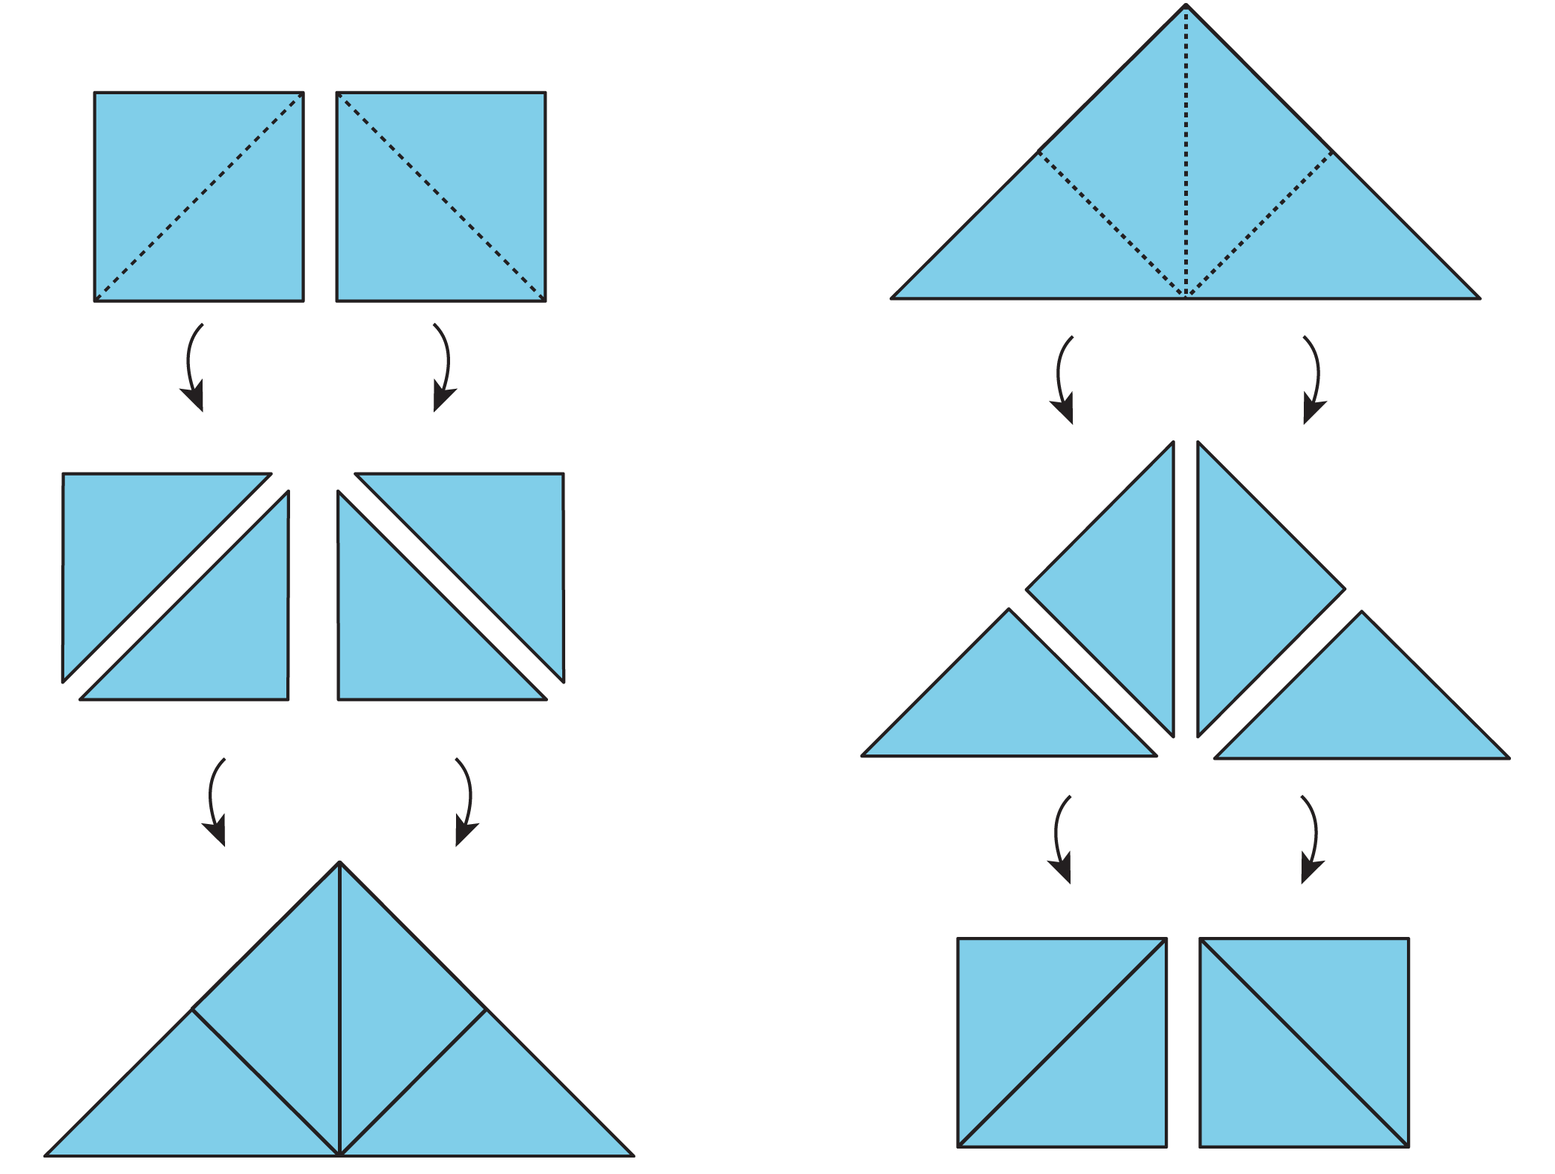
​
- Each square on the left can be decomposed into 2 triangles. These triangles can be rearranged into a large triangle. So the large triangle has the same area as the 2 squares.
- Similarly, the large triangle on the right can be decomposed into 4 equal triangles. The triangles can be rearranged to form 2 squares. If each square has an area of 1 square unit, then the area of the large triangle is 2 square units. We also can say that each small triangle has an area of $\frac{1}{2}$ square unit.
© CC BY Open Up Resources. Adaptations CC BY IM.

