Lesson 3 Practice Problems
- Complete the table and determine the rule for this transformation.
- input | - output
- $(2,\text{-}3)$ | - $(\text{-}3,2)$
- $(4,5)$ | - $(5,4)$
- $(,4)$ | - $(4,0)$
- $(1,6)$
 | - $(\text{-}1,\text{-}2)$
- $(x,y)$
- Write a rule that describes this transformation.
- original figure | - image
- $(5,1)$ | - $(2,\text{-}1)$
- $(\text{-}3,4)$ | - $(\text{-}6,\text{-}4)$
- $(1,\text{-}2)$ | - $(\text{-}2,2)$
- $(\text{-}1,\text{-}4)$ | - $(\text{-}4,4)$
- Select all the transformations that produce congruent images.
  - dilation
  - horizontal stretch
  - reflection
  - rotation
  - translation
- Here are some transformation rules. For each transformation, first predict what the image of triangle $ABC$ will look like. Then compute the coordinates of the image and draw it.
  - $(x,y)→(x−4,y−1)$
  - $(x,y)→(y,x)$
  - $(x,y)→(1.5x,1.5y)$
- 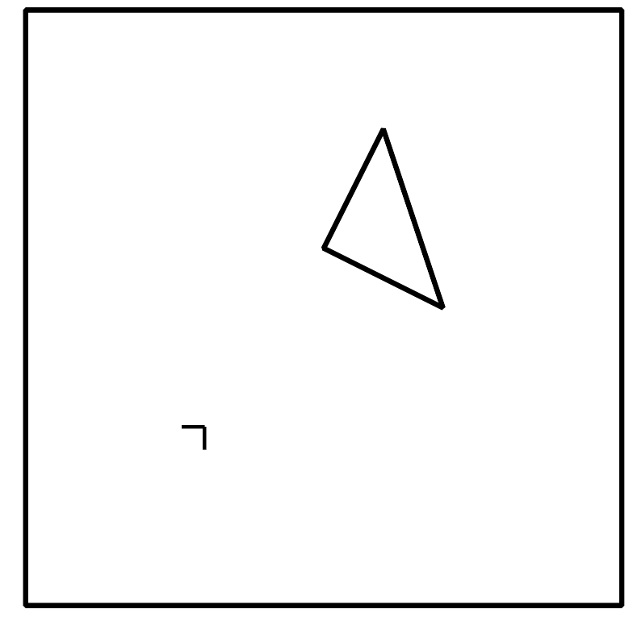
- (From Unit 6, Lesson 2.)
- A cylinder has radius 3 inches and height 5 inches. A cone has the same radius and height.
  - Find the volume of the cylinder.
  - Find the volume of the cone.
  - What fraction of the cylinder’s volume is the cone’s volume?
- (From Unit 5, Lesson 13.)
- Reflect triangle $ABC$ over the line $x=\text{-}2$. Call this new triangle $A^{′}B^{′}C^{′}$. Then reflect triangle $A^{′}B^{′}C^{′}$ over the line $x=0$. Call the resulting triangle $A^{″}B^{″}C^{″}$.
- Describe a single transformation that takes $ABC$ to $A^{″}B^{″}C^{″}$.
- (From Unit 6, Lesson 1.)
- In the construction, $A$ is the center of one circle, and $B$ is the center of the other.
- Explain why segments $AC$, $BC$, $AD$, $BD$, and $AB$ have the same length.
- (From Unit 1, Lesson 2.)
© CC BY 2019 by Illustrative Mathematics®

