Unit 6 Lesson 16: Surface Area of Right Prisms

1 Multifaceted (Warm up)

Student Task Statement
Your teacher will show you a prism.
- What are some things you could measure about the object?
- What units would you use for these measurements?

2 So Many Faces

Student Task Statement
Here is a picture of your teacher's prism:
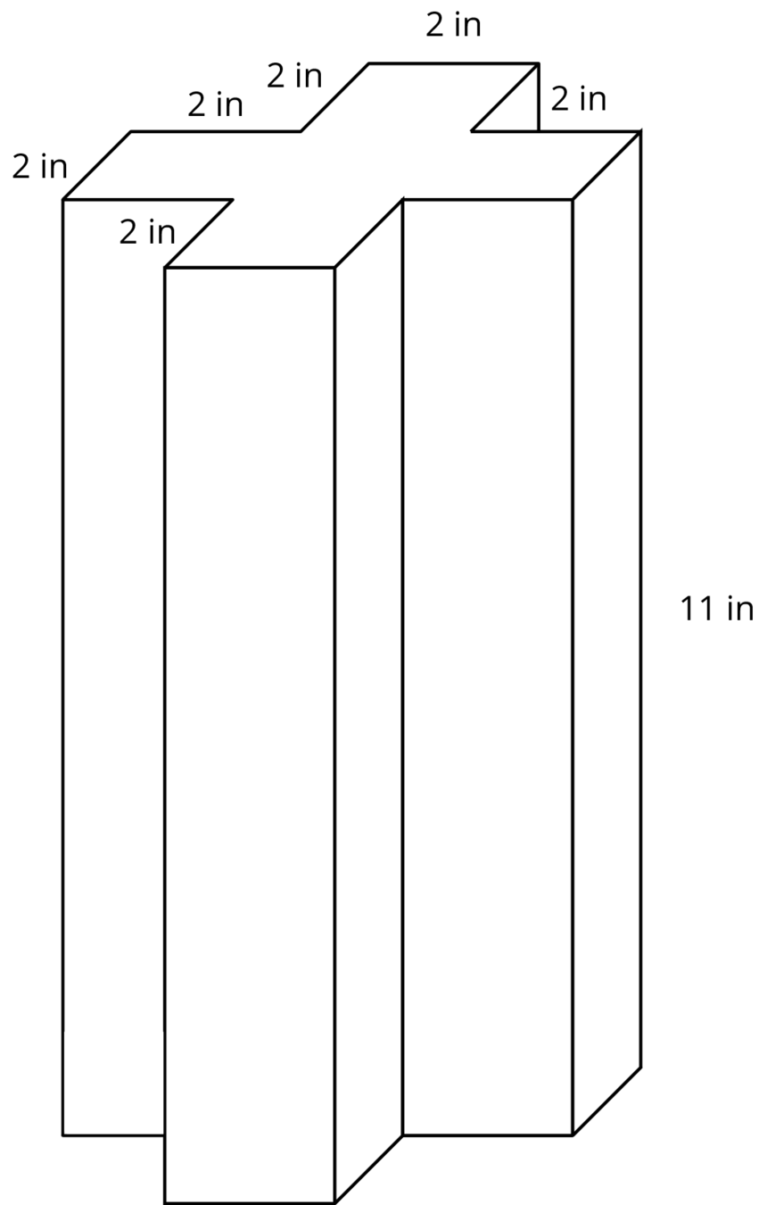
Three students are trying to calculate the surface area of this prism.
- Noah says, “This is going to be a lot of work. We have to find the areas of 14 different faces and add them up.”
- Elena says, “It’s not so bad. All 12 rectangles are identical copies, so we can find the area for one of them, multiply that by 12 and then add on the areas of the 2 bases.”
- Andre says, “Wait, I see another way! Imagine unfolding the prism into a net. We can use 1 large rectangle instead of 12 smaller ones.”
- Do you agree with any of them? Explain your reasoning.
- How big is the “1 large rectangle” Andre is talking about? Explain or show your reasoning. If you get stuck, consider drawing a net for the prism.
- Will Noah’s method always work for finding the surface area of any prism? Elena’s method? Andre’s method? Be prepared to explain your reasoning.
- Which method do you prefer? Why?

Activity Synthesis
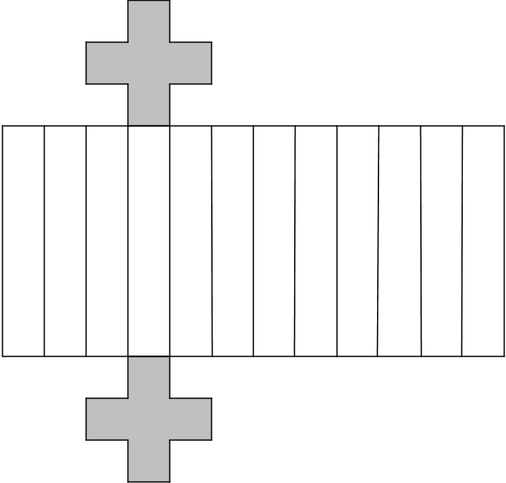

3 Revisiting the Box of Chocolates

Images for Launch
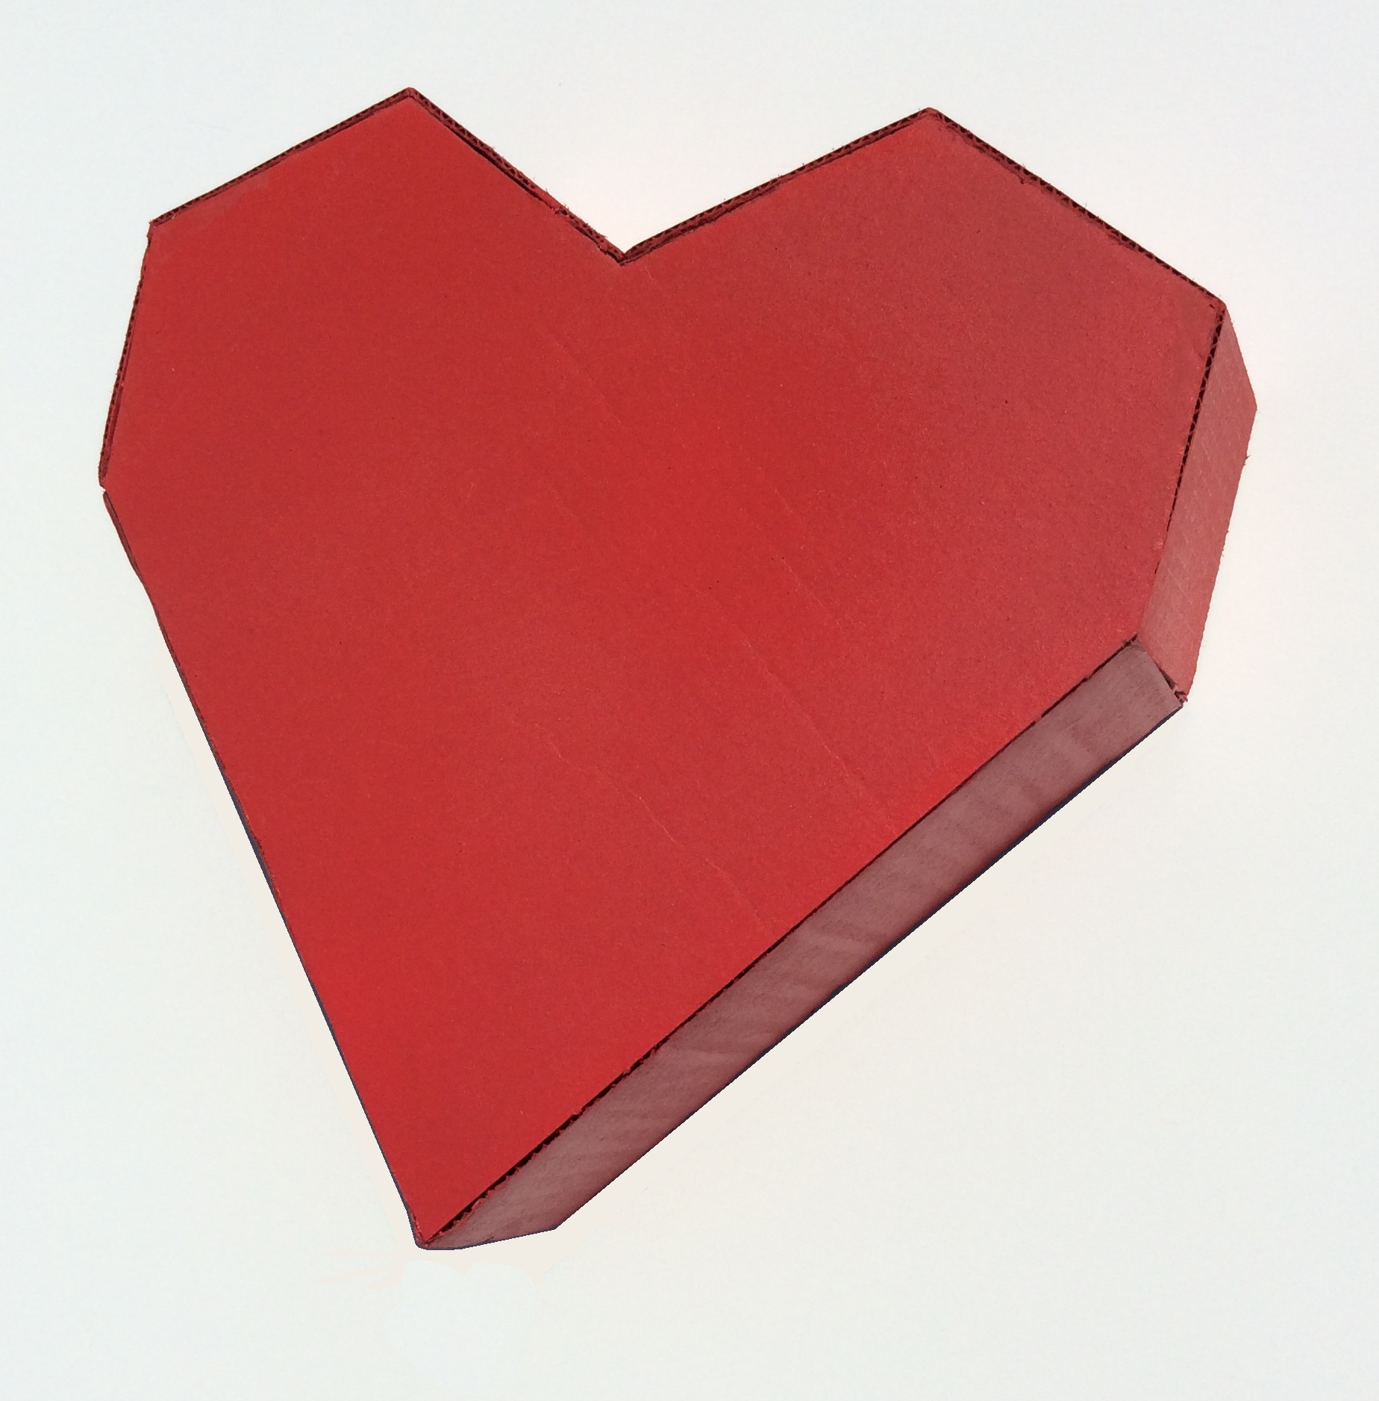

Student Task Statement
The other day, you calculated the volume of this heart-shaped box of chocolates.
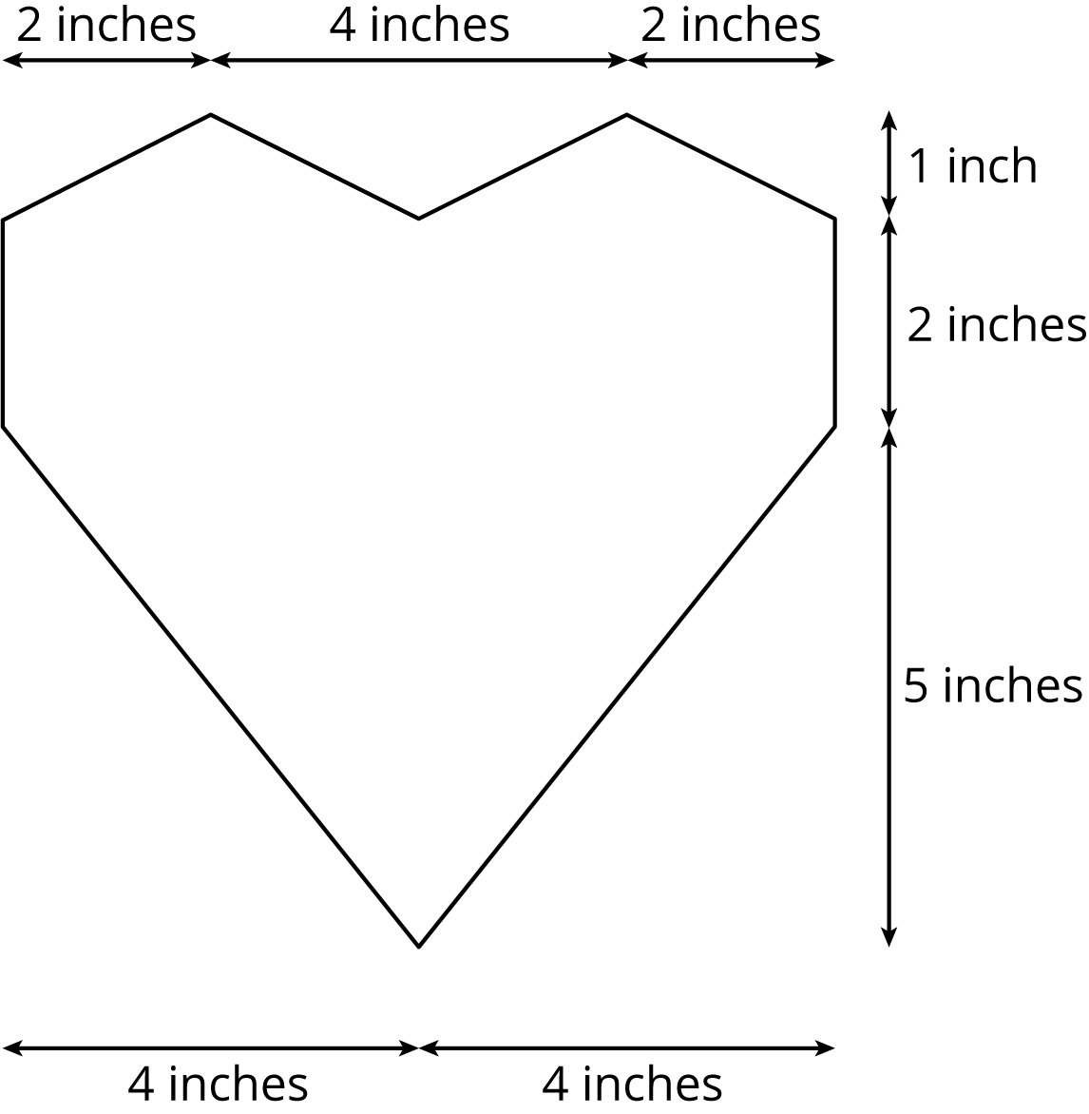
The depth of the box is 2 inches. How much cardboard is needed to create the box?

4 A Wheelbarrow of Concrete (Optional)

Images for Launch
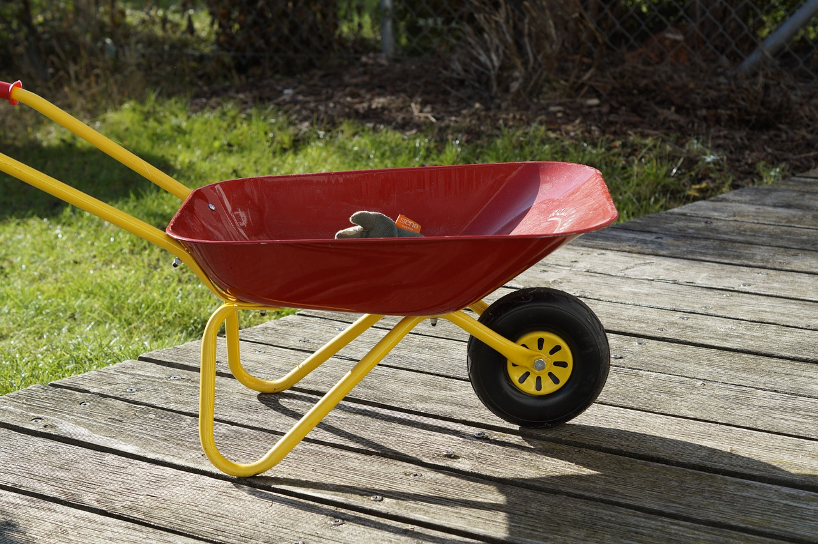

Student Task Statement
A wheelbarrow is being used to carry wet concrete. Here are its dimensions.
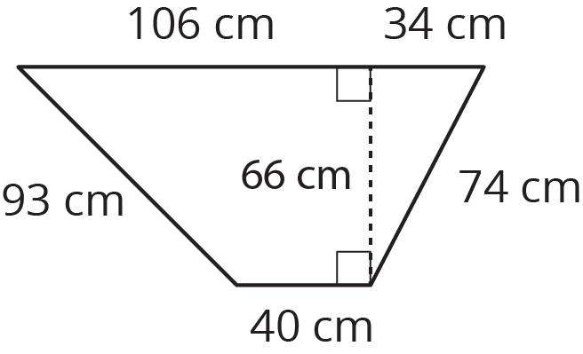
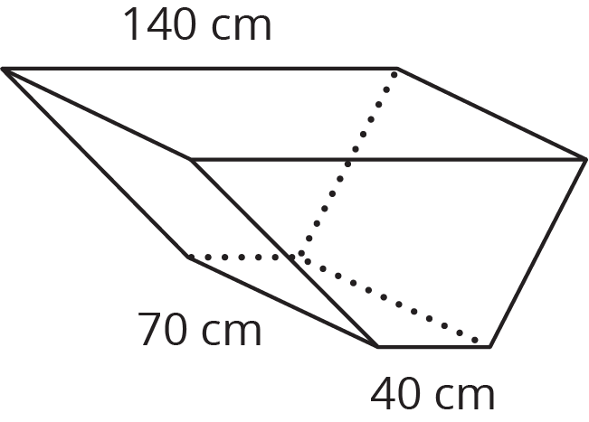
- What volume of concrete would it take to fill the tray?
- After dumping the wet concrete, you notice that a thin film is left on the inside of the tray. What is the area of the concrete coating the tray? (Remember, there is no top.)
© CC BY Open Up Resources. Adaptations CC BY IM.

