Unit 4 Lesson 1: Angles and Steepness

1 Ratios Galore (Warm up)

Student Task Statement
Triangle $ABC$ is similar to triangle $DEF$. Write as many equations as you can to describe the relationships between the sides and angles of the 2 triangles.

2 Can You Calculate?

Student Task Statement
Find the values of $x,y,\text{ and }z$. If there is not enough information, what else do you need to know?

3 Is it Accessible?

Student Task Statement
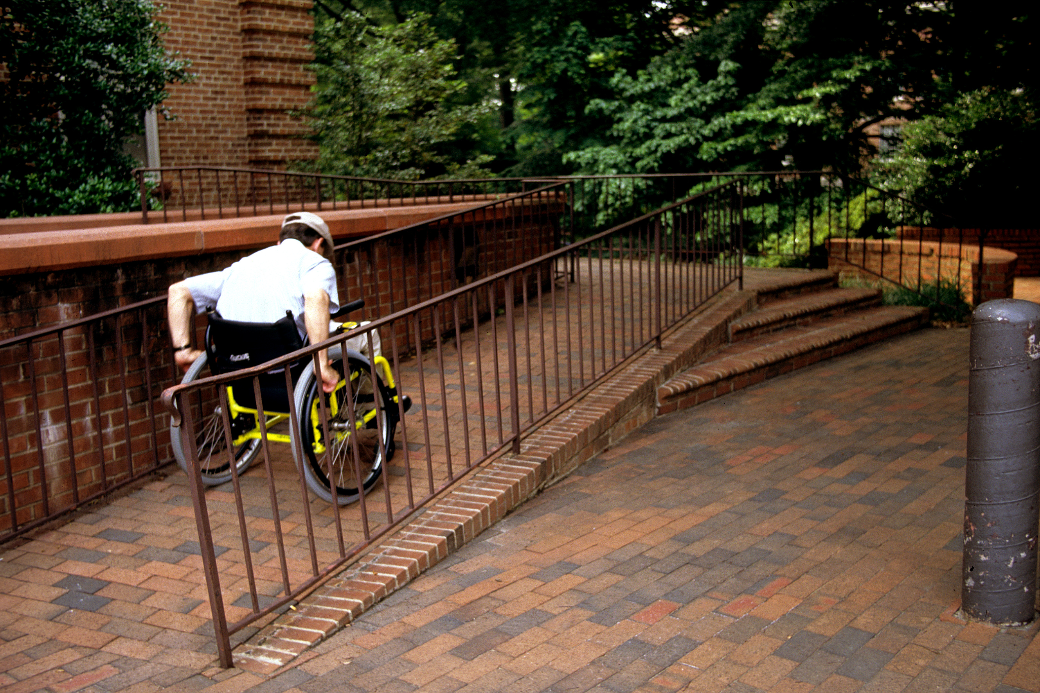
- Some buildings offer ramps in addition to stairs so people in wheelchairs have access to the building. What characteristics make a ramp safe?
- A school has 4 steps to the front door. Each step is 7 inches tall. Design a ramp for the school.
- Your teacher will give you the Americans with Disabilities Act (ADA) guidelines. Does your design follow the rules of this law? If not, draw a new design that does.
© CC BY 2019 by Illustrative Mathematics®

