Unit 6 Lesson 7: Finding Unknown Coordinates on a Circle

1 Notice and Wonder: Big and Small (Warm up)

Student Task Statement
What do you notice? What do you wonder?
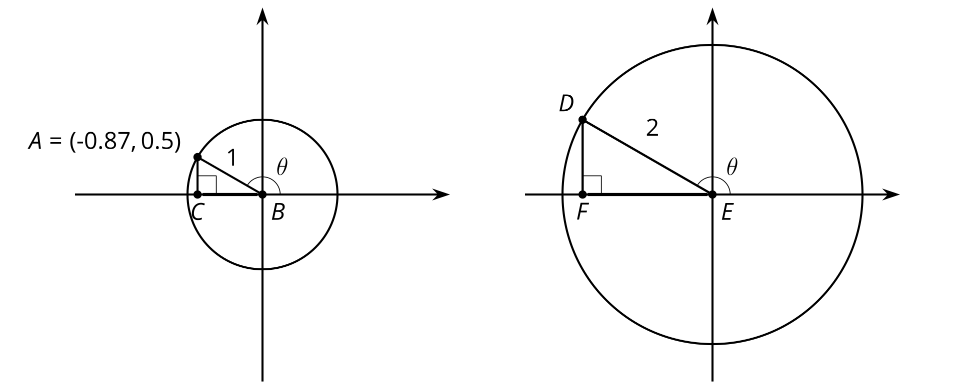

2 Clock Coordinates

Student Task Statement
Here is a clock face.
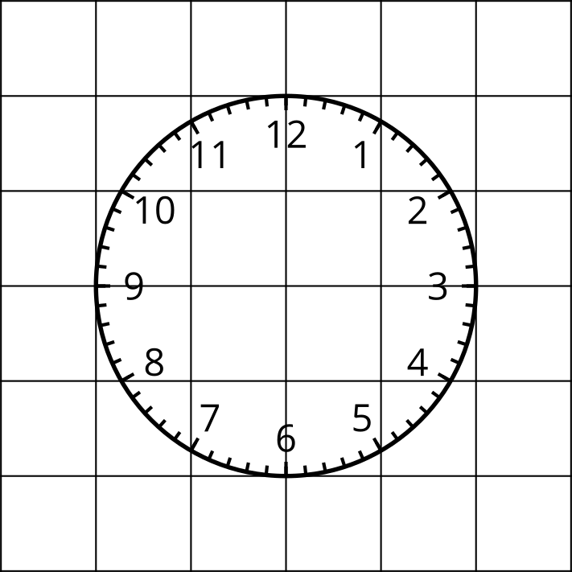
- The length of the minute hand on a clock is 5 inches and the center of the clock is at $\left(0,0\right)$ on a coordinate plane. Determine the coordinates of the end of the minute hand at the following times. Explain or show your reasoning.
  - 45 minutes after the hour
  - 10 minutes after the hour
  - 40 minutes after the hour
- The minute hand on another clock, also centered at $\left(0,0\right)$, has a length of 15 inches. Determine the coordinates of the end of the minute hand at the following times. Explain or show your reasoning.
  - 45 minutes after the hour
  - 10 minutes after the hour
  - 40 minutes after the hour
- At a certain time, the end of the minute hand of a third clock centered at $\left(0,0\right)$ has coordinates approximately $\left(7.5,7.5\right)$. How long is the minute hand of the clock if each grid square is one inch by one inch? Explain or show your reasoning.

3 Around a Ferris Wheel

Student Task Statement
The center of a Ferris wheel is 40 feet off of the ground, and the radius of the Ferris wheel is 30 feet. Point $P$ is shown at 0 radians.
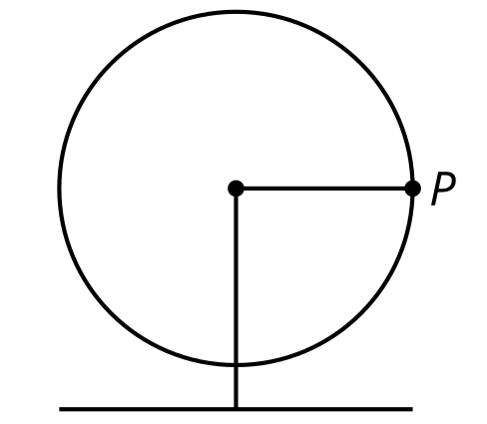
- Calculate how high off the ground point $P$ is as the Ferris wheel rotates counterclockwise starting from 0 radians.
  - $\frac{π}{12}$ radians
  - $\frac{π}{2}$radians
  - $\frac{5π}{6}$ radians
  - $\frac{5π}{3}$ radians
- As $P$ goes around on the Ferris wheel, estimate which angle(s) of rotation put $P$ 60 feet off the ground. Explain your reasoning.
© CC BY 2019 by Illustrative Mathematics®

