Lesson 25: Solving Problems with Systems of Linear Inequalities in Two Variables
- Let’s use systems of inequalities to solve some problems.

25.1: Which One Doesn’t Belong: Graphs of Solutions
Which one doesn’t belong?

A
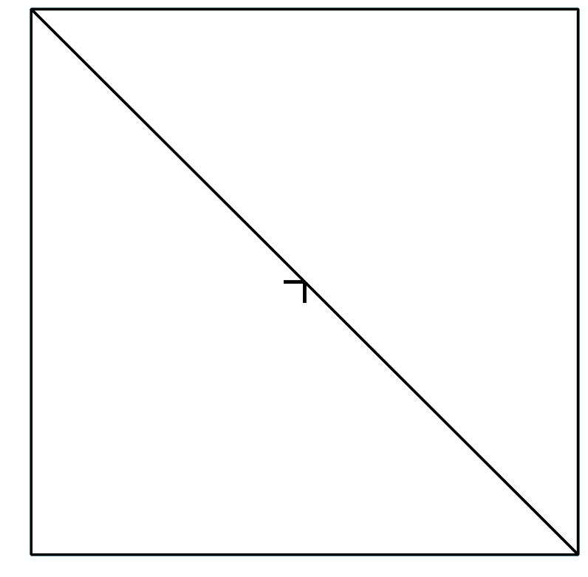

B
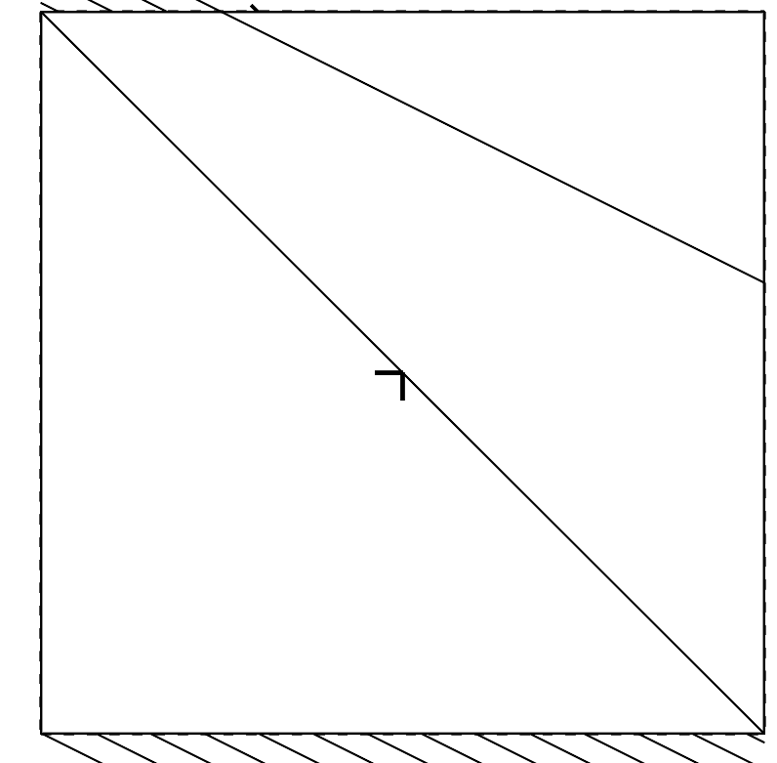

C

D

25.2: Focusing on the Details
Here are the graphs of the inequalities in this system:
$\left\{\begin{matrix}x<y \\ y≥\text{-}2x−6\end{matrix}\right.$
Decide whether each point is a solution to the system. Be prepared to explain how you know.
- $(3,\text{-}5)$
- $(0,5)$
- $(\text{-}6,6)$
- $(3,3)$
- $(\text{-}2,\text{-}2)$

Are you ready for more?
Find a system of inequalities with this triangle as its set of solutions.
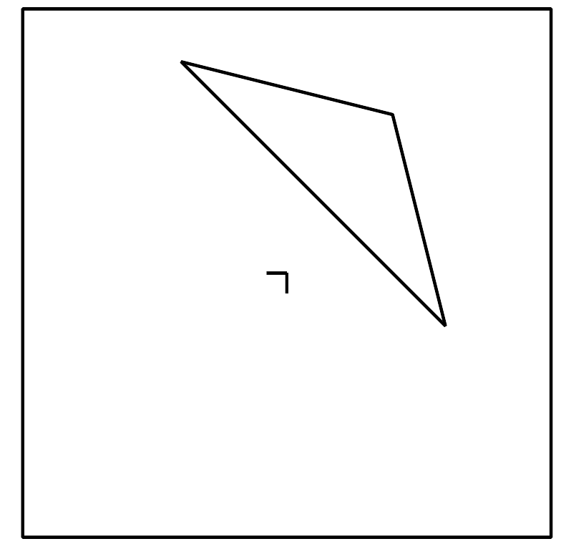

25.3: Info Gap: Terms of A Team
Your teacher will give you either a problem card or a data card. Do not show or read your card to your partner.
If your teacher gives you the data card:
- Silently read the information on your card.
- Ask your partner “What specific information do you need?” and wait for your partner to ask for information. Only give information that is on your card. (Do not figure out anything for your partner!)
- Before telling your partner the information, ask “Why do you need to know (that piece of information)?”
- Read the problem card, and solve the problem independently.
- Share the data card, and discuss your reasoning.
If your teacher gives you the problem card:
- Silently read your card and think about what information you need to answer the question.
- Ask your partner for the specific information that you need.
- Explain to your partner how you are using the information to solve the problem.
- When you have enough information, share the problem card with your partner, and solve the problem independently.
- Read the data card, and discuss your reasoning.
Pause here so your teacher can review your work. Ask your teacher for a new set of cards and repeat the activity, trading roles with your partner.
The blank coordinate planes are provided here in case they are useful.
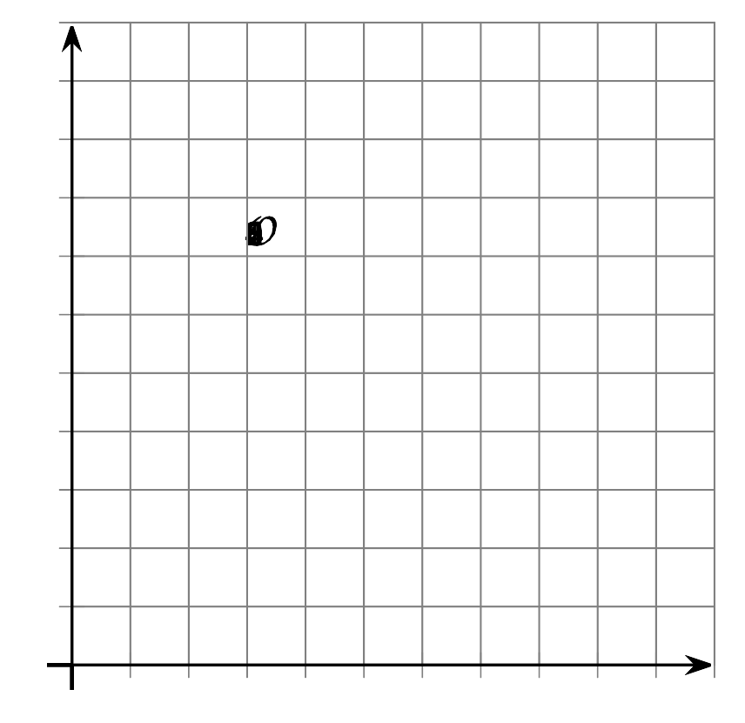
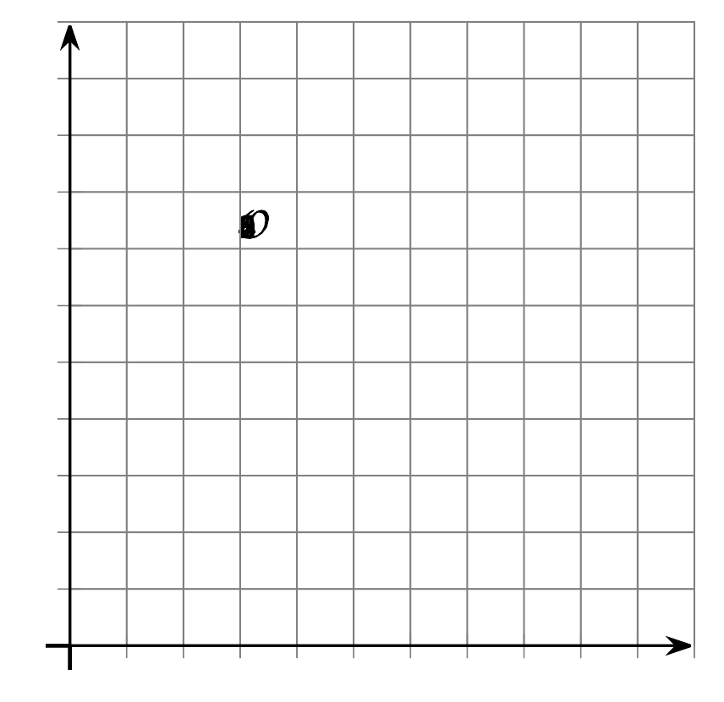

Lesson 25 Summary
A family has at most $25 to spend on activities at Fun Zone. It costs $10 an hour to use the trampolines and $5 an hour to use the pool. The family can stay less than 4 hours.
What are some combinations of trampoline time and pool time that the family could choose given their constraints?
We could find some combinations by trial and error, but writing a system of inequalities and graphing the solution would allow us to see all the possible combinations.
Let $t$ represent the time, in hours, on the trampolines and $p$ represent the time, in hours, in the pool.
The constraints can be represented with the system of inequalities:
$\left\{\begin{matrix}\begin{matrix}10t+5p & ≤25 \\ t+ p & <4\end{matrix}\end{matrix}\right.$
Here are graphs of the inequalities in the system.​​​​
The solution set to the system is represented by the region where shaded parts of the two graphs overlap. Any point in that region is a pair of times that meet both the time and budget constraints.
The graphs give us a complete picture of the possible solutions.
​​​​​​
- Can the family spend 1 hour on the trampolines and 3 hours in the pool?
- No. We can reason that it is because those times add up to 4 hours, and the family wants to spend less than 4 hours. But we can also see that the point $(1,3)$ lies on the dashed line of one graph, so it is not a solution.
- Can the family spend 2 hours on the trampolines and 1.5 hours in the pool?
- No. We know that these two times add up to less than 4 hours, but to find out the cost, we need to calculate $10(2)+5(1.5)$, which is 27.5 and is more than the budget.
- It may be easier to know that this combination is not an option by noticing that the point $(2,1.5)$ is in the region with line shading, but not in the region with solid shading. This means it meets one constraint but not the other.
© CC BY 2019 by Illustrative Mathematics®

