Unit 5 Lesson 16: Compounding Interest

1 Five Years Later (Warm up)

Student Task Statement
You owe 12% interest each year on a $500 loan. If you make no payments and take no additional loans, what will the loan balance be after 5 years?
Write an expression to represent the balance and evaluate it to find the answer in dollars.

2 Resizing Images

Student Task Statement
Andre and Mai need to enlarge two images for a group project. The two images are the same size.
Andre makes a scaled copy of his image, increasing the lengths by 10%. It was still a little too small, so he increases the lengths by 10% again.
Mai says, “If I scale my image and increase the lengths by 20%, our images will be exactly the same size.”
Do you agree with Mai? Explain or show your reasoning.

Activity Synthesis
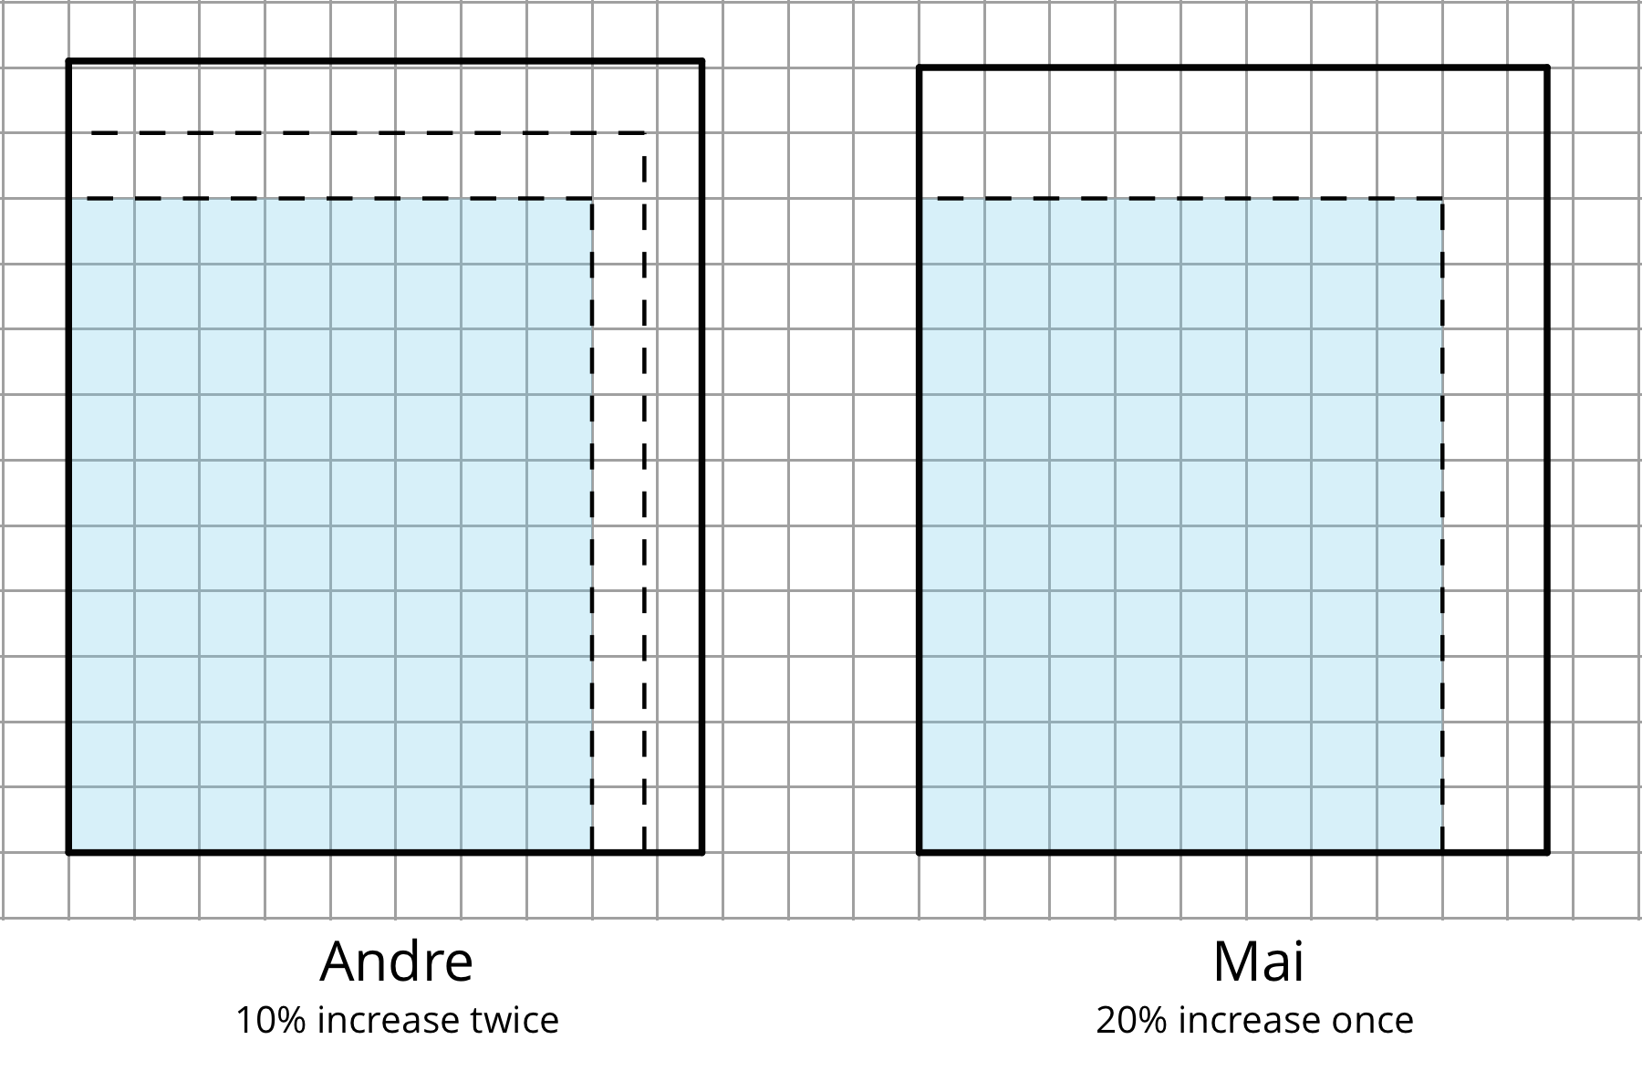

3 Earning Interest

Student Task Statement
A bank account has a monthly interest rate of 1% and initial balance of $1,000. Any earned interest is added to the account and no other deposits or withdrawals are made.
- What is the account balance after 6 months, 1 year, 2 years, and 5 years? Show your reasoning.
- Write an equation expressing the account balance ($a$) in terms of the number of months ($m$). Assume that all interest earned continues to be added to the account and no other deposits or withdrawals are made.
- How much interest will the account earn in 1 year? What percentage of the initial balance is that? Show your reasoning.
- The term annual return refers to the percent of interest an account holder could expect to receive in one year. Discuss with your partner: If you were the bank, would you advertise the account as having a 12% annual return? Why or why not? Use your work so far to explain your reasoning.
© CC BY 2019 by Illustrative Mathematics®

