Unit 2 Lesson 20: Writing and Solving Inequalities in One Variable

1 Dinner for Drama Club (Warm up)

Student Task Statement
Kiran is getting dinner for his drama club on the evening of their final rehearsal. The budget for dinner is $60.
Kiran plans to buy some prepared dishes from a supermarket. The prepared dishes are sold by the pound, at $5.29 a pound. He also plans to buy two large bottles of sparkling water at $2.49 each.
- Represent the constraints in the situation mathematically. If you use variables, specify what each one means.
- How many pounds of prepared dishes can Kiran buy? Explain or show your reasoning.

2 Gasoline in the Tank

Student Task Statement
Han is about to mow some lawns in his neighborhood. His lawn mower has a 5-gallon fuel tank, but Han is not sure how much gasoline is in the tank.
He knows, however, that the lawn mower uses 0.4 gallon of gasoline per hour of mowing.
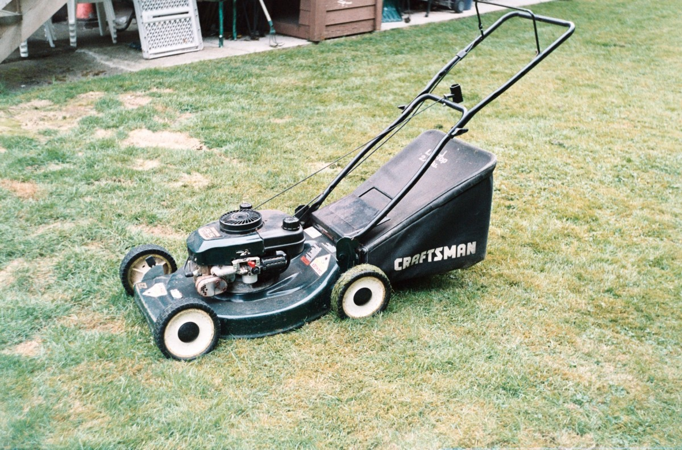
What are all the possible values for $x$, the number of hours Han can mow without refilling the lawn mower?
Write one or more inequalities to represent your response. Be prepared to explain or show your reasoning.

3 Different Ways of Solving

Student Task Statement
Andre and Priya used different strategies to solve the following inequality but reached the same solution.
$2\left(2x+1.5\right)<18−x$
- Make sense of each strategy until you can explain what each student has done.
- Andre
- $\begin{matrix}2\left(2x+1.5\right) & =18−x \\ 4x+3 & =18−x \\ 4x−15 & =\text{-}x \\ \text{-}15 & =\text{-}5x \\ 3 & =x\end{matrix}$
- Testing to see if $x=4$ is a solution:
- $\begin{matrix}2\left(2⋅4+1.5\right) & <18−4 \\ 2\left(9.5\right) & <14 \\ 19 & <14\end{matrix}$
- The inequality is false, so 4 is not a solution. If a number greater than 3 is not a solution, the solution must be less than 3, or $3>x$.
- Priya
- $\begin{matrix}2\left(2x+1.5\right) & =18−x \\ 4x+3 & =18−x \\ 5x+3 & =18 \\ 5x & =15 \\ x & =3\end{matrix}$
- In $4x+3=18−x$, there is $4x$ on the left and $\text{-}x$ on the right.
- If $x$ is a negative number, $4x+3$ could be positive or negative, but $18−x$ will always be positive.
- For $4x+3<18−x$ to be true, $x$ must include negative numbers or $x$ must be less than 3.
- Here are four inequalities.
  - $\frac{1}{5}p>\text{-}10$.
  - $4\left(x+7\right)≤\text{4}\left(2x+8\right)$
  - $\text{-}9n<36$
  - $\frac{c}{3}<\text{-}2\left(c−7\right)$
- Work with a partner to decide on at least two inequalities to solve. Solve one inequality using Andre's strategy (by testing values on either side the given solution), while your partner uses Priya's strategy (by reasoning about the parts of the inequality). Switch strategies for the other inequality.

4 Matching Inequalities and Solutions (Optional)

Student Task Statement
Match each inequality to a graph that represents its solutions. Be prepared to explain or show your reasoning.
- $6x≤3x$
- $\frac{1}{4}x>\text{-}\frac{1}{2}$
- $5x+4≥7x$
- $8x−2<−4\left(x−1\right)$
- $\frac{4x−1}{3}>\text{-}1$
- $\frac{12}{5}−\frac{x}{5}≤x$

A

B

C

D

E

F
© CC BY 2019 by Illustrative Mathematics®

