Lesson 21: Multiply More Decimals
- Let’s multiply decimals.

Warm-up: Estimation Exploration: Central Park
Central Park is a large park in Manhattan. It is about 3.85 kilometers long and 0.79 km wide. What is the area of Central Park?
Record an estimate that is:
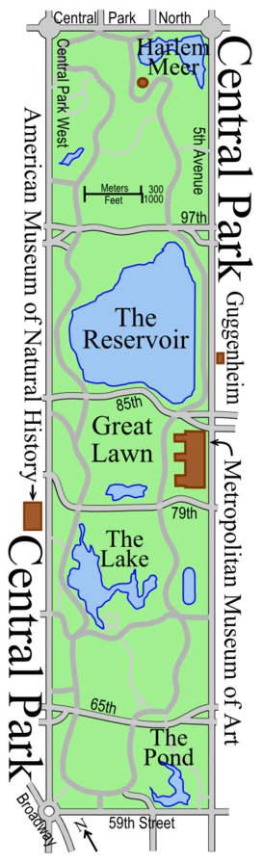
too low | about right | too high

21.1: Multiply More Decimals
- Explain or show why each pair of expressions is equivalent.
  - $7.2×5.3$ and $\left(72×53\right)×0.01$
  - $6.5×2.8$ and $\left(65×28\right)÷100$
  - $31×0.44$ and $\left(31×44\right)×\frac{1}{100}$
- Find the value of the products in the previous problem.

21.2: Choose Your Strategy
Find the value of each product.
- $7.3×4.2$
- $38×0.55$
- $285×0.17$

Section Summary
Section Summary
In this section, we learned to use place value relationships to multiply a whole number and a decimal. For example,
$6×0.14=0.84$
because 6 groups of 14 hundredths is $6×14$ or 84 hundredths.
We also found products like $1.7×0.3$. We can use a diagram to see that this is $17×3$ hundredths or $0.51$.
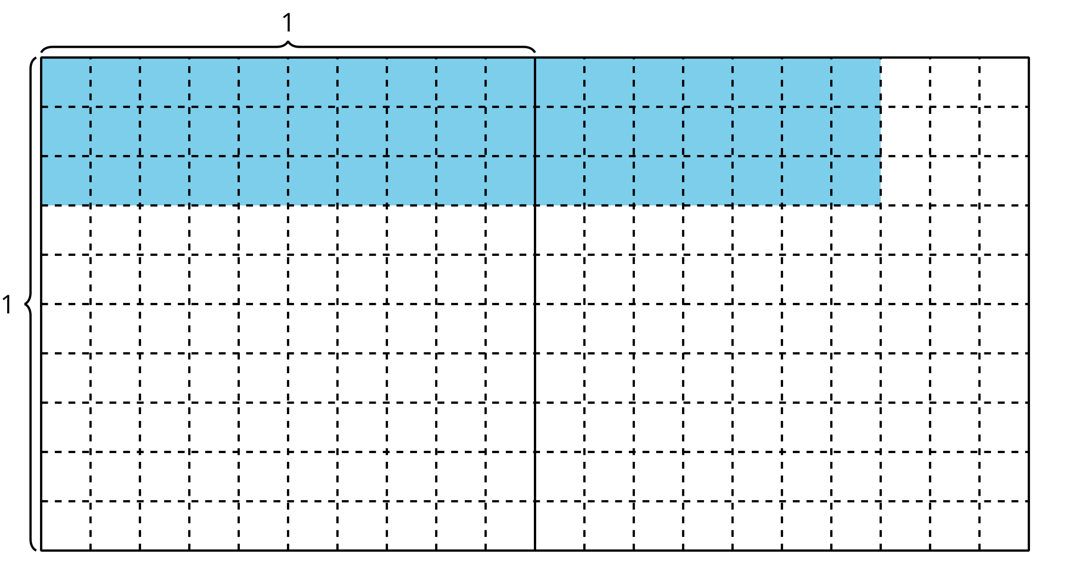
© CC BY 2021 Illustrative Mathematics®

