Lesson 16: Find the Value of Expressions
- Let’s find the value of expressions.

Warm-up: What Do You Know About $3+2$?
What do you know about $3+2$?

16.2: Find the Value of Expressions
$3+1$
$6−3$
$5−4$
$7+2$
$5+0$
$9−4$

16.3: Centers: Choice Time
Choose a center.
Roll and Add
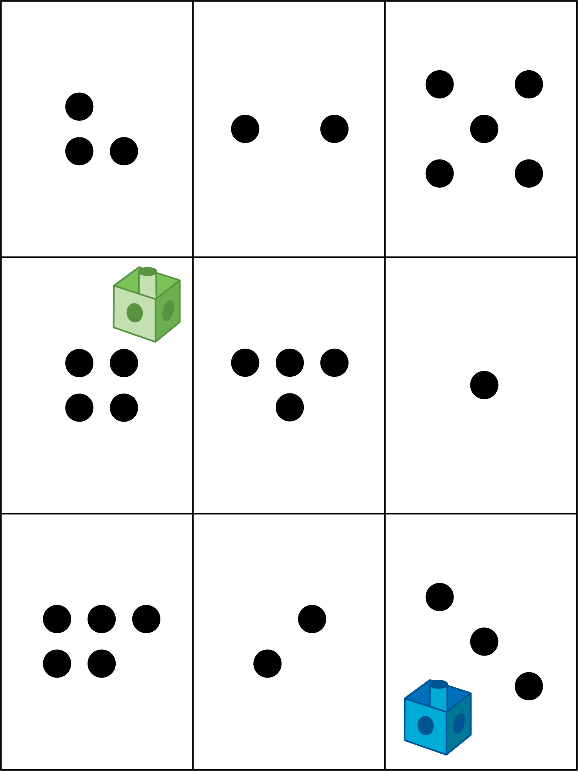
Shake and Spill
Number Race
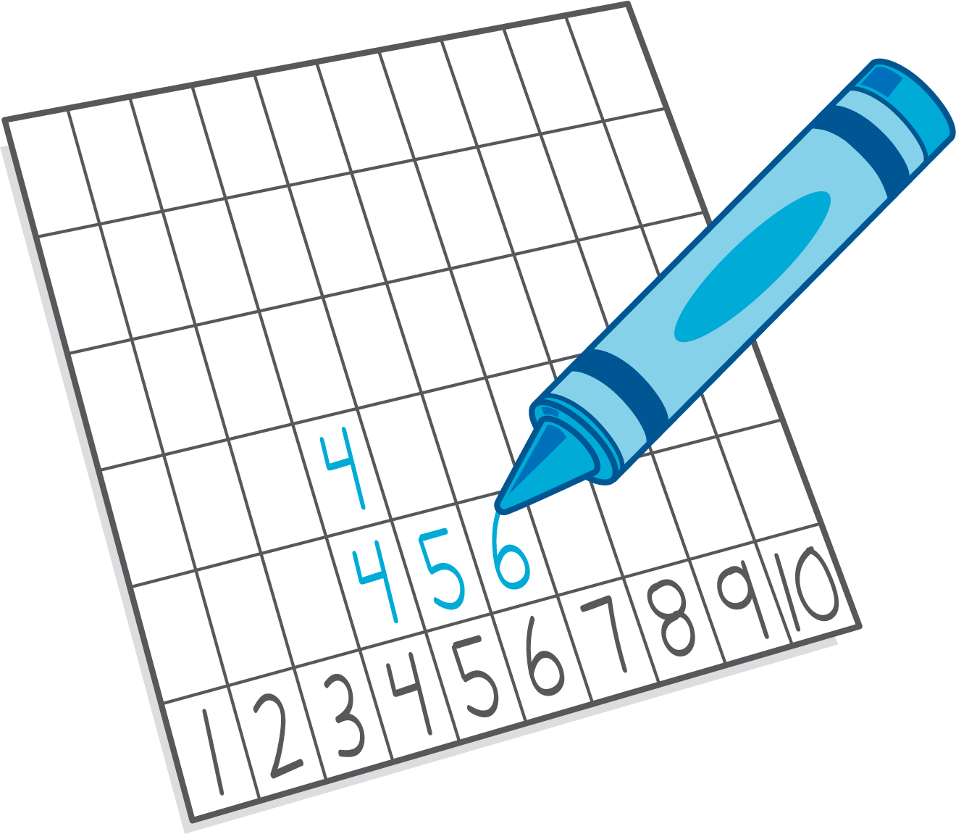
Math Stories
© CC BY 2021 Illustrative Mathematics®

