Unit 4 Lesson 16: Write Comparisons with Symbols

WU Notice and Wonder: 49 and 45 (Warm up)

Student Task Statement
What do you notice?
What do you wonder?
- $49>45$
- $45<49$

1 Introduce Greatest of Them All, Two-digit Numbers

Student Task Statement

2 Make the Statement True

Student Task Statement
- Compare the numbers.
Write <, >, or = in each blank.
Then read the comparison statement.
  - $56\underset{_}{}26$
  - $72\underset{_}{}78$
  - $6\underset{_}{}55$
  - $92\underset{_}{}29$
  - $23\underset{_}{}23$
- 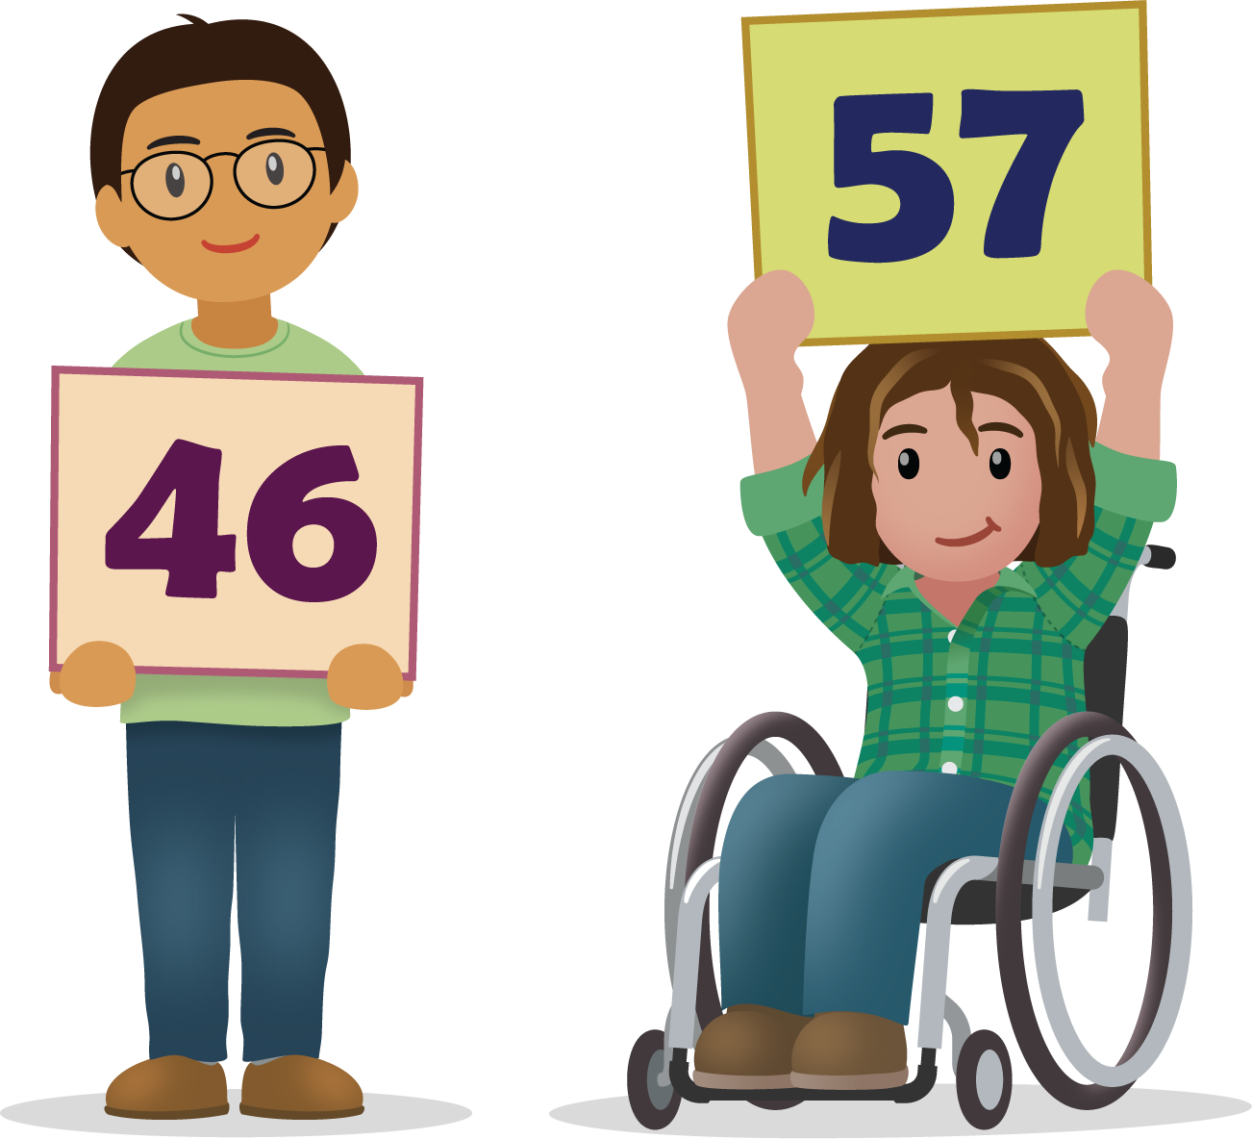
- Fill in each box with a number to make each statement true.
  - aaaiaaai>78
  - 39<aaaiaaai
  - 13=aaaiaaai
  - aaaiaaai<aaaiaaai
  - aaaiaaai>aaaiaaai
© CC BY 2021 Illustrative Mathematics®

