Unit 6 Lesson 9: Recording Partial Products: One-digit and Three- or Four-digit Factors

WU Which One Doesn’t Belong: Expressions Galore (Warm up)

Student Task Statement
Which one doesn’t belong?
- $7×50$
- $\left(3×50\right)+\left(4×50\right)$
- $\left(5×10\right)×7$
- $50+50+50+50+50+50+50$

1 An Algorithm for Noah

Student Task Statement
- Noah drew a diagram and wrote expressions to show his thinking as he multiplied two numbers.
- 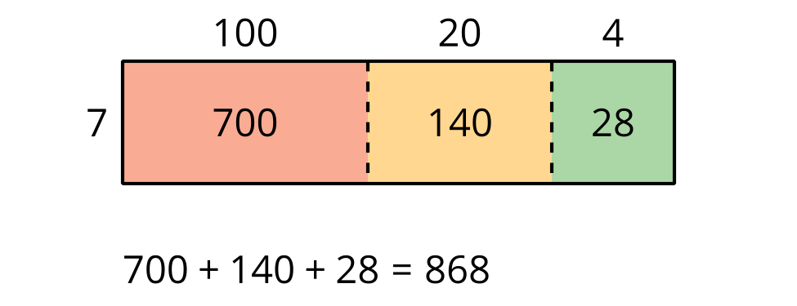
- $7×124$
$7×\left(100+20+4\right)$
$\left(7×100\right)+\left(7×20\right)+\left(7×4\right)$
$700+140+28$
- How does each expression represent Noah’s diagram? Be prepared to share your thinking with a partner.
- Later, Noah learned another way to record the multiplication, as shown here.
- Step 1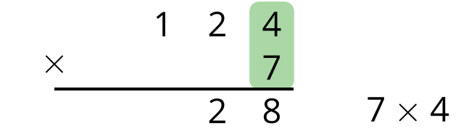
- Step 2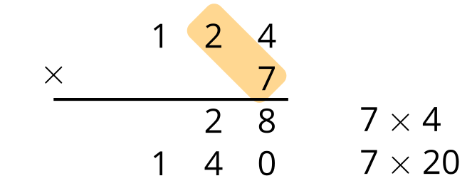
- Step 3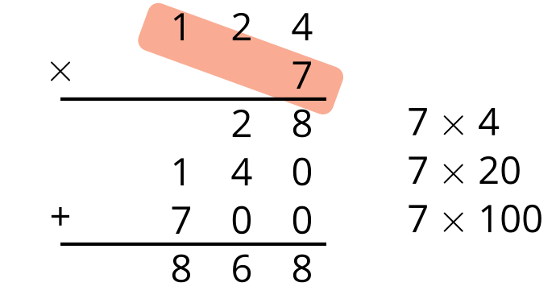
- Make sense of each step of the calculations and record your thoughts. Be prepared to explain Noah’s steps to a partner.
- Complete the diagram to find the value of $217×8$. Use Noah’s recording method to check your work.
- 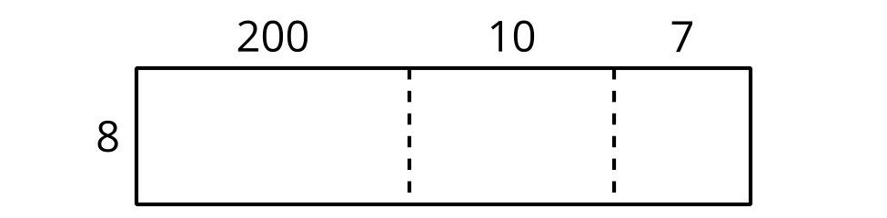
- 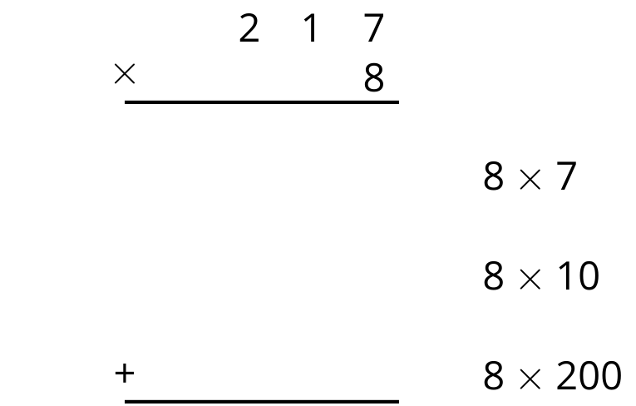

Activity Synthesis
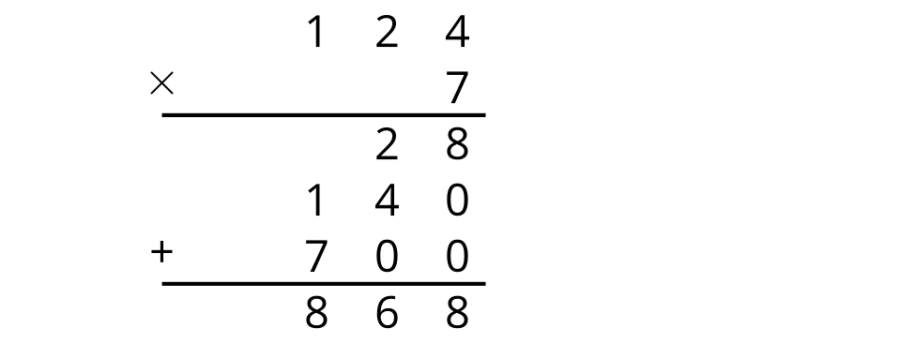

2 Try an Algorithm with Partial Products

Student Task Statement
Noah and Mai want to find the value of $8×3,​419$. They recorded their steps in different ways, as shown.
Noah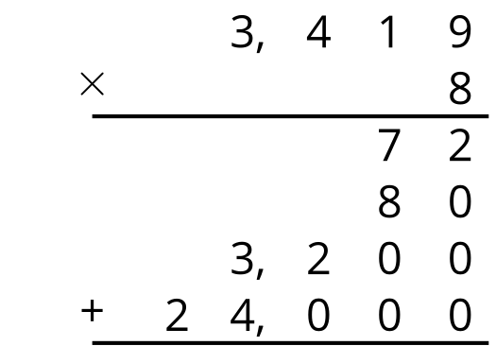
Mai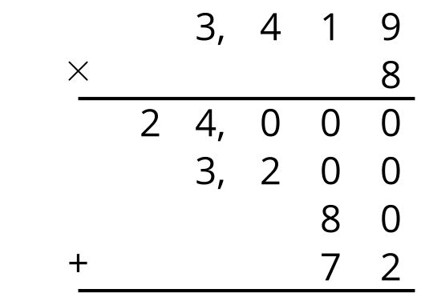
- How are Mai’s and Noah’s notation alike? How are they different?
- Use a diagram to show what each of the partial products 72, 80, 3,200 and 24,000 represent. Then, find the value of $8×3,​419$.
- Find the value of each expression. For at least one expression, use the algorithm that Noah used. Show your reasoning.
  - $4×5,​342$
  - $7×983$

Images for Activity Synthesis
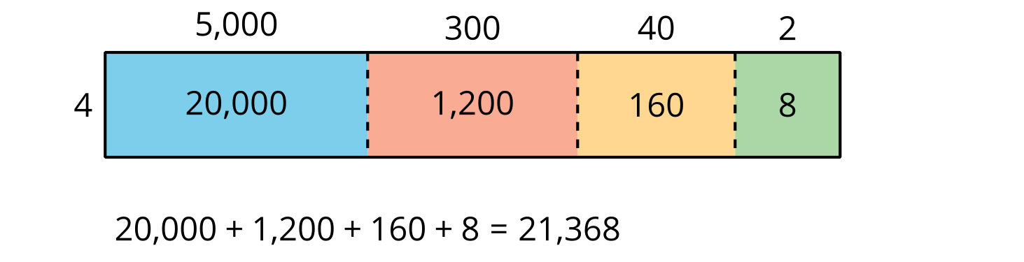
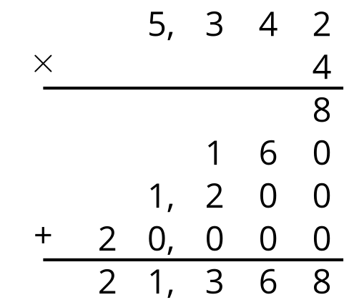
© CC BY 2021 Illustrative Mathematics®

