Unit 8 Lesson 6 Cumulative Practice Problems
- Here is a diagram of an acute triangle and three squares.
- 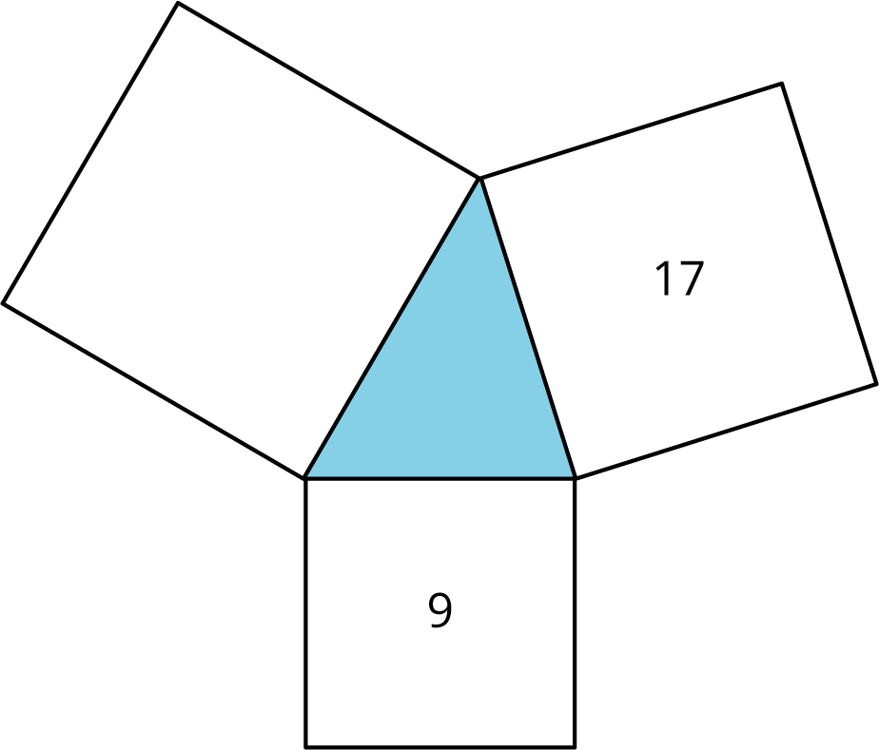
- Priya says the area of the large unmarked square is 26 square units because $9+17=26$. Do you agree? Explain your reasoning.

- $m$, $p$, and $z$ represent the lengths of the three sides of this right triangle.
- 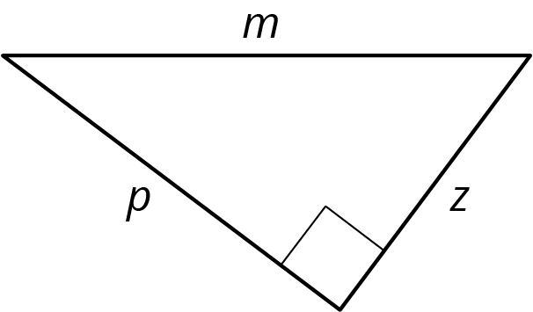
- Select all the equations that represent the relationship between $m$, $p$, and $z$.
  - $m^{2}+p^{2}=z^{2}$
  - $m^{2}=p^{2}+z^{2}$
  - $m^{2}=z^{2}+p^{2}$
  - $p^{2}+m^{2}=z^{2}$
  - $z^{2}+p^{2}=m^{2}$
  - $p^{2}+z^{2}=m^{2}$
- The lengths of the three sides are given for several right triangles. For each, write an equation that expresses the relationship between the lengths of the three sides.
  - 10, 6, 8
  - $\sqrt{5},\sqrt{3},\sqrt{8}$
  - 5, $\sqrt{5},\sqrt{30}$
  - 1, $\sqrt{37}$, 6
  - 3, $\sqrt{2},\sqrt{7}$
- Order the following expressions from least to greatest.
- $25÷10$
- $250,​000÷1,​000$
- $2.5÷1,​000$
- $0.025÷1$

- (From Unit 4, Lesson 1.)
- Which is the best explanation for why $\text{-}\sqrt{10}$ is irrational?
  - $\text{-}\sqrt{10}$ is irrational because it is not rational.
  - $\text{-}\sqrt{10}$ is irrational because it is less than zero.
  - $\text{-}\sqrt{10}$ is irrational because it is not a whole number.
  - $\text{-}\sqrt{10}$ is irrational because if I put $\text{-}\sqrt{10}$ into a calculator, I get -3.16227766, which does not make a repeating pattern.
- (From Unit 8, Lesson 3.)
- A teacher tells her students she is just over 1 and $\frac{1}{2}$ billion seconds old.
  - Write her age in seconds using scientific notation.
  - What is a more reasonable unit of measurement for this situation?
  - How old is she when you use a more reasonable unit of measurement?
- (From Unit 7, Lesson 15.)
© CC BY Open Up Resources. Adaptations CC BY IM.

