Lesson 5 Practice Problems
- Match each quadratic expression with an equivalent expression in factored form.​​​​​​
  - $x^{2}+6x$
  - $x^{2}+6x+5$
  - $x^{2}+6x−7$
  - $x^{2}+6x+8$
  - $x^{2}+6x+9$
  - $(x+7)(x−1)$
  - $(x+5)(x+1)$
  - $(x+4)(x+2)$
  - $(x+3)(x+3)$
  - $x(x+6)$
- An equation of a circle is $x^{2}−8x+16+y^{2}+10y+25=81$.
  - What is the radius of the circle?
  - What is the center of the circle?
- Write 3 perfect square trinomials. Then rewrite them as squared binomials.
- Write an equation of the circle that has a diameter with endpoints $(12,3)$ and $(\text{-}18,3)$.
- (From Unit 6, Lesson 4.)
  - Graph the circle $(x−2)^{2}+(y−1)^{2}=25$.
  - For each point, determine if it is on the circle. If not, decide whether it is inside the circle or outside of the circle.
    - $(4,0)$
    - $(\text{-}3,3)$
    - $(\text{-}2,\text{-}2)$
  - How can you use distance calculations to decide if a point is inside, on, or outside a circle?
- 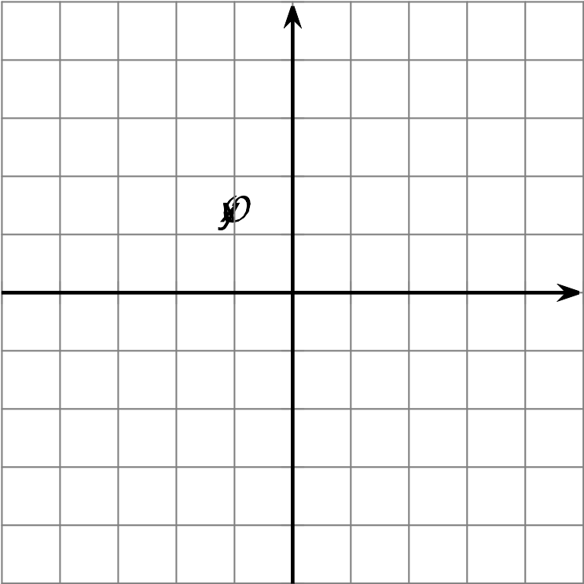
- (From Unit 6, Lesson 4.)
- The triangle whose vertices are $(2,5),(3,1),$ and $(4,2)$ is transformed by the rule $(x,y)→(x−2,y+4)$. Is the image similar or congruent to the original figure?
  - The image is congruent to the original triangle.
  - The image is similar but not congruent to the original triangle.
  - The image is neither similar nor congruent to the original triangle.
- (From Unit 6, Lesson 3.)
- Technology required. A triangular prism has height 6 units. The base of the prism is shown in the image. What is the volume of the prism? Round your answer to the nearest tenth.
- (From Unit 5, Lesson 15.)
© CC BY 2019 by Illustrative Mathematics®

