Unit 6 Lesson 18: The Volume and Dimensions of a Cylinder

1 A Circle's Dimensions (Warm up)

Student Task Statement
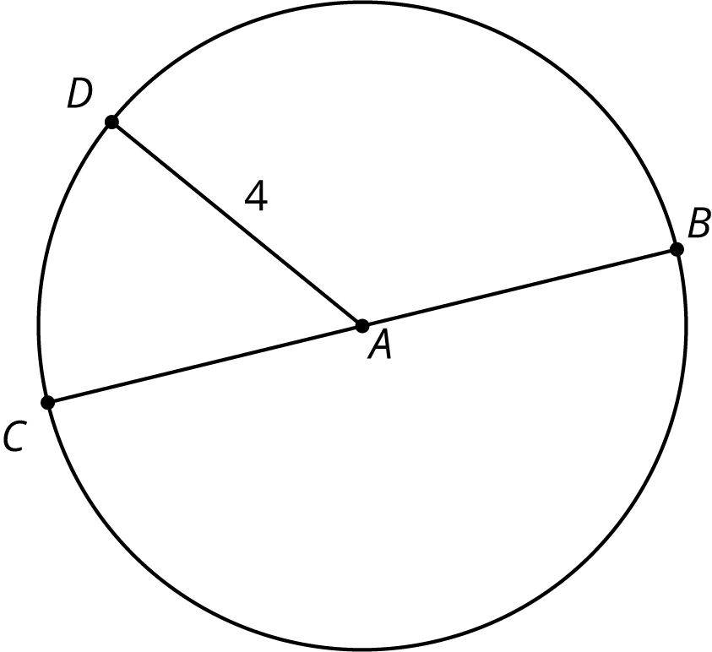
Here is a circle. Points $A$, $B$, $C$, and $D$ are drawn, as well as Segments $AD$ and $BC$.
- What is the area of the circle, in square units? Select all that apply.
  - $4π$
  - $π8$
  - $16π$
  - $π4^{2}$
  - approximately 25
  - approximately 50
- If the area of a circle is $49π$ square units, what is its radius? Explain your reasoning.

2 Circular Volumes

Student Task Statement
What is the volume of each figure, in cubic units? Even if you aren’t sure, make a reasonable guess.
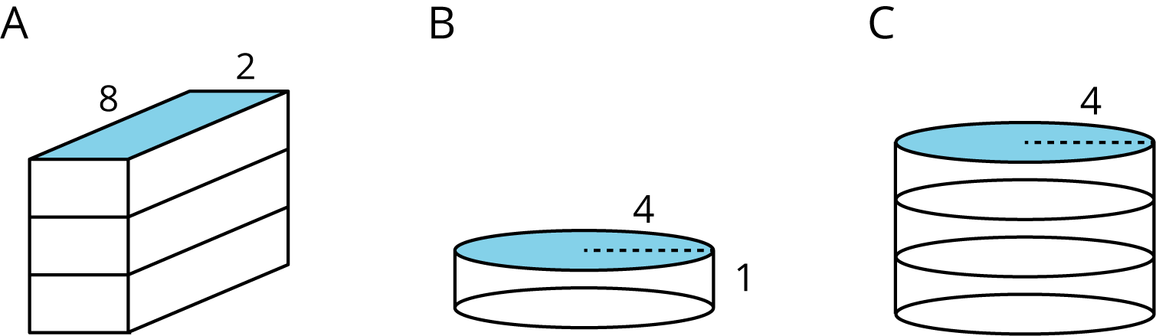
- Figure A: A rectangular prism whose base has an area of 16 square units and whose height is 3 units.
- Figure B: A cylinder whose base has an area of 16$π$ square units and whose height is 1 unit.
- Figure C: A cylinder whose base has an area of 16$π$ square units and whose height is 3 units.

3 What’s the Dimension?

Student Task Statement
The volume $V$ of a cylinder with radius $r$ is given by the formula $V=πr^{2}h$.
- The volume of this cylinder with radius 5 units is $50π$ cubic units. This statement is true: $50π=5^{2}πh$
- 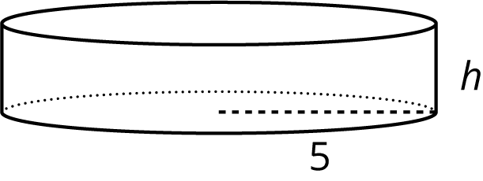
- What does the height of this cylinder have to be? Explain how you know.
- The volume of this cylinder with height 4 units is $36π$ cubic units. This statement is true: $36π=r^{2}π4$
- 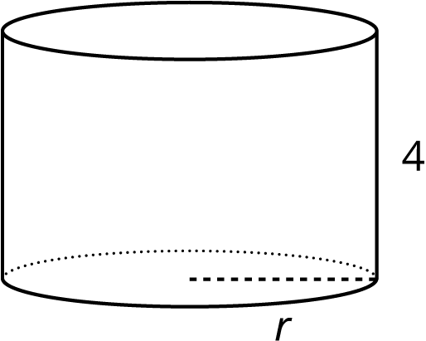
- What does the radius of this cylinder have to be? Explain how you know.

4 Cylinders with Unknown Dimensions

Student Task Statement
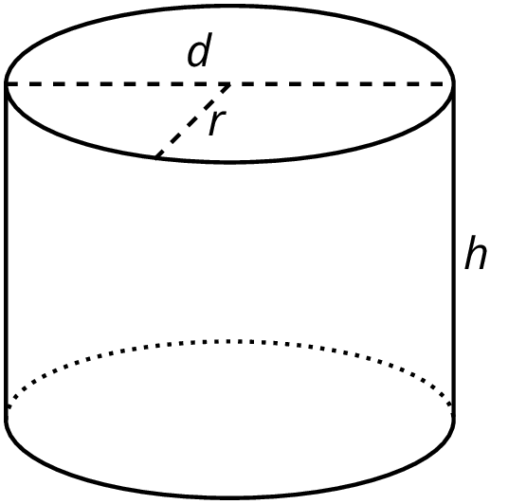
Each row of the table has information about a particular cylinder. Complete the table with the missing dimensions.
diameter (units) | radius (units) | area of the base (square units) | height (units) | volume (cubic units)
 | 3 |  | 5
12 |  |  |  | $108π$
 |  |  | 11 | $99π$
8 |  |  |  | $16π$
 |  |  | 100 | $16π$
 | 10 |  |  | $20π$
20 |  |  |  | 314
 |  |  | $b$ | $π⋅b⋅a^{2}$

© CC BY Open Up Resources. Adaptations CC BY IM.

