Unit 2 Lesson 1: Fingers as a Math Tool

WU Choral Count: Fingers and Counting (Warm up)

Student Task Statement

1 How Many Fingers?

Student Task Statement

2 Show Some Fingers

Student Task Statement
1
3
5
4
6
8
10
9
2
7

3 Introduce Math Fingers, Show and Say

Student Task Statement
Choose a center.
Math Fingers
Pattern Blocks
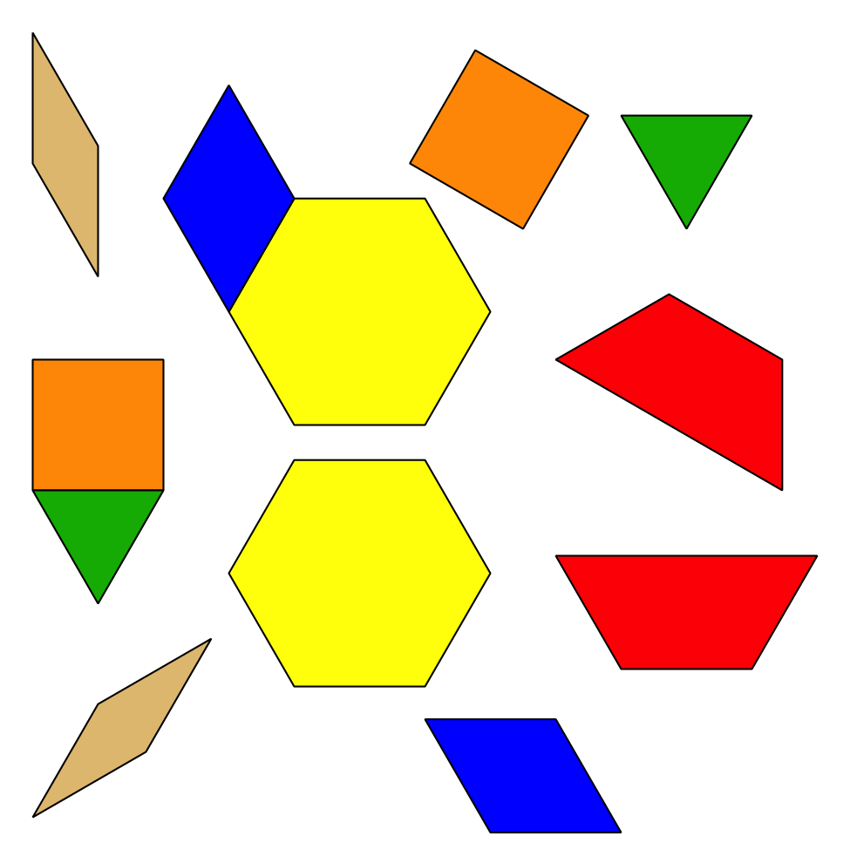
Picture Books
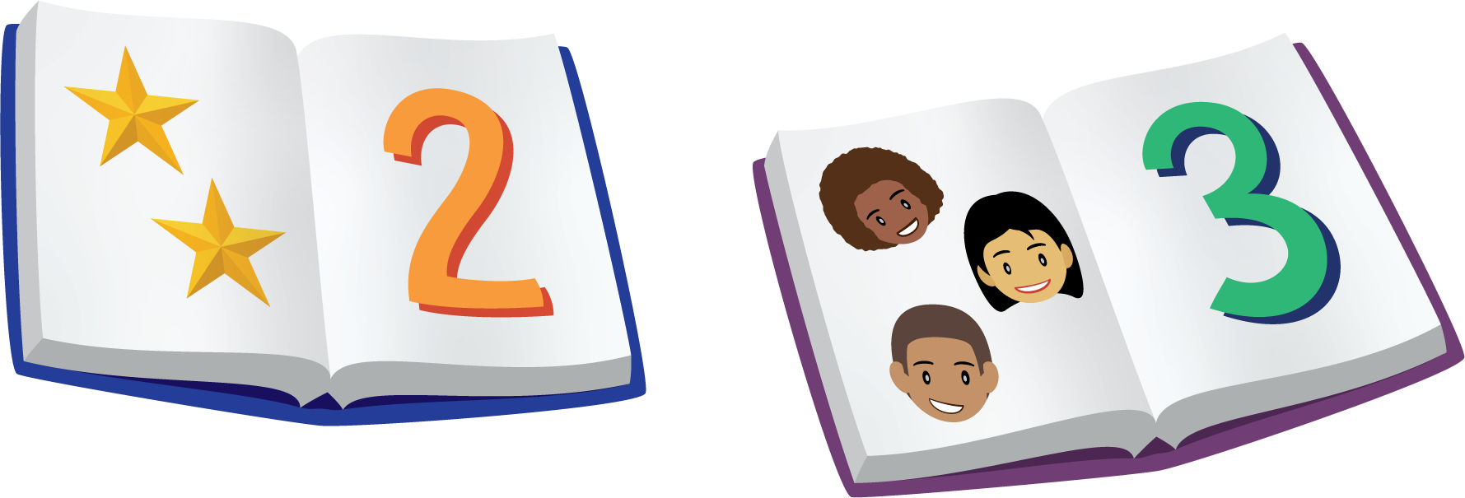
© CC BY 2021 Illustrative Mathematics®

