Lesson 22: Divide Whole Numbers by 0.1 and 0.01
- Let’s divide whole numbers by one tenth and one hundredth.

Warm-up: Number Talk: Remember Division of Unit Fractions
Find the value of each expression mentally.
- $1÷\frac{1}{10}$
- $2÷\frac{1}{10}$
- $1÷0.01$
- $2÷0.01$

22.1: Patterns in Dividing by Decimal Units
- Find the value of each expression. Explain or show your reasoning. Use a diagram if it is helpful.
  - $3÷0.1$
  - $3÷0.01$
  - $4÷0.1$
  - $4÷0.01$
- What patterns do you notice?

22.2: Divide Whole Numbers by Decimals
- Describe how you can find the value of any whole number divided by 0.1. Use a diagram if it is helpful.
- Describe how you can find the value of any whole number divided by 0.01. Use a diagram if it is helpful.
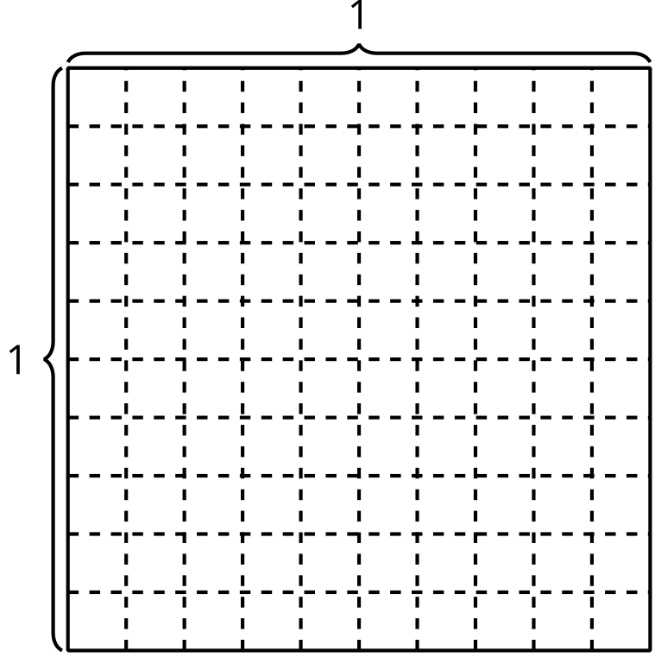
© CC BY 2021 Illustrative Mathematics®

