Unit 4 Lesson 17: Compare and Order Numbers

WU Which One Doesn’t Belong: Comparison Statements (Warm up)

Student Task Statement
Which one doesn’t belong?
A
B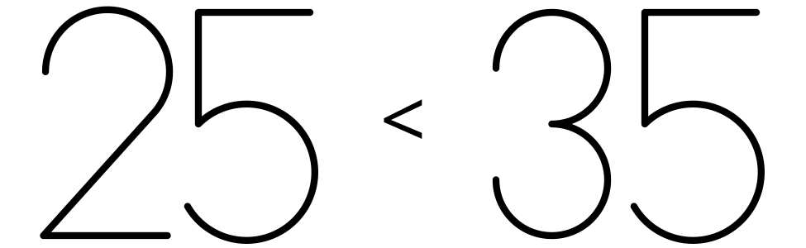
C
D

1 Compare and Order Quantities

Student Task Statement
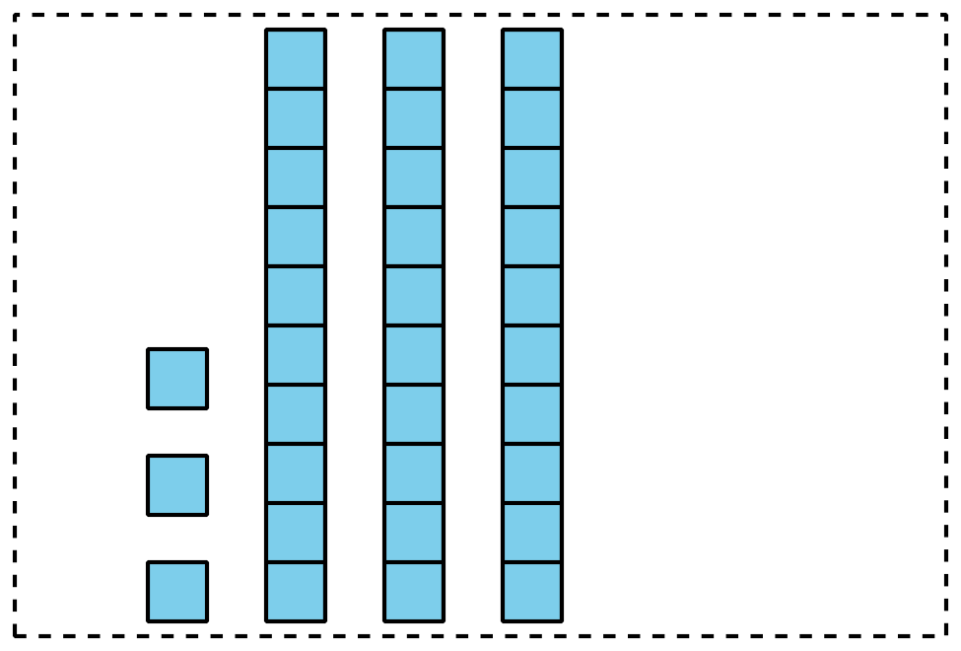
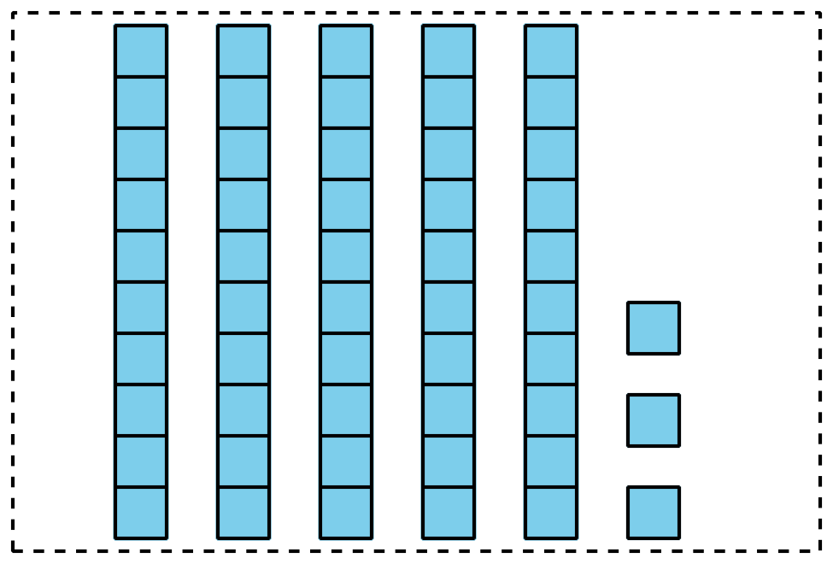
Pick a set of cards.
Put the cards in order from least to greatest.
Be ready to explain how you ordered your cards.
Write the numbers in order from least to greatest.
Set A: ______________________________________________
Set B: ______________________________________________
Set C: ______________________________________________
Set D: ______________________________________________
If you have time:
Mix two sets of cards together.
Put them in order from least to greatest.
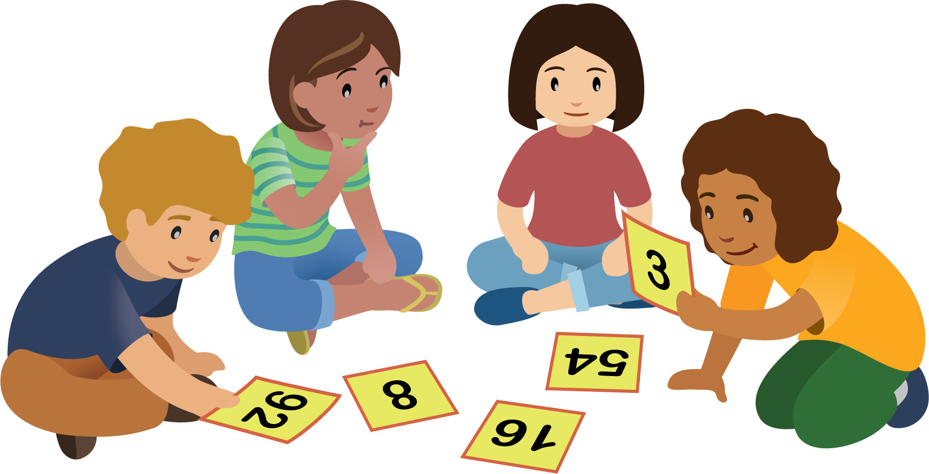

2 Order Numbers

Student Task Statement
- Here are some numbers in order:
- 1
- 5
- 10
- 50
- 99
- Add these numbers to the list:
  - 49
  - 8
  - 25
  - 98
  - 13
- Make sure all the numbers are in order from least to greatest.
- Choose 2 numbers. Explain how you knew where to place them.
  - I knew where to place aaaiaaai because
  - I knew where to place aaaiaaai because
- Write a number that makes each comparison statement true.
- 25<aaaiaaai
- 25>aaaiaaai
© CC BY 2021 Illustrative Mathematics®

