Lesson 20: The Commutative Property
- Let’s learn about the commutative property.

Warm-up: Number Talk: Subtraction
Find the value of each expression mentally.
- $70−10$
- $68−10$
- $70−12$
- $68−12$

20.1: Learn More About Multiplication
What do you notice? What do you wonder?
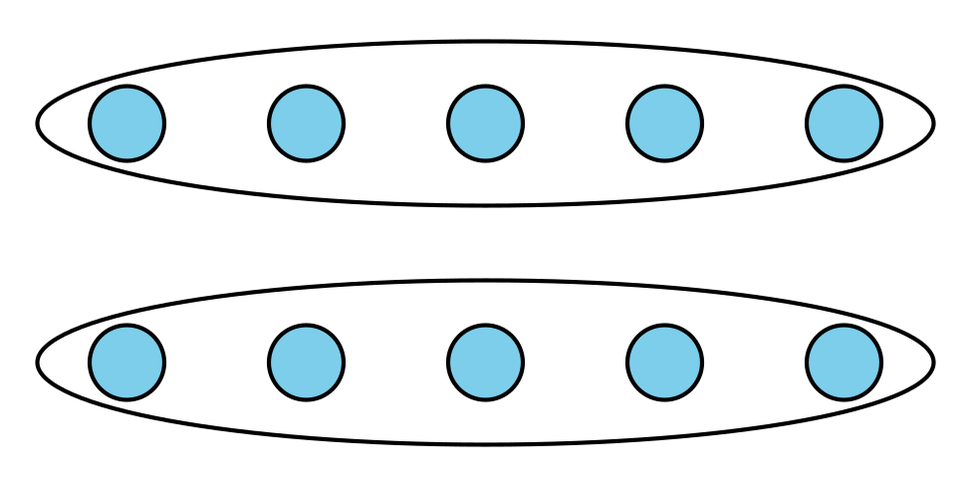
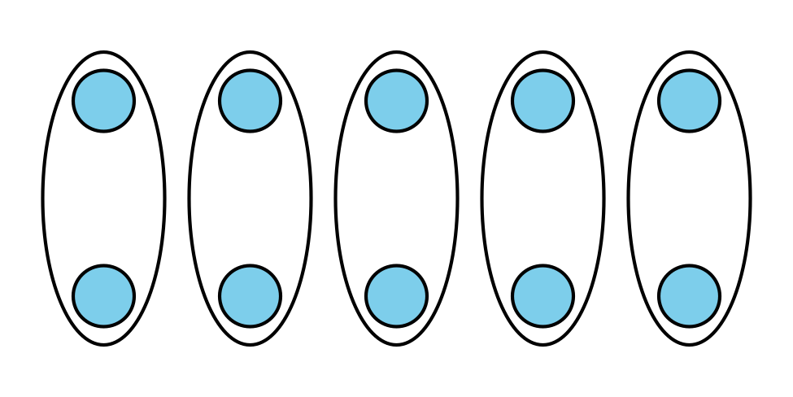
Image A
Image B

  - Write an array situation for each array.
  - Image A
  - Image B
  - How are the situations the same? How are the situations different?

  - Write an equation for each situation.
  - Image A
  - Image B
  - How does your equation connect to the situation and array?
  - Image A
  - Image B

20.2: Revisit Arrays
- Write 2 multiplication equations that represent the array.
- 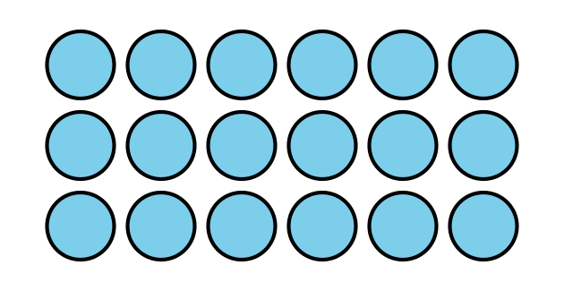
- Explain why both equations can represent the array.

Section Summary
Section Summary
In this section, we learned how equal groups are related to arrays and how to represent arrays with expressions and equations.
drawing of equal groups
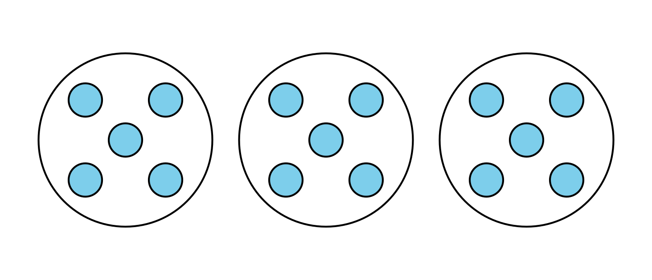
array
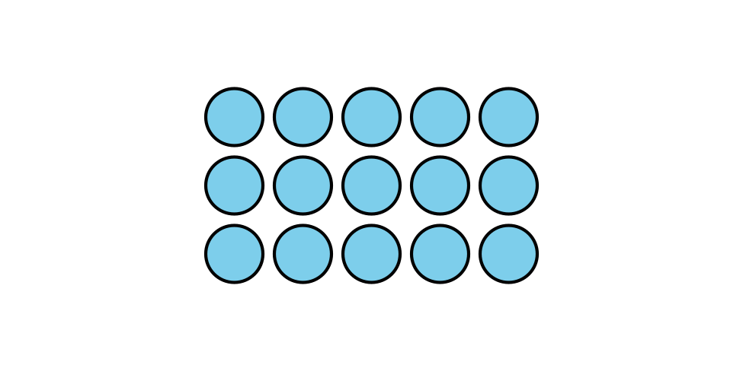
expression
$3×5$
equation
$3×5=15$
We also learned that we can multiply numbers in any order and get the same product.
$3×5=15$
$5×3=15$
$3×5=5×3$
© CC BY 2021 Illustrative Mathematics®

