Unit 6 Lesson 10: Using Algorithms with Partial Products: 2 Two-digit Numbers

WU Number Talk: Products (Warm up)

Student Task Statement
Find the value of each expression mentally.
- $30×7$
- $15×14$
- $50×8$
- $25×16$

1 Partial Products, Recorded

Student Task Statement
- Tyler used an algorithm to find the value of $64×87$.
- 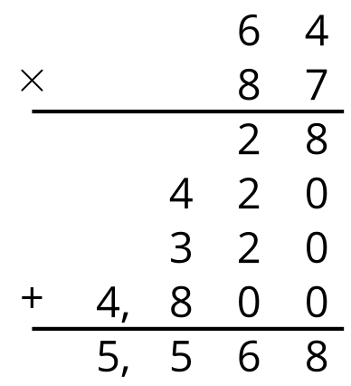
- How do you think he arrived at the last five numbers? Record your thinking. Be prepared to share it with a partner.
- Use Tyler’s method to find the value of $31×15$. Then, draw a diagram to check your answer.

Activity Synthesis
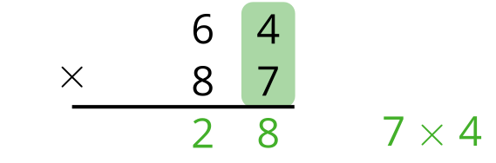
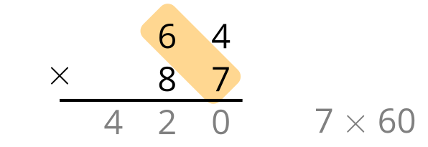
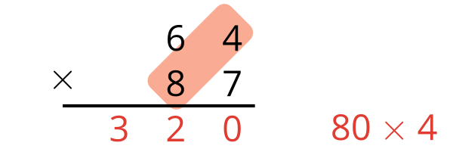
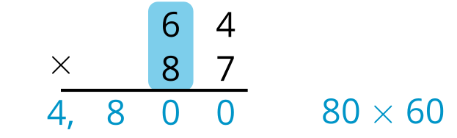
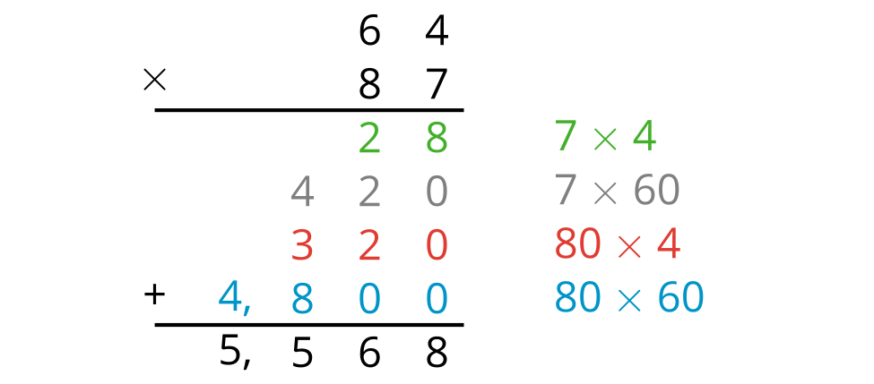
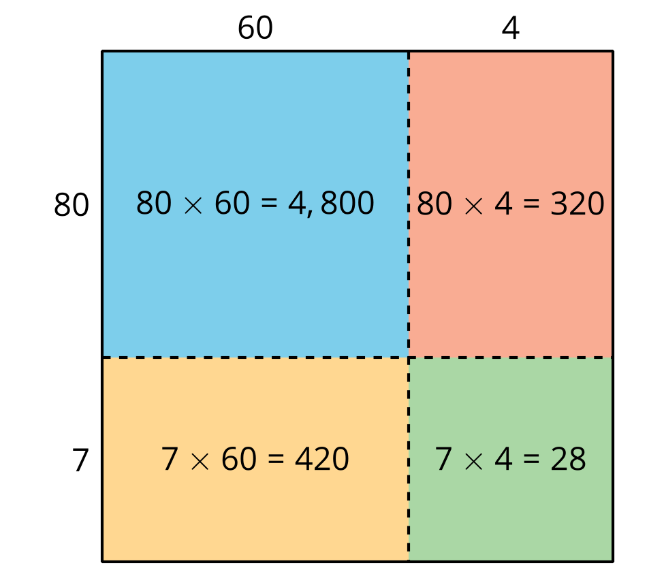

2 Han’s Multiplication Mishap

Student Task Statement
- Decide with your partner who will find each product. Show your reasoning.
- Here is Han’s computation of $51×47$.
- 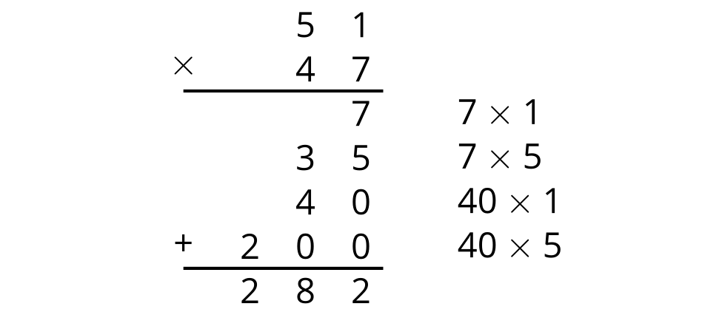
  - What error or errors did Han make?
  - Show the correct computation for finding the value of $51×47$.
© CC BY 2021 Illustrative Mathematics®

