Unit 8 Lesson 7 Cumulative Practice Problems
  - Find the lengths of the unlabeled sides.
  - 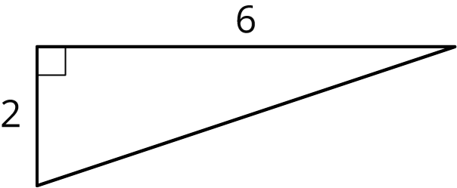
  - 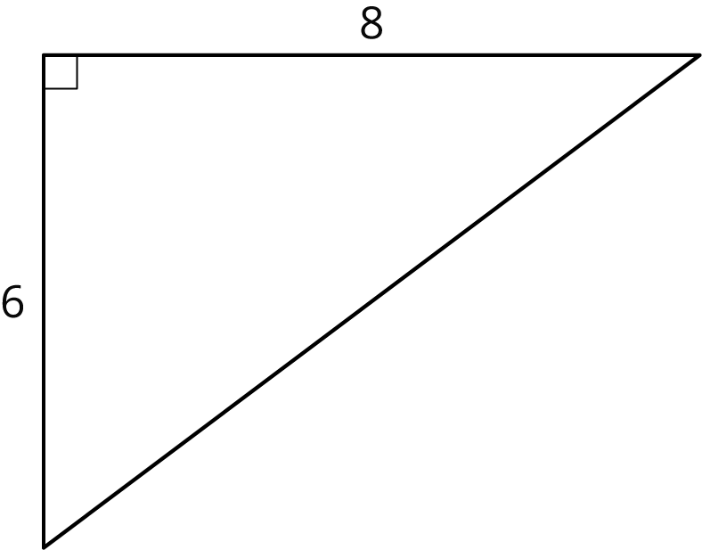
  - One segment is $n$ units long and the other is $p$ units long. Find the value of $n$ and $p$. (Each small grid square is 1 square unit.)
  - 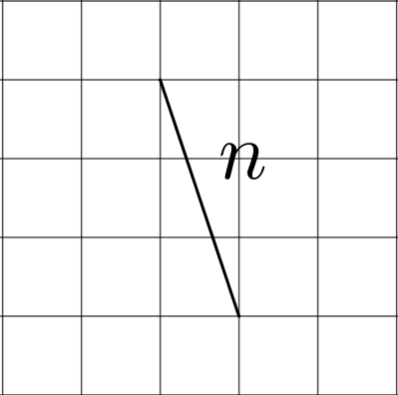
  - 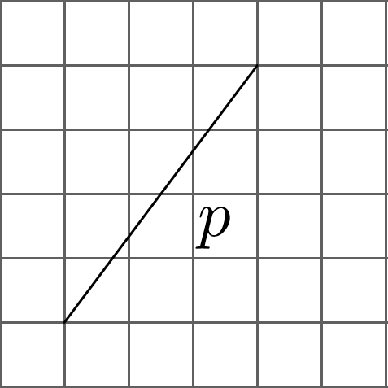
- Use the areas of the two identical squares to explain why $5^{2}+{12}^{2}={13}^{2}$ without doing any calculations.
- 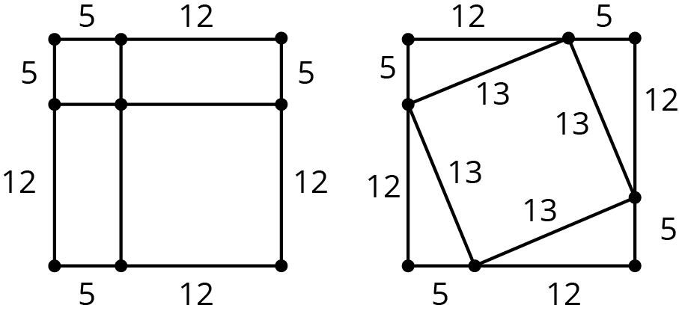

- Each number is between which two consecutive integers?
  - $\sqrt{10}$
  - $\sqrt{54}$
  - $\sqrt{18}$
  - $\sqrt{99}$
  - $\sqrt{41}$
- (From Unit 8, Lesson 5.)
  - Give an example of a rational number, and explain how you know it is rational.
  - Give three examples of irrational numbers.
- (From Unit 8, Lesson 3.)
- Write each expression as a single power of 10.
  - ${10}^{5}⋅{10}^{0}$
  - $\frac{{10}^{9}}{{10}^{0}}$
- (From Unit 7, Lesson 4.)
- Andre is ordering ribbon to make decorations for a school event. He needs a total of exactly 50.25 meters of blue and green ribbon. Andre needs 50% more blue ribbon than green ribbon for the basic design, plus an extra 6.5 meters of blue ribbon for accents. How much of each color of ribbon does Andre need to order?
- (From Unit 4, Lesson 15.)
© CC BY Open Up Resources. Adaptations CC BY IM.

