Unit 2 Lesson 2: Count and Arrange

WU Choral Count: Fingers and Numbers (Warm up)

Student Task Statement

1 Count, Rearrange, Count

Student Task Statement

Activity Synthesis
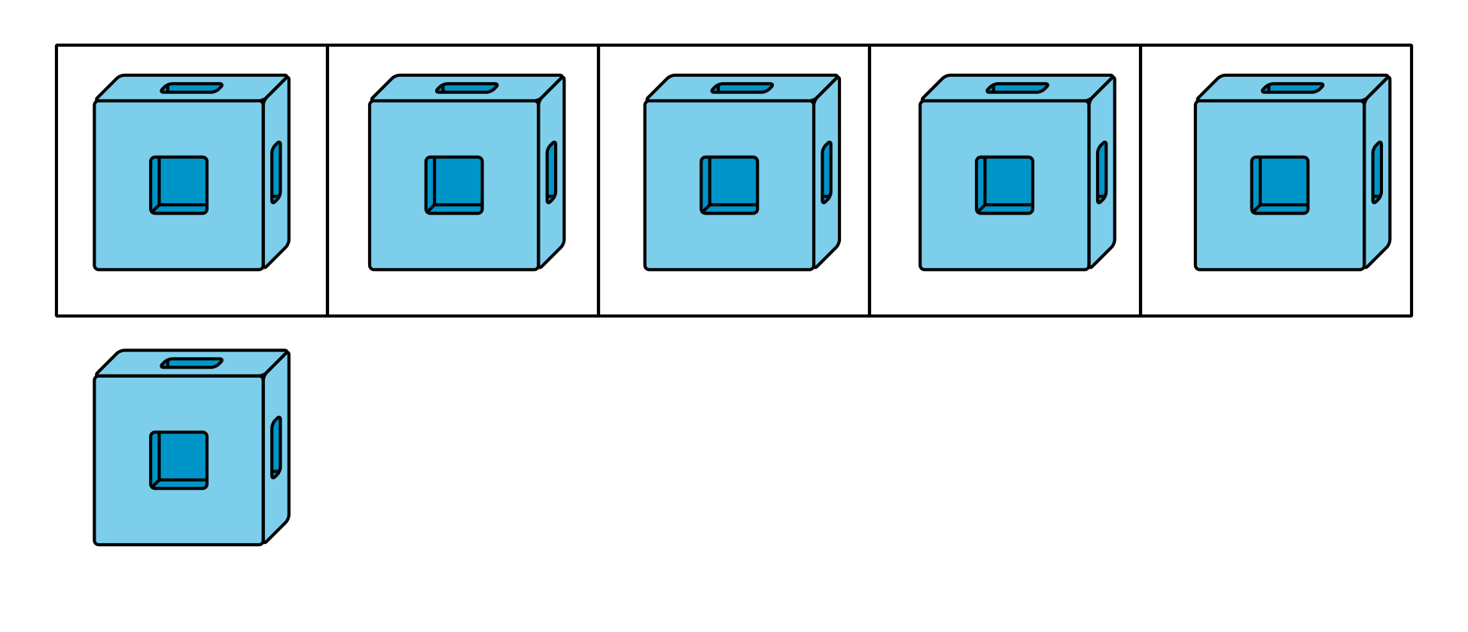

2 Introduce Shake and Spill, Count

Student Task Statement

3 Centers: Choice Time

Student Task Statement
Choose a center.
Shake and Spill
Math Fingers
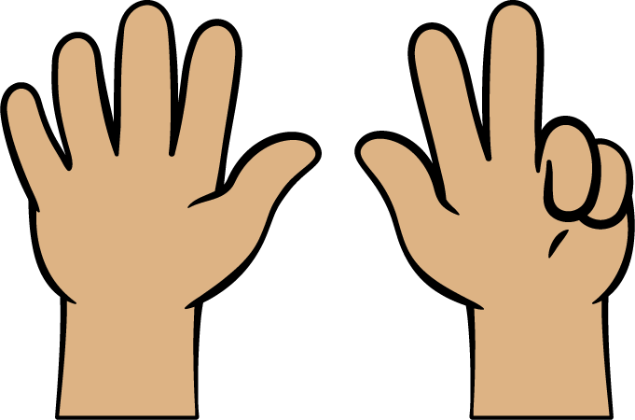
Pattern Blocks
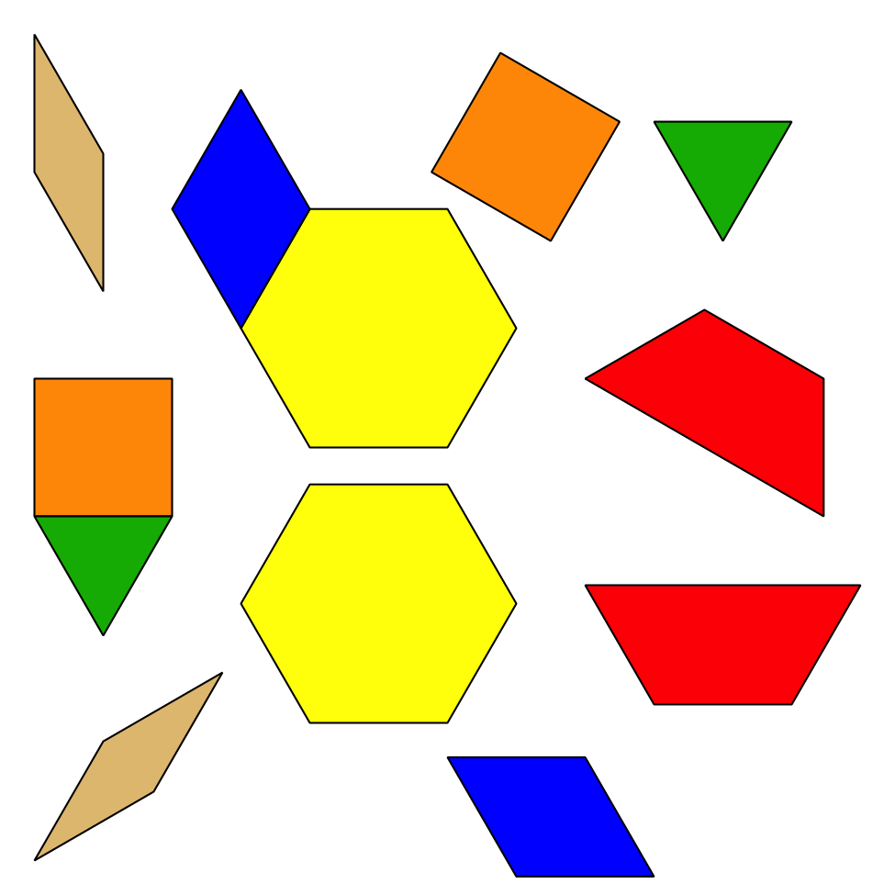
Picture Books
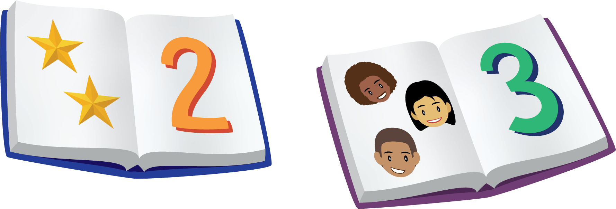

Images for Activity Synthesis
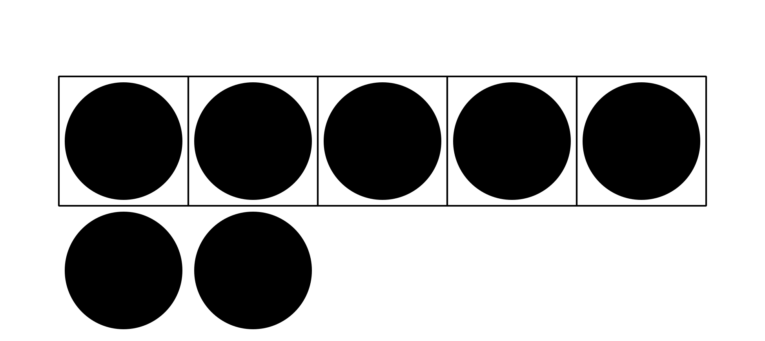
© CC BY 2021 Illustrative Mathematics®

