Unit 5 Lesson 7: Using Negative Exponents

1 Exponent Rules (Warm up)

Student Task Statement
How would you rewrite each of the following as an equivalent expression with a single exponent?
- $2^{4}⋅2^{0}$
- $2^{4}⋅2^{\text{-}1}$
- $2^{4}⋅2^{\text{-}3}$
- $2^{4}⋅2^{\text{-}4}$

2 Coral in the Sea

Student Task Statement
A marine biologist estimates that a structure of coral has a volume of 1,200 cubic centimeters and that its volume doubles each year.
- Write an equation of the form $y=a⋅b^{t}$ representing the relationship, where $t$ is time in years since the coral was measured and $y$ is volume of coral in cubic centimeters. (You need to figure out what numbers $a$ and $b$ are in this situation.)
- Find the volume of the coral when $t$ is 5, 1, 0, -1, and -2.
- What does it mean, in this situation, when $t$ is -2?
- In a certain year, the volume of the coral is 37.5 cubic centimeters. Which year is this? Explain your reasoning.

3 Windows of Graphs (Optional)

Student Task Statement
The volume, $y$, of coral in cubic centimeters is modeled by the equation $y=1,​200⋅2^{x}$ where $x$ is the number of years since the coral was measured. Three students used graphing technology to graph the equation that represents the volume of coral as a function of time.

A
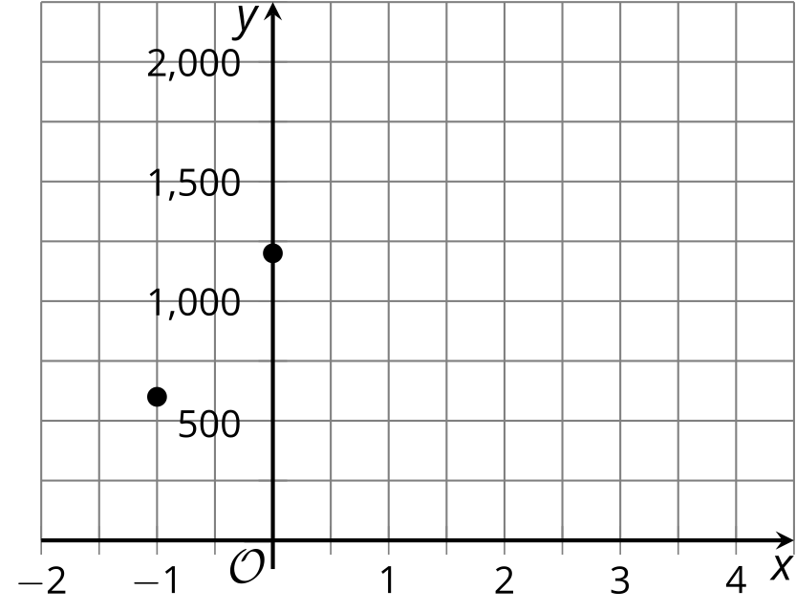

B
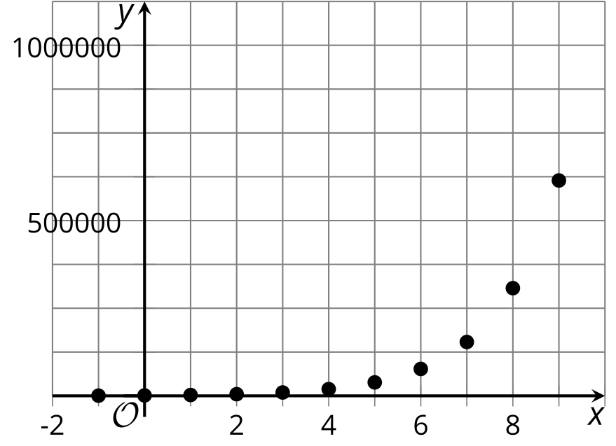

C
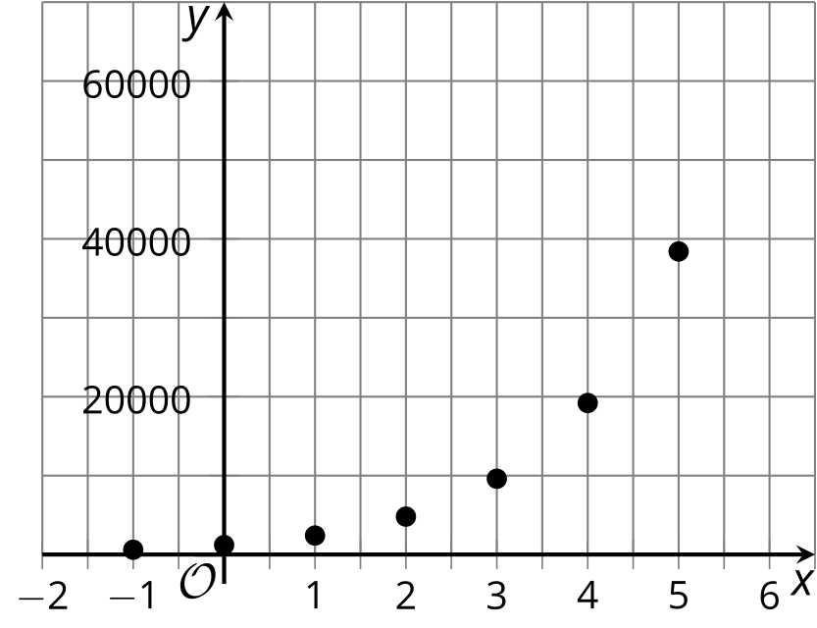
For each graph:
- Describe how well each graphing window does, or does not, show the behavior of the function.
- For each graphing window you think does not show the behavior of the function well, describe how you would change it.
- Make the change(s) you suggested, and sketch the revised graph using graphing technology.

4 Measuring Meds

Student Task Statement
A person took some medicine but does not remember how much. Concerned that she took too much, she has a blood test every hour for several hours.

  - Time $t$ is measured in hours since the first blood test and amount of medicine in her body, $m$, is measured in milligrams. What is the growth factor? That is, what is $b$ in an equation of the form $m=a⋅b^{t}$ ? What is $a$?
  - Find the amounts of medicine in the patient’s body when $t$ is -1 and -3. Record them in the table.
- $t$, time (hours) | - $m$, medicine (mg)
- 0 | - 100
- 1 | - 50
- 2 | - 25
- What do $t=0$ and $t=\text{-}3$ mean in this context?
- The medicine was taken when $t$ is -5. Assuming the person did not have any of the medication in her body beforehand, how much medicine did the patient take?
- Plot the points whose coordinates are shown in the table. Make sure to draw and label tick marks on the axes.
- 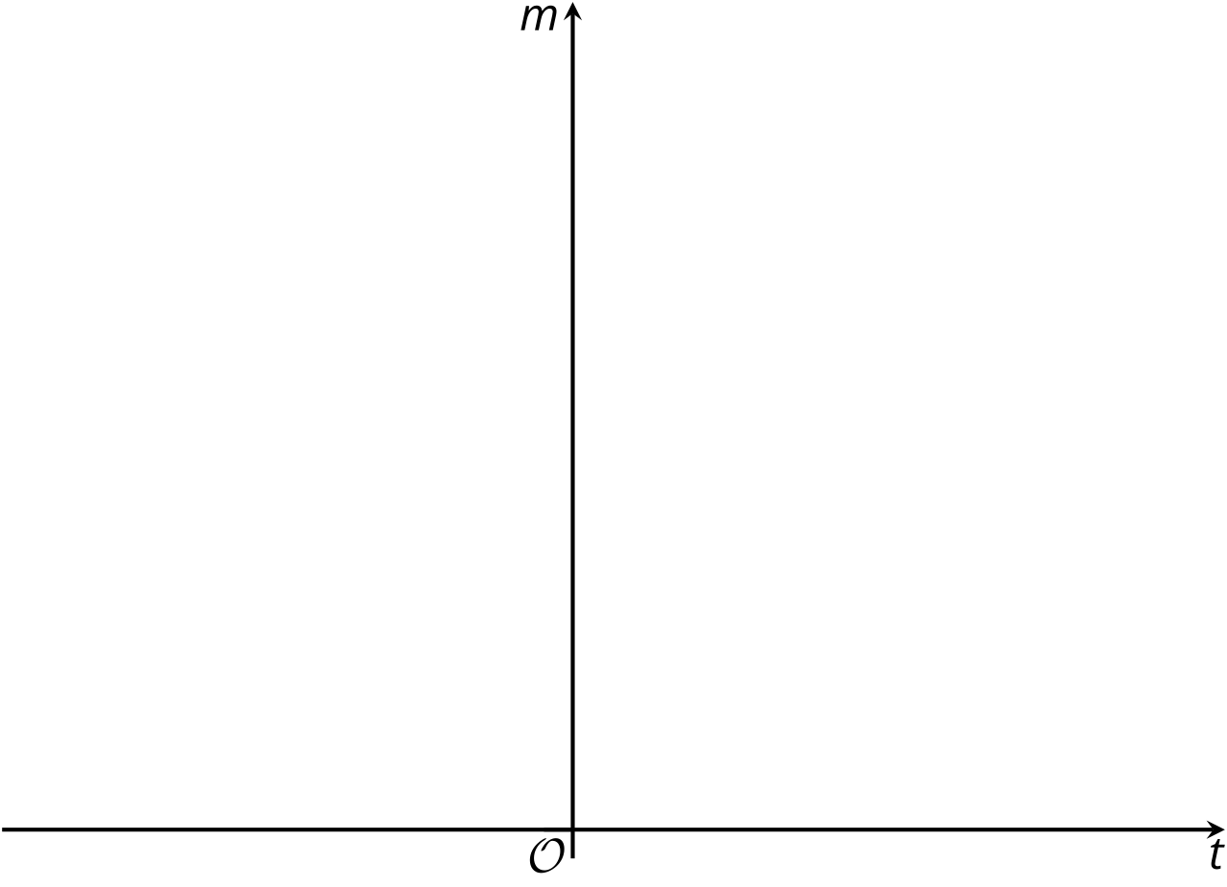
- Based on your graph, when do you think the patient will have:
  - 500 mg of medicine remaining in the body
  - no medicine remaining in the body

Activity Synthesis
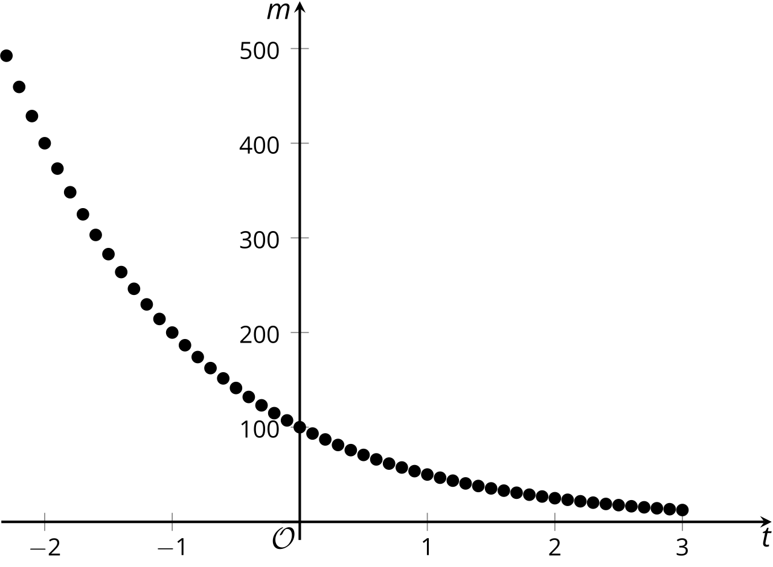
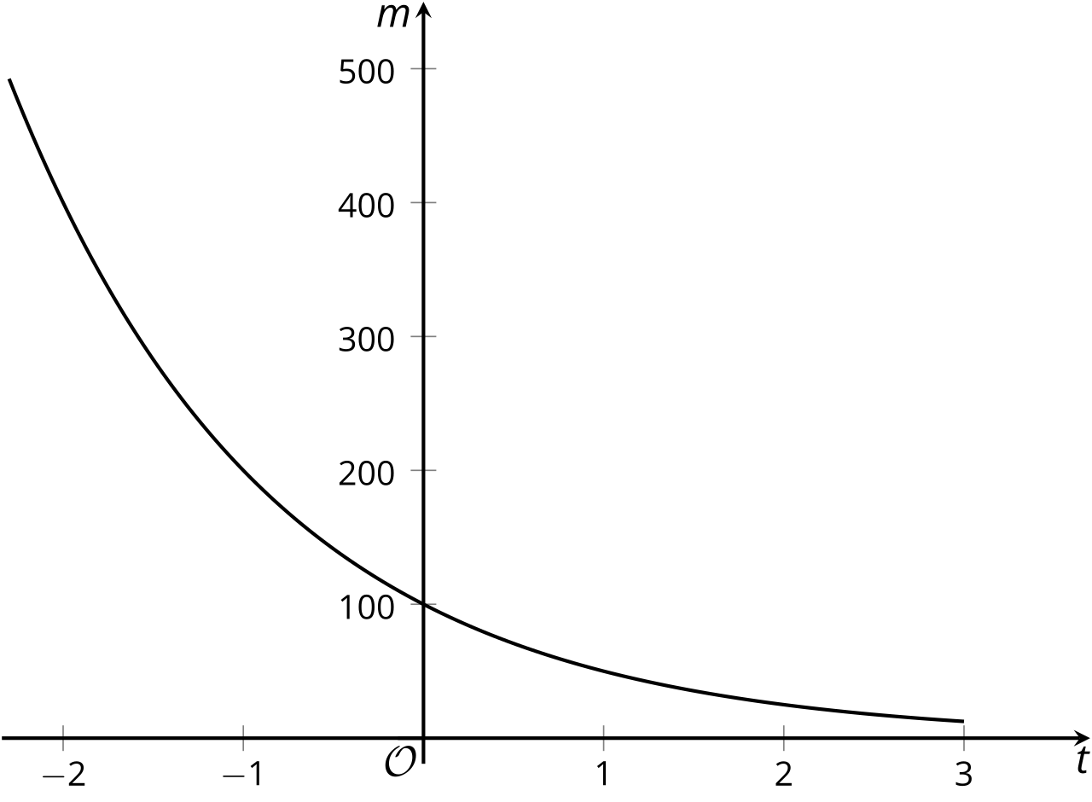
© CC BY 2019 by Illustrative Mathematics®

