Unit 4 Lesson 1 Cumulative Practice Problems
- Tyler reads $\frac{2}{15}$ of a book on Monday, $\frac{1}{3}$ of it on Tuesday, $\frac{2}{9}$ of it on Wednesday, and $\frac{3}{4}$ of the remainder on Thursday. If he still has 14 pages left to read on Friday, how many pages are there in the book?

- Clare asks Andre to play the following number puzzle:
  - Pick a number
  - Add 2
  - Multiply by 3
  - Subtract 7
  - Add your original number
- Andre’s final result is 27.
Which number did he start with?
- In a basketball game, Elena scores twice as many points as Tyler. Tyler scores four points fewer than Noah, and Noah scores three times as many points as Mai. If Mai scores 5 points, how many points did Elena score? Explain your reasoning.

- Select all of the given points in the coordinate plane that lie on the graph of the linear equation $4x−y=3$.
  - $(\text{-}1,\text{-}7)$
  - $(0,3)$
  - $(\frac{3}{4},0)$
  - $(1,1)$
  - $(2,5)$
  - $(4,\text{-}1)$
- (From Unit 3, Lesson 12.)
- A store is designing the space for rows of nested shopping carts. Each row has a starting cart that is 4 feet long, followed by the nested carts (so 0 nested carts means there's just the starting cart). The store measured a row of 13 nested carts to be 23.5 feet long, and a row of 18 nested carts to be 31 feet long.
  - Create a graph of the situation.
  - How much does each nested cart add to the length of the row? Explain your reasoning.
  - If the store design allows for 43 feet for each row, how many total carts fit in a row?
- (From Unit 3, Lesson 5.)
- Triangle $A$ is an isosceles triangle with two angles of measure $x$ degrees and one angle of measure $y$ degrees.
  - Find three combinations of $x$ and $y$ that make this sentence true.
  - Write an equation relating $x$ and $y$.
  - If you were to sketch the graph of this linear equation, what would its slope be? How can you interpret the slope in the context of the triangle?
- (From Unit 3, Lesson 13.)
- Consider the following graphs of linear equations. Decide which line has a positive slope, and which has a negative slope. Then calculate each line’s exact slope.
- 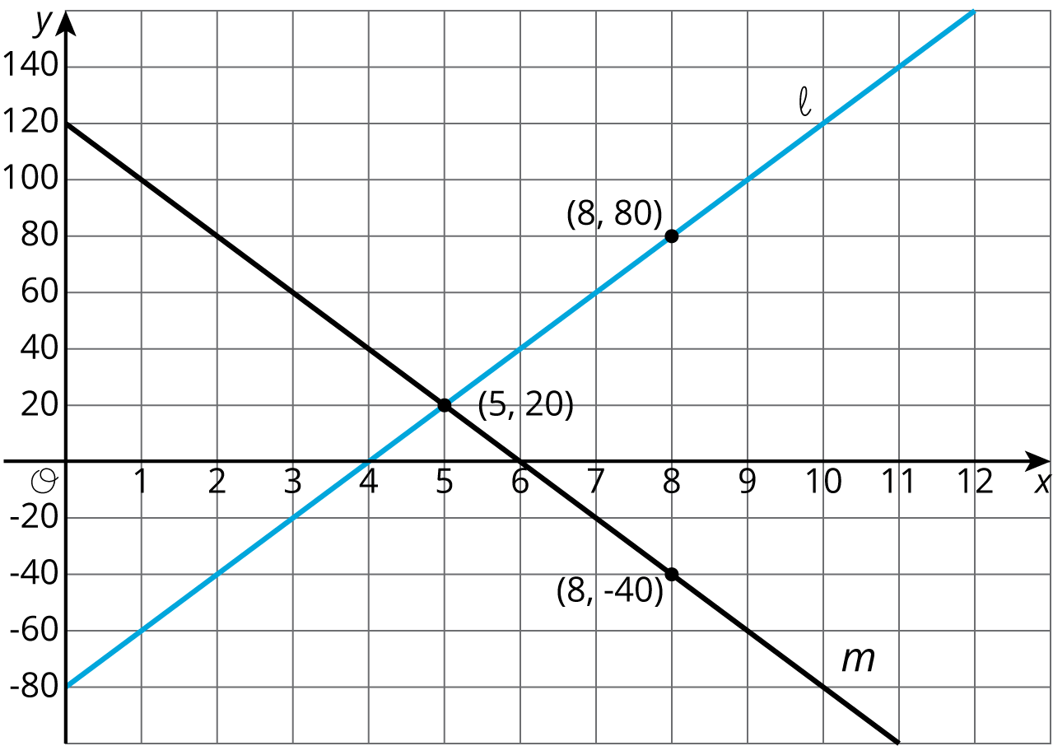
- (From Unit 3, Lesson 10.)
© CC BY Open Up Resources. Adaptations CC BY IM.

