Lesson 3: Interpreting Division Situations
Let’s explore situations that involve division.

3.1: Dot Image: Properties of Multiplication
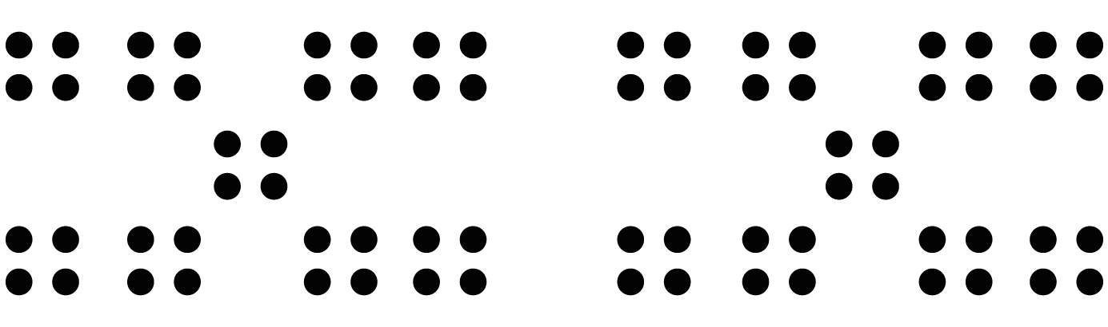

3.2: Homemade Jams
Draw a diagram, and write a multiplication equation to represent each situation. Then answer the question.
- Mai had 4 jars. In each jar, she put $2\frac{1}{4}$ cups of homemade blueberry jam. Altogether, how many cups of jam are in the jars?
- Priya filled 5 jars, using a total of $7\frac{1}{2}$ cups of strawberry jam. How many cups of jam are in each jar?
- Han had some jars. He put $\frac{3}{4}$ cup of grape jam in each jar, using a total of $6\frac{3}{4}$ cups. How many jars did he fill?

3.3: Making Granola
- Consider the problem: To make 1 batch of granola, Kiran needs 26 ounces of oats. The only measuring tool he has is a 4-ounce scoop. How many scoops will it take to measure 26 ounces of oats?
  - Will the answer be more than 1 or less than 1?
  - Write a multiplication equation and a division equation that represent this situation. Use “?” to represent the unknown quantity.
  - Find the unknown quantity. If you get stuck, consider drawing a diagram.
- The recipe calls for 14 ounces of mixed nuts. To get that amount, Kiran uses 4 bags of mixed nuts.
  - Write a mathematical question that might be asked about this situation.
  - What might the equation $14÷4= ?$ represent in Kiran’s situation?
  - Find the quotient. Show your reasoning. If you get stuck, consider drawing a diagram.

Lesson 3 Summary
If a situation involves equal-sized groups, it is helpful to make sense of it in terms of the number of groups, the size of each group, and the total amount. Here are three examples to help us better understand such situations.
- Suppose we have 3 bottles with $6\frac{1}{2}$ ounces of water in each, and the total amount of water is not given. Here we have 3 groups, $6\frac{1}{2}$ ounces in each group, and an unknown total, as shown in this diagram:
- 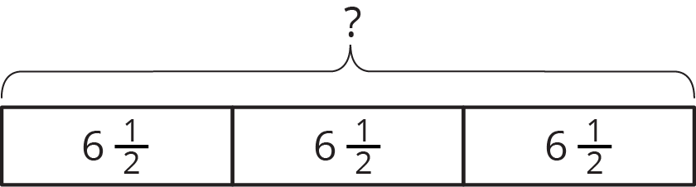
- We can express this situation as a multiplication problem. The unknown is the product, so we can simply multiply the 2 known numbers to find it. $3⋅6\frac{1}{2}=?$
- Next, suppose we have 20 ounces of water to fill 6 equal-sized bottles, and the amount in each bottle is not given. Here we have 6 groups, an unknown amount in each, and a total of 20. We can represent it like this:
- 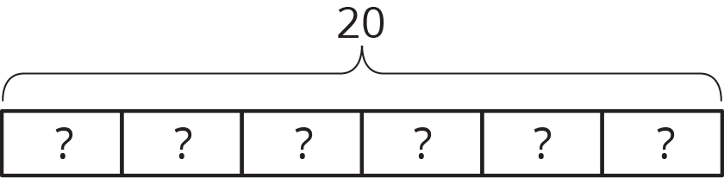
- This situation can also be expressed using multiplication, but the unknown is a factor, rather than the product: $6 ⋅?=20$
- To find the unknown, we cannot simply multiply, but we can think of it as a division problem: $20÷6= ?$
- Now, suppose we have 40 ounces of water to pour into bottles, 12 ounces in each bottle, but the number of bottles is not given. Here we have an unknown number of groups, 12 in each group, and a total of 40.
- 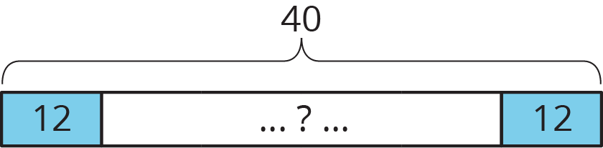
- Again, we can think of this in terms of multiplication, with a different factor being the unknown: $?⋅12=40$
- Likewise, we can use division to find the unknown: $40÷12= ?$
Whenever we have a multiplication situation, one factor tells us how many groups there are, and the other factor tells us how much is in each group.
Sometimes we want to find the total. Sometimes we want to find how many groups there are. Sometimes we want to find how much is in each group. Anytime we want to find out how many groups there are or how much is in each group, we can represent the situation using division.
© CC BY Open Up Resources. Adaptations CC BY IM.

