Lesson 23: Divide Whole Numbers by Decimals
- Let’s divide whole numbers by decimals.

Warm-up: True or False: Tenths and Hundredths
Decide if each statement is true or false. Be prepared to explain your reasoning.
- $6÷0.01=60$
- $6÷0.1<6÷0.01$
- $6÷0.01=60÷0.1$

23.1: Same Divisor, Different Dividend
- Find the value of each expression. Explain or show your reasoning.
  - $1÷0.2$
  - $2÷0.2$
  - $3÷0.2$
  - $4÷0.2$
- Find the value of each expression. Explain or show your reasoning.
  - $1÷0.02$
  - $2÷0.02$
  - $3÷0.02$
  - $4÷0.02$
- What patterns do you notice?

23.2: Evaluate Expressions
- Find the value of the expression. Use a diagram if it is helpful.
- $12÷0.2$
- 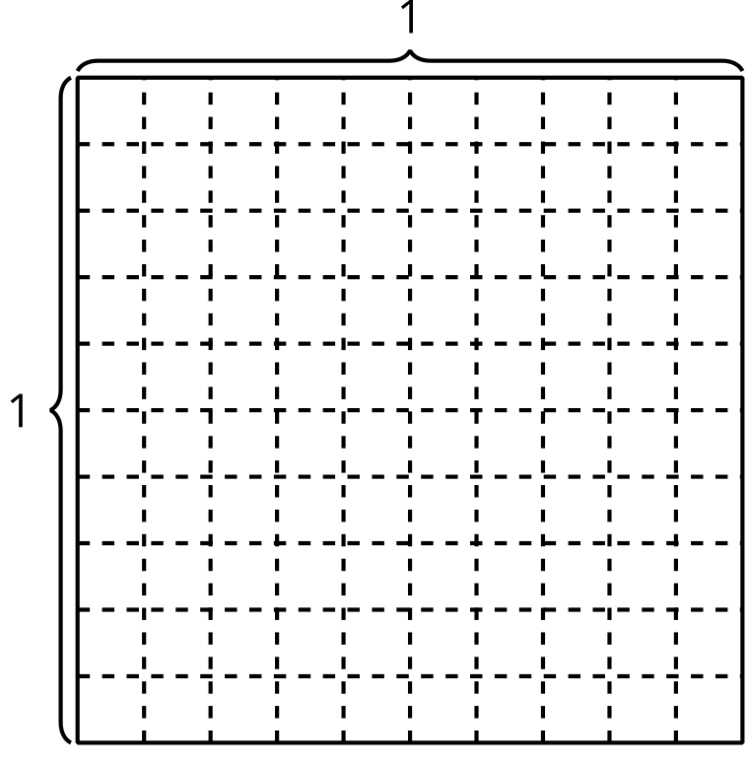
- This is the diagram and explanation Tyler used to justify why $12÷0.2=60$.
- 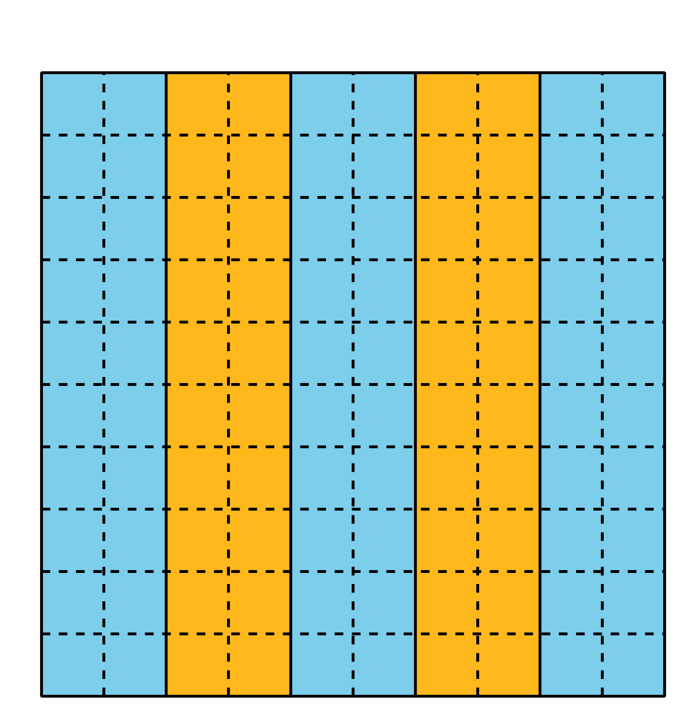
- 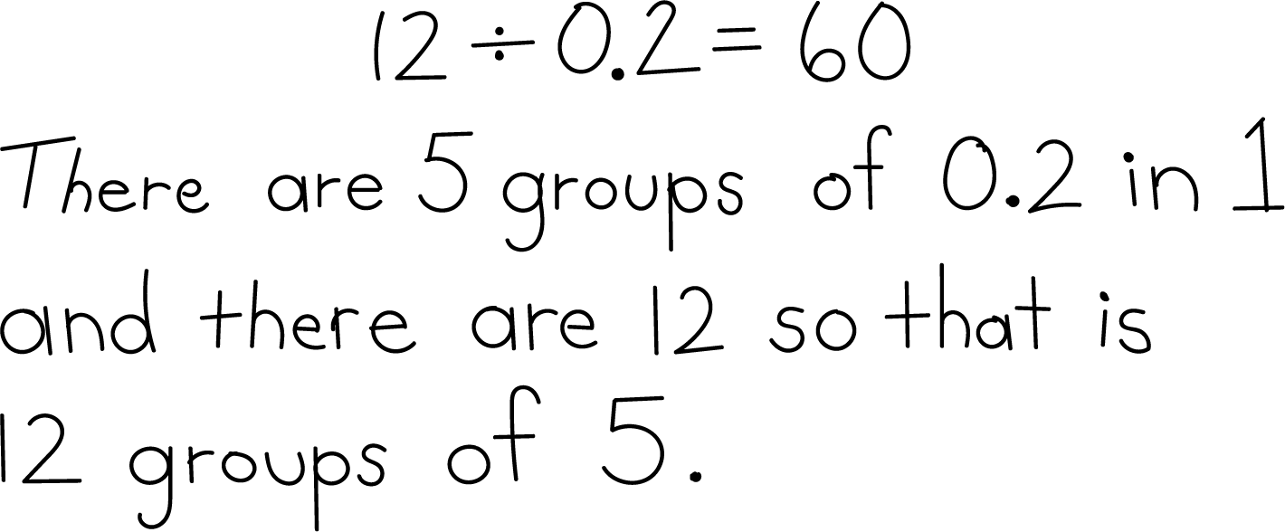
- Explain how the expression $12×\left(1÷0.2\right)$ relates to Tyler's reasoning.
- Find the value of each expression.
  - $14÷0.5$
  - $5÷0.25$
© CC BY 2021 Illustrative Mathematics®

