Unit 7 Lesson 11: Patterns and Ordered Pairs

WU Notice and Wonder: The Coordinate Grid (Warm up)

Student Task Statement
What do you notice? What do you wonder?
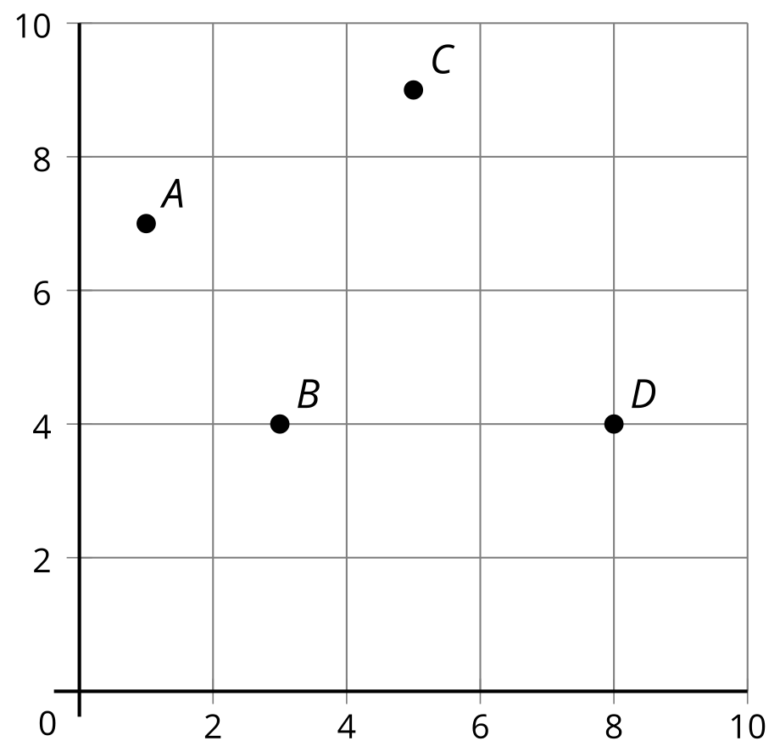

1 Patterns on the Coordinate Grid, Part 1

Student Task Statement
Partner A
Rule 1: Start at 0. Keep adding 8.
Rule 2: Start at 0. Keep adding 2.
- Use the rules to complete the table.
 | - A | - B | - C | - D | - E | - F
- rule 1
- rule 2
- Which table column represents the point on the coordinate grid? Label the point with the appropriate letter.
- 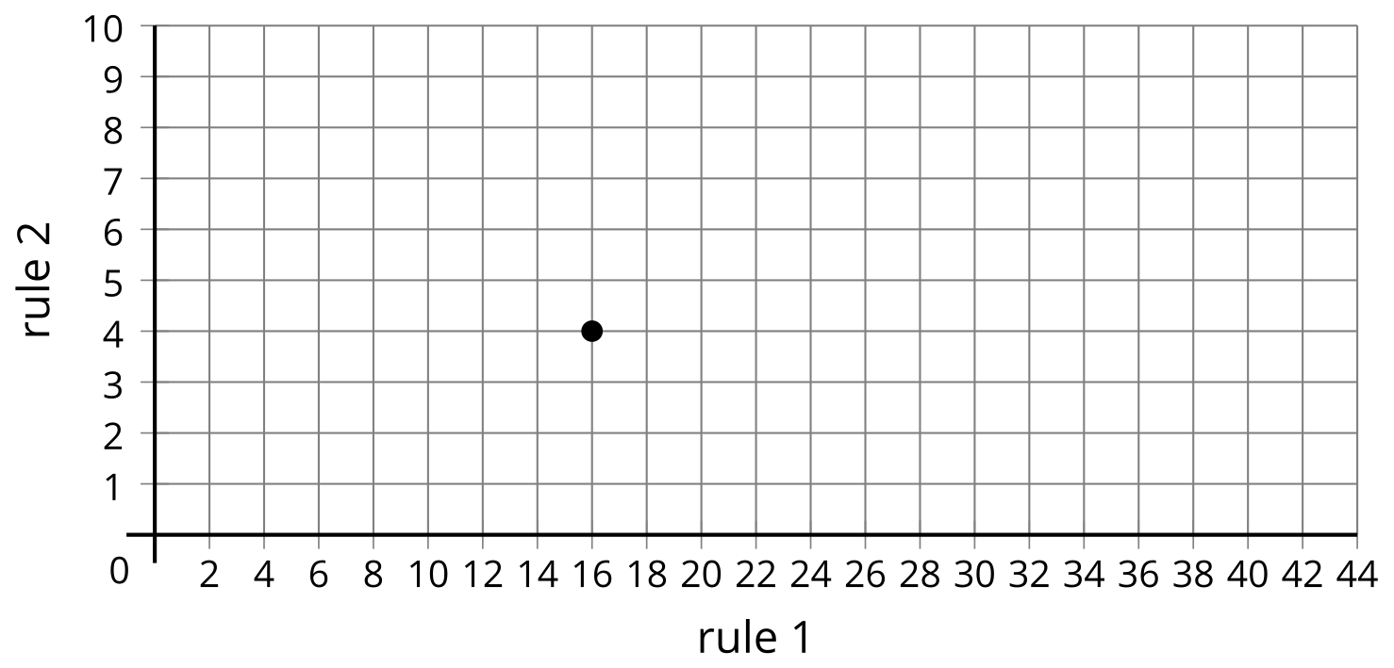
- Plot and label the rest of the points.
Partner B
Rule 1: Start at 0. Keep adding 10.
Rule 2: Start at 0. Keep adding 40.
- Use the rules to complete the table.
 | - A | - B | - C | - D | - E | - F
- rule 1
- rule 2
- Which table column represents the point on the coordinate grid? Label the point with the appropriate letter.
- 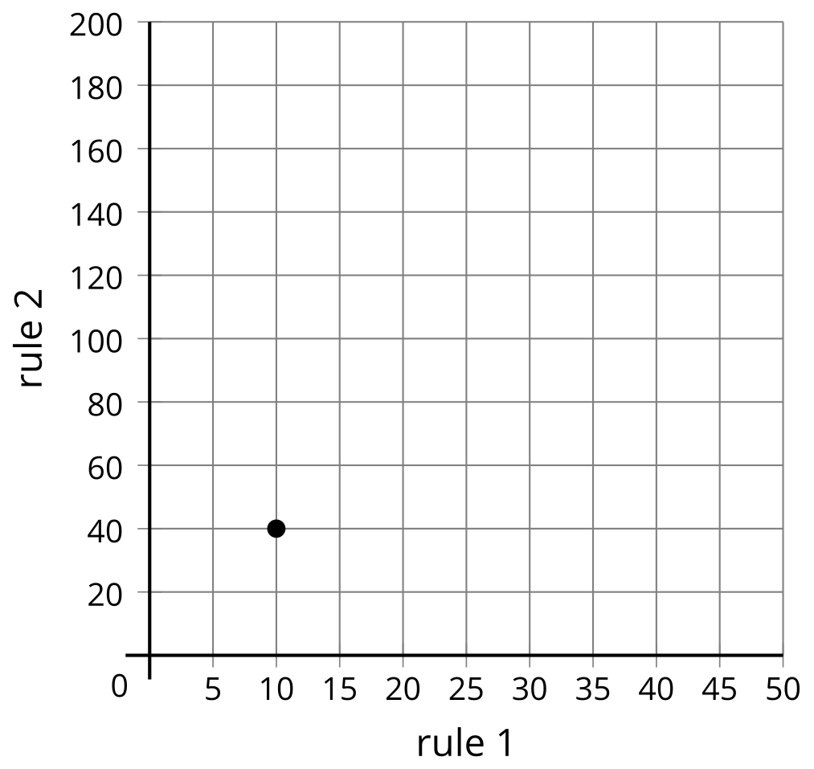
- Plot and label the rest of the points.

2 Patterns on the Coordinate Grid, Part 2

Student Task Statement
- Use the rules to complete the table.
  - Rule 1: Start with 0. Add 2.
  - Rule 2: Start with 0. Add 5.
 | - A | - B | - C | - D | - E | - F
- Rule 1
- Rule 2
- What patterns do you notice between the corresponding terms of the two patterns?
- Plot and label the points from the table.
- 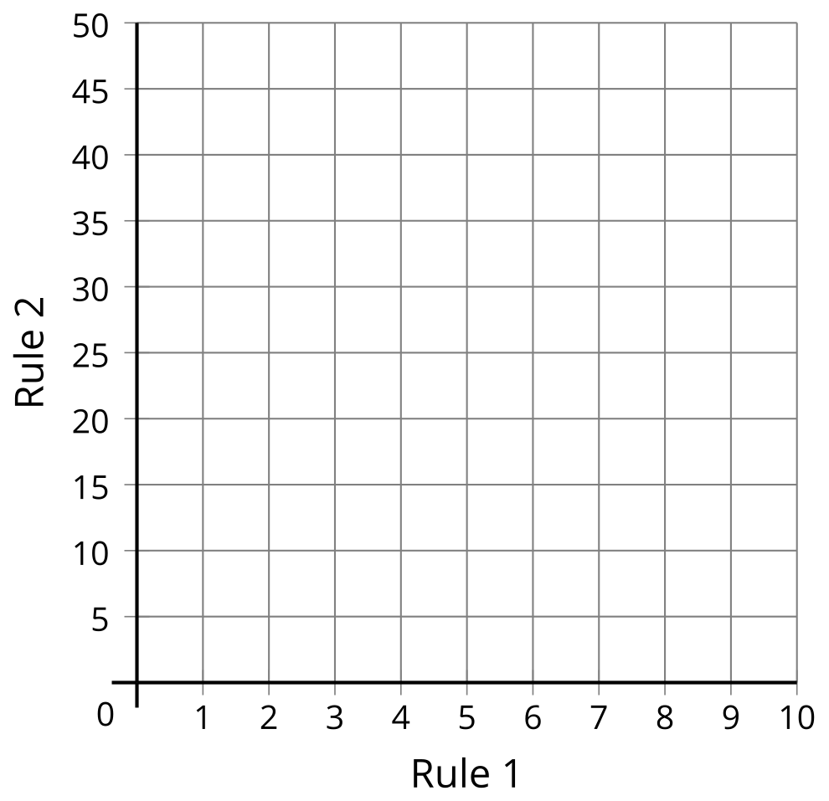
- What does the point $C$ tell you about Rule 1 and Rule 2?
© CC BY 2021 Illustrative Mathematics®

