Lesson 18: Tell Story Problems for Expressions
- Let’s tell story problems to match expressions.

18.1: Tell a Story Problem to Match an Expression

18.2: Story Problem and Expression Gallery Walk
$\underset{_}{}+\underset{_}{}$
$\underset{_}{}−\underset{_}{}$
$\underset{_}{}+\underset{_}{}$
$\underset{_}{}−\underset{_}{}$
$\underset{_}{}+\underset{_}{}$
$\underset{_}{}−\underset{_}{}$
$\underset{_}{}+\underset{_}{}$
$\underset{_}{}−\underset{_}{}$
$\underset{_}{}+\underset{_}{}$
$\underset{_}{}−\underset{_}{}$
$\underset{_}{}+\underset{_}{}$
$\underset{_}{}−\underset{_}{}$

18.3: Centers: Choice Time
Choose a center.
Find the Value of
Expressions
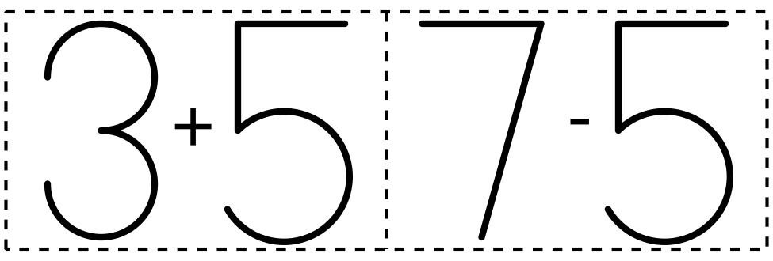
​​​​​​
Roll and Add
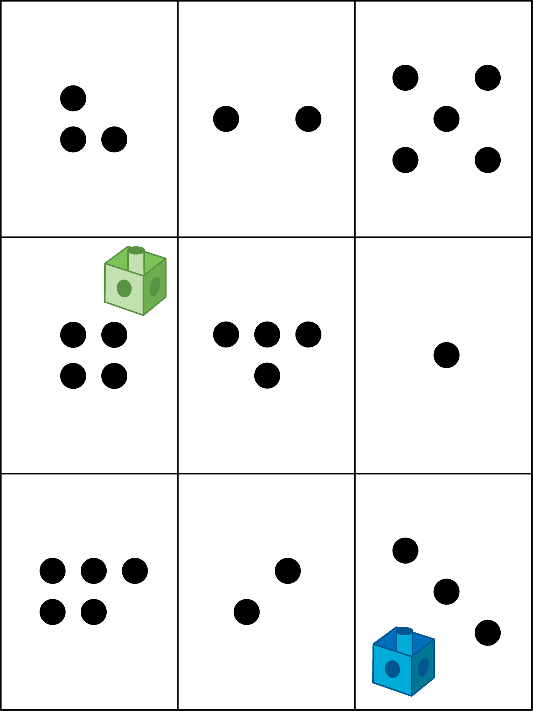
Shake and Spill
Math Stories
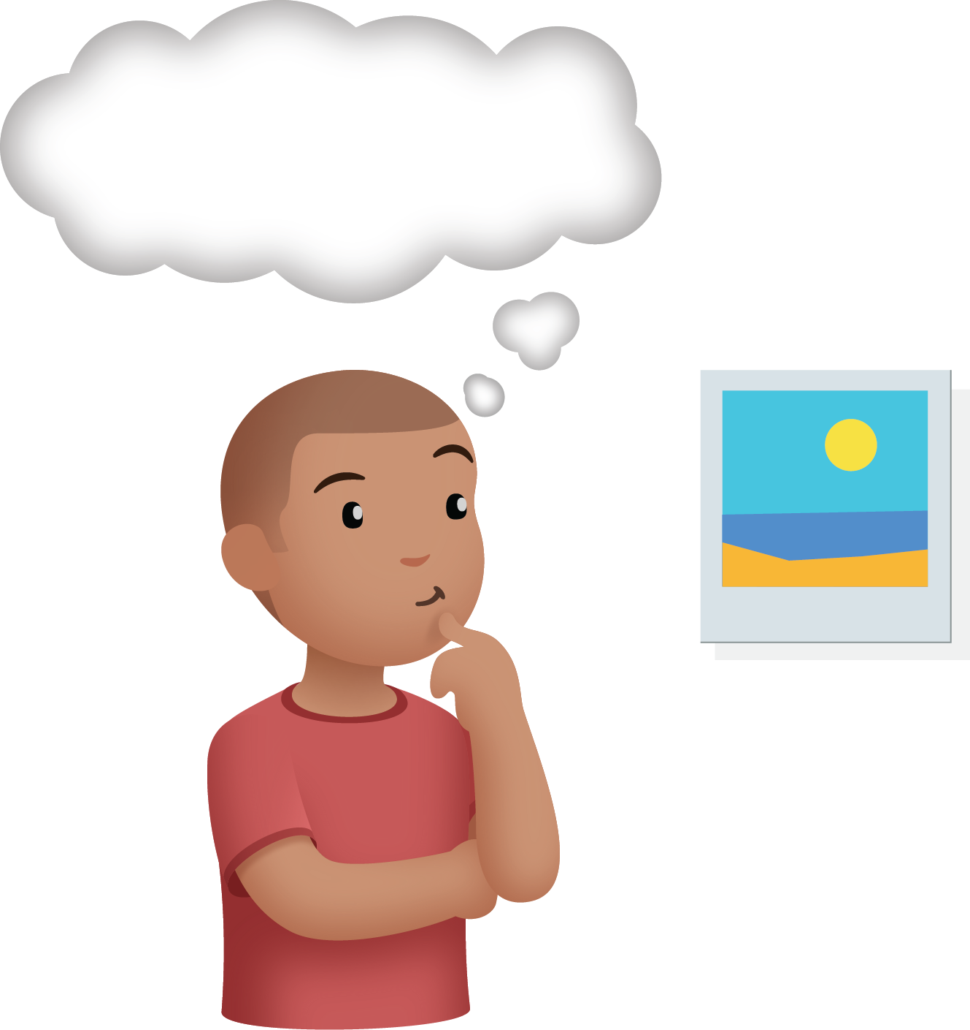
Number Race
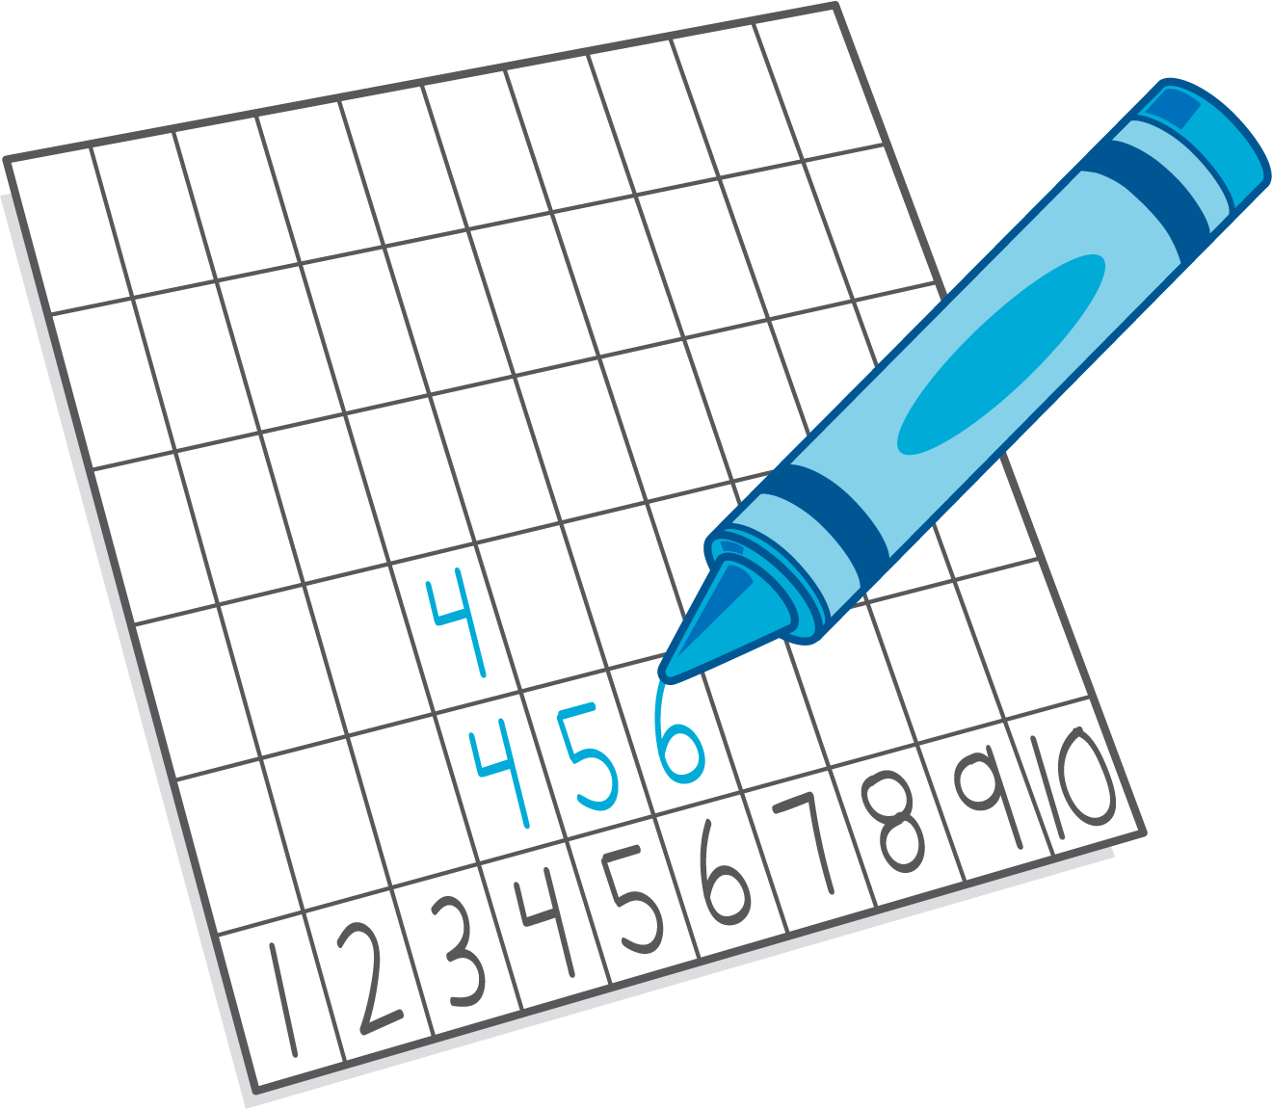
© CC BY 2021 Illustrative Mathematics®

