## Unit 2 Lesson 10: Meet Slope

### 1 Equal Quotients (Warm up)

#### Student Task Statement

Write some numbers that are equal to .

### 2 Similar Triangles on the Same Line

#### Student Task Statement

1. The figure shows three right triangles, each with its longest side on the same line. Your teacher will assign you two triangles. Explain why the two triangles are similar.

* 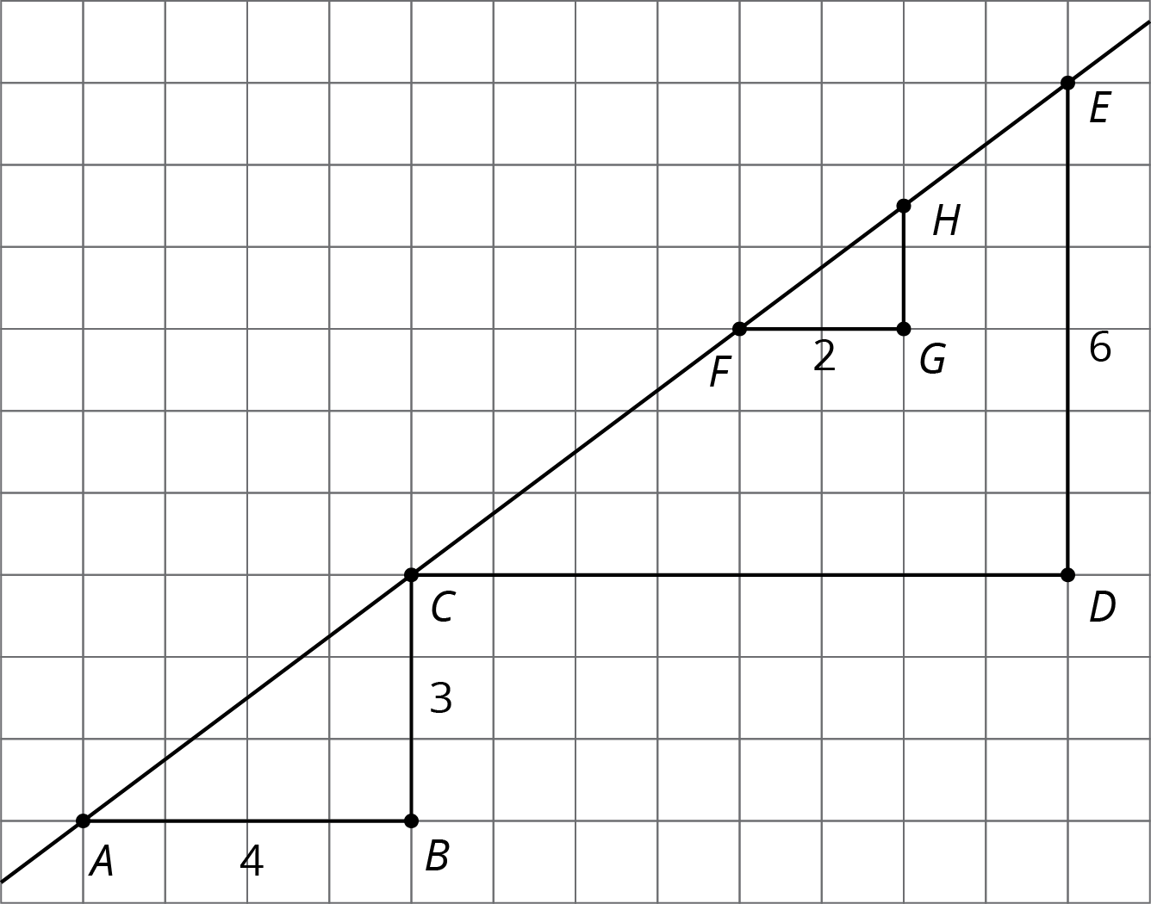

1. Complete the table.

|  |  |  |  |
| --- | --- | --- | --- |
| * triangle | * length of vertical side | * length of horizontal side | * (vertical side) (horizontal side) |
|  |  |  |  |
|  |  |  |  |
|  |  |  |  |

#### Activity Synthesis

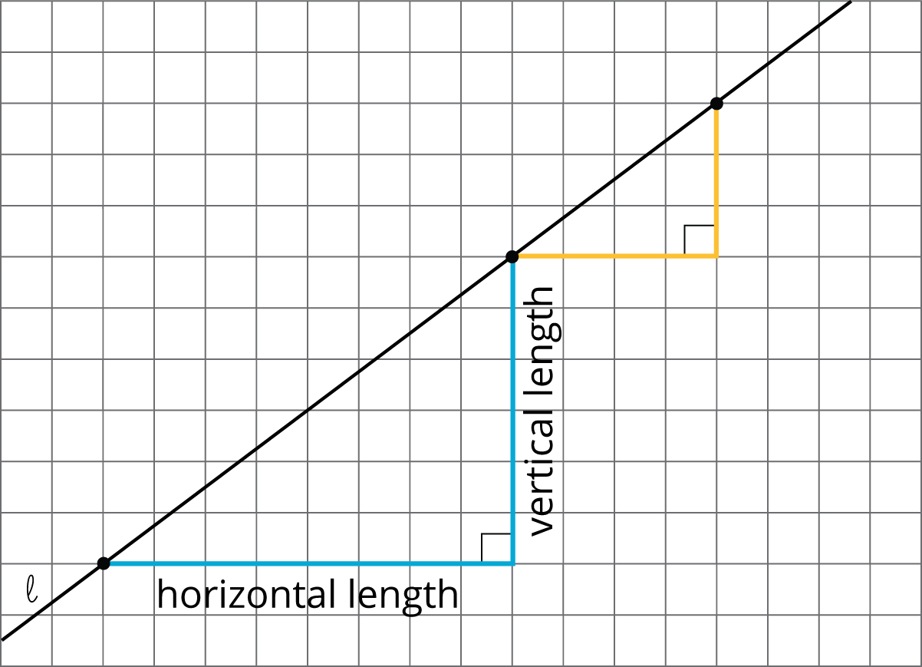

### 3 Multiple Lines with the Same Slope

#### Student Task Statement

1. Draw two lines with slope 3. What do you notice about the two lines?
2. Draw two lines with slope . What do you notice about the two lines?



### 4 Different Slopes of Different Lines (Optional)

#### Student Task Statement

Here are several lines.

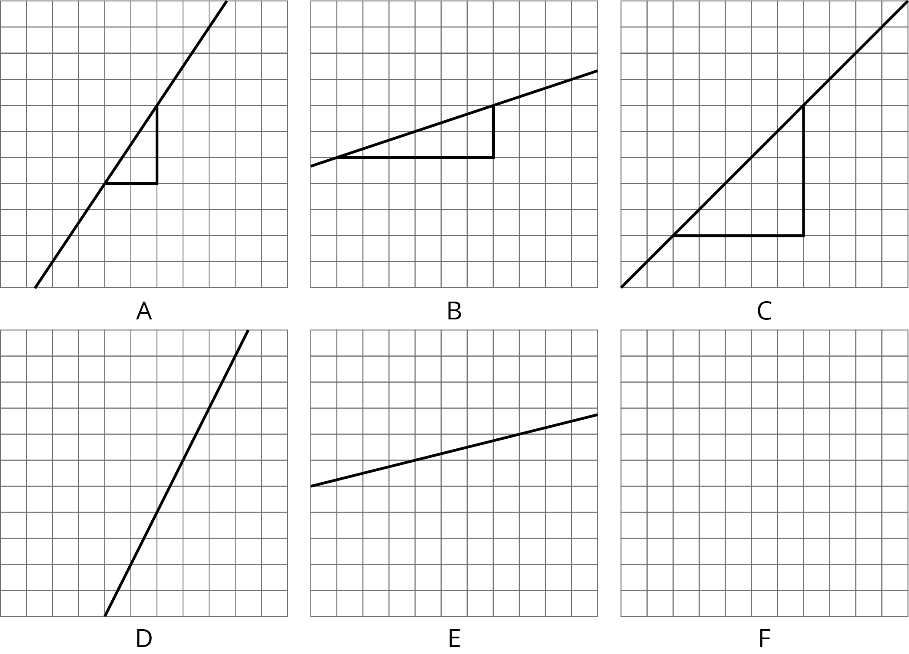

1. Match each line shown with a slope from this list: , 2, 1, 0.25, , .
2. One of the given slopes does not have a line to match. Draw a line with this slope on the empty grid (F).

#### Images for Activity Synthesis





© CC BY Open Up Resources. Adaptations CC BY IM.