Unit 3 Lesson 9: Solving Rate Problems

1 Grid of 100 (Warm up)

Student Task Statement
How much is shaded in each one?
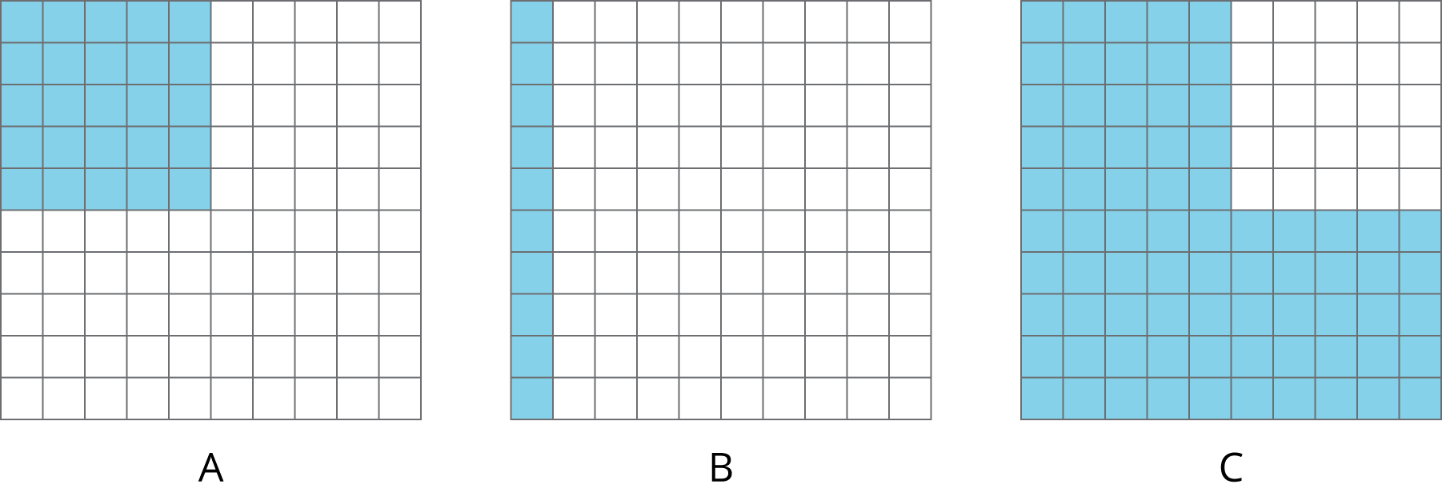

2 Card Sort: Is it a Deal?

Student Task Statement
Your teacher will give you a set of cards showing different offers.
- Find card A and work with your partner to decide whether the offer on card A is a good deal. Explain or show your reasoning.
- Next, split cards B–E so you and your partner each have two.
  - Decide individually if your two cards are good deals. Explain your reasoning.
  - For each of your cards, explain to your partner if you think it is a good deal and why. Listen to your partner’s explanations for their cards. If you disagree, explain your thinking.
  - Revise any decisions about your cards based on the feedback from your partner.
- When you and your partner are in agreement about cards B–E, place all the cards you think are a good deal in one stack and all the cards you think are a bad deal in another stack. Be prepared to explain your reasoning.

3 The Fastest of All

Student Task Statement
Wild animals from around the world wanted to hold an athletic competition, but no one would let them on an airplane. They decided to just measure how far each animal could sprint in one minute and send the results to you to decide the winner.
You look up the following information about converting units of length:
1 inch = 2.54 centimeters
animal | sprint distance
cougar | 1,408 yards
antelope | 1 mile
hare | 49,632 inches
kangaroo | 1,073 meters
ostrich | 1.15 kilometers
coyote | 3,773 feet
- Which animal sprinted the farthest?
- What are the place rankings for all of the animals?
© CC BY Open Up Resources. Adaptations CC BY IM.

