Lesson 17: Mosaic Pictures
- Let’s make a mosaic.

Warm-up: Notice and Wonder: Mosaic
What do you notice? What do you wonder?
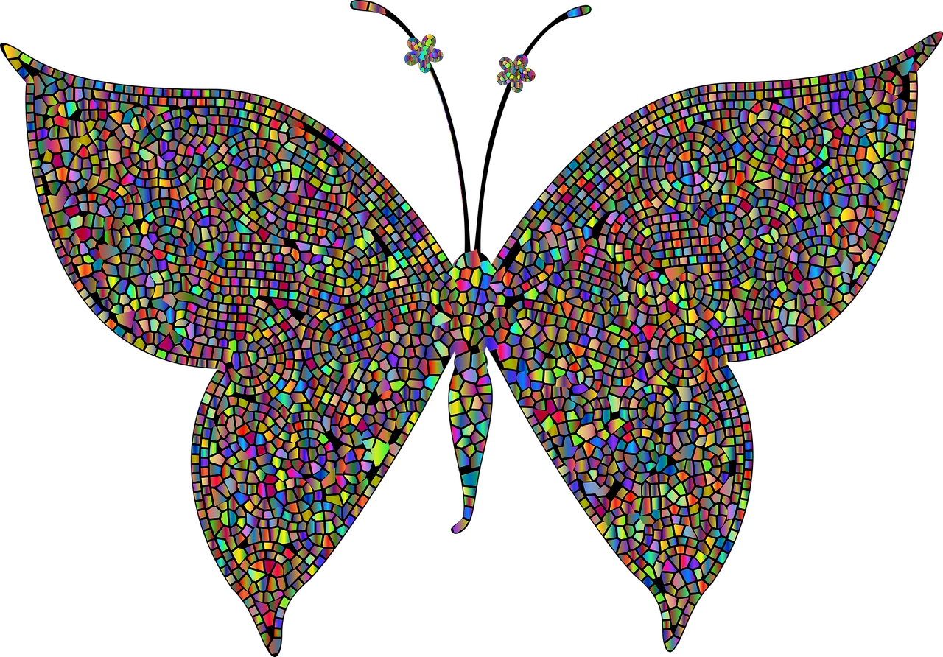

17.1: Create a Mosaic
- Use the colored paper and scissors to cut identical rectangles. Make sure the measurement of one side of the rectangle is a whole number and the other is a fraction greater than 1.
- What is the area of one of your rectangles? Show your reasoning.
- Use the rectangles from your group to make a group mosaic by arranging some of the different colored rectangles on a blank piece of paper.

17.2: Cost of Mosaic
About how much would it cost to create your mosaic with your preferred material? Explain or show your reasoning.
Material | Cost per square unit
Stone | $5
Tile | $3
Glass | $2
© CC BY 2021 Illustrative Mathematics®

