Lesson 7: Make Halves, Thirds, and Fourths
- Let’s make halves, thirds, and fourths or quarters.

Warm-up: Which One Doesn’t Belong: Compare Equal Pieces
Which one doesn’t belong?
A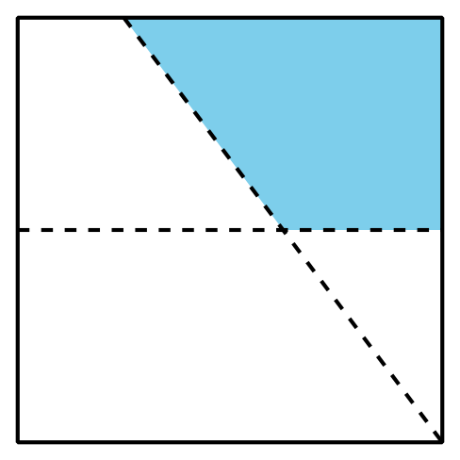

B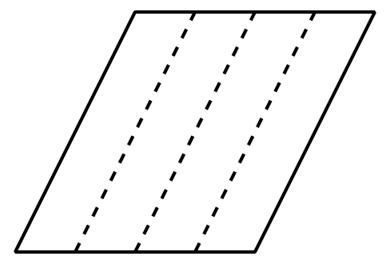
C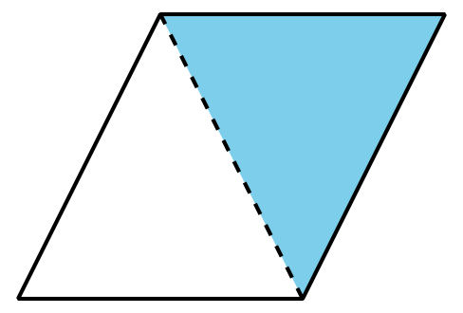
D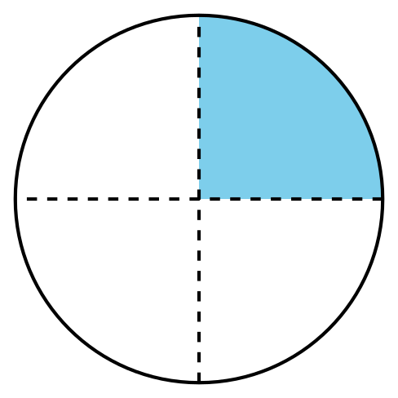

7.1: Fold Equal Pieces
- Fold the rectangle to make 2 equal pieces and cut them out.
- Each piece is called a ____________________.
- Compare with your partner. Tell how you know the pieces are equal.
- Fold the rectangle to make 4 equal pieces and cut them out.
- Each piece is called a ____________________.
- Compare with your partner. Tell how you know the pieces are equal.
- Fold the rectangle to make 3 equal pieces and cut them out.
- Each piece is called a ____________________.
- Compare with your partner. Tell how you know the pieces are equal.

7.2: That’s Not It
- Noah is looking for examples of circles that have been partitioned into halves, thirds, or fourths.
  - Put an X on the 2 circles in each row that are not examples.
  - halves
  - 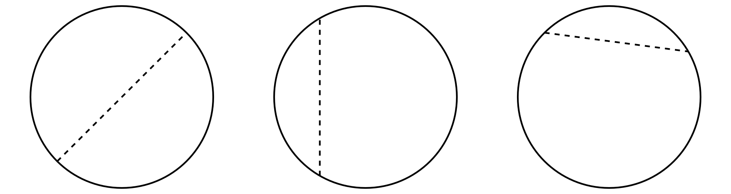
  - fourths
  - 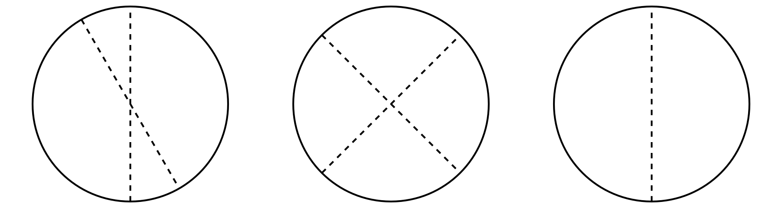
  - thirds
  - 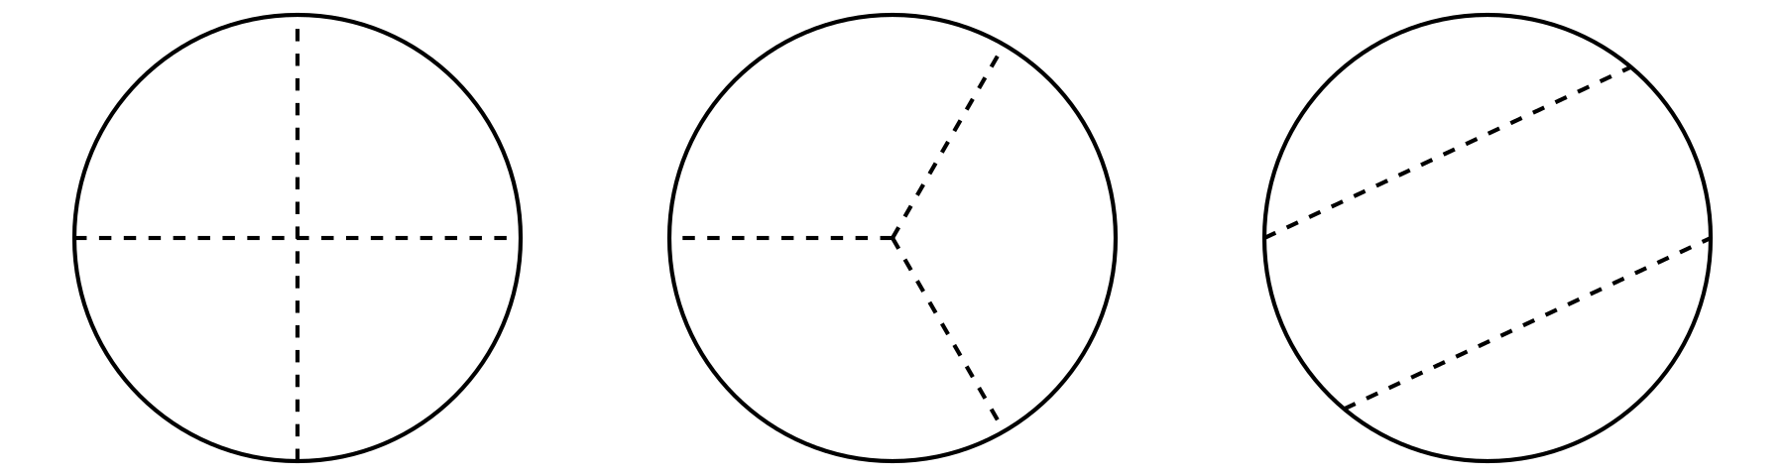
  - Explain why each of the shapes you marked is not an example of halves, fourths, or thirds.
- Partition this circle into thirds.
© CC BY 2021 Illustrative Mathematics®

